Brennor’s rpg corner

Mass Effect Unofficial Role Playing Game

Role Playing Game

Player’s Handbook & Core Rules
Version 1.08

Mass Effect © 2010 EA International (Studio and Publishing) Ltd. All Rights Reserved.
Brennor’s RPG Corner – http://brennor.dyndns.org/rpg

Version Changes
Version 1.0, Published February 23, 2010
Version 1.01, Published February 23, 2010
- Removed armor fortitude bonus
- Removed armor maximum dexterity
- Lowered armor penalties (removed penalty from light armor)
- Changed defense per character level calculation to 1 defense point per level
- Removed Frictionless Joints armor upgrade
Version 1.02, Published March 3, 2010
- Added Binoculars general equipment
- Added grenades (standard, smoke, high explosive, cryo, inferno)
- Added heavy weapons (flamethrower, grenade launcher, missile launcher)
- Added heavy weapons ammo (standard, smoke, high explosive, cryo, inferno)
- Added heavy weapons upgrades (ammo extension)
- Added freighters entry under starships
- Added rule regarding Improved Damage Threshold (Saga feat)
- Updated Combat Drone Tech Power stats
- Added Combat Sensor Omni-Tool upgrade
- Changed attribute bonus (each 4 levels) to +2
Version 1.03, Published April 6, 2010
- Added Miscellanous Items section
- Added UT-47 Kodiak drop shuttle
- Added A-61 Mantis Gunship
- Added Shadow Cloak equipment
- Added Talon Claw Knife equipment
- Added Combat Powers versus Defenses table

Version 1.04, Published ? ?, 2010
- Added cost to light armor

Version 1.05, Published February, 2012
- Made editing clean up fixes
- Removed XP spending refrences
- Updated Level Up Chart
- Added Vorcha racial bonuses
- Added cost to armor tables

Version 1.06, Published March, 2012
- Second Wind for Shield added
- Armor Price Change
- Armor Package Chart Updated
- Added Omni-Tool Power Blade
- Added Rules for Shield Recharge
- Added Extra Shield Recharge Feat
- Updated Shield/Armor/Omni Tool stats regarding shield recharge
- Changed how SP/BB/AP/HP are displayed and listed in combat (flipped)
- Updated Improved Damage Threashold Feat
- Updated Armor Familiarity Feat

Version 1.07, Published March 2012
- Removed incorrect costs in Biotic Implant decriptions
- Added Ranges to Ranged Weapon Table
- Updated Table 4: Armor & Shield Modules
Version 1.08, Published March 2012
- Minor editing mistakes (Hayabusa)

Contents

Introduction 1
Chapter 1: Character Races 3
Human 4
Asari 7
Batarian 12
Drell 14
Krogan 16
Quarian 21
Salarian 27
Turian 32
Volus 37
Vorcha 39
Chapter 2: Feats 41
Acquiring Feats 41
Prerequisites 41
Restriction List 41
Feat Descriptions 41
Combat Feats 41
Biotic Feats 43
Technology Feats 44
General Feats 45
Chapter 3: Skills and Defense 47
Skill Descriptions 47
Chapter 4: Biotics 48
Biotics throughout the Galaxy 48
Power Descriptions 50
Chapter 5: Tech 56
Power Descriptions 56
Chapter 6: Equipment 60
Armor 61
Base Armor 62
Armor Upgrades 64
Weapons 66
Melee Weapons 66
Base Ranged Weapons 67
Ammo Upgrades 69
Ranged Weapon Upgrades 71
Heavy Weapons 72
Base Heavy Weapons 72
Heavy Weapon Ammunition 73
Heavy Weapon Upgrades 75
Grenades 76
Omni-Tools 77
Base Omni-Tool 77
Omni-Tool Upgrades 79
Biotic Amplifiers 81
Base Biotic Amplifiers 81
Biotic Amplifier Upgrades 82
Biotic Implants 83
General Equipment 85
Miscellaneous Items 86
New Special Materials 86
Narcotics 87
Starships 87
Chapter 7: Combat 89
Attacking 89
Chapter 8: Organizations 91
Humanity-Based Organizations 91
Citadel Based Organizations 94
Mercenaries 95
Other Organizations 96
Chapter 9: Mass Effect Campaign 97
Timeline 97
Eras 98
Index 101

Introduction
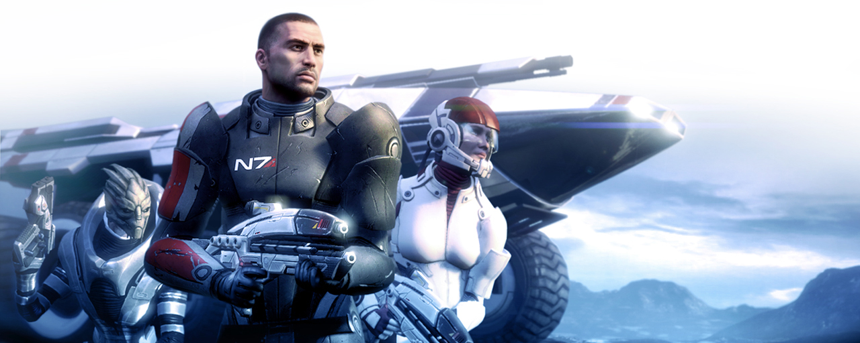

This book is designed as a supplement for d20 rulebooks and specifically designed to enhance the d20 Star Wars Saga Edition Revised Core Rulebook. Additional d20 supplements and rulebooks can be added to the rules outlined in this handbook as needed.

Changes from Mass Effect Games
The following list summarizes the changes to conform to a d20 role playing system from the Mass Effect video games.
- Slam, Throw, and Lift biotic powers are now grouped under a single biotic power called Kinetics.
- Biotic power cool downs are per power (instead of using a single cool down timer)

Changes from d20 Games
The following list summarizes the rule changes of a typical d20 Future or d20 Star Wars Saga Edition game. The Mass Effect RPG Handbook rules are greatly based on the d20 Star Wars Saga Edition Core Rulebook.
- There is a great emphasis on shields. Hit Points are greatly reduced compared to most D20 games. However, shield points, armor points, and biotic barriers provide several layers of defense.
- Ranged attacks are calculated the same way as d20 Star Wars Saga RPG.
- Damage is applied to shields first; biotic barriers second, armor third, and hit points last.
- Critical hits are a typical exception to the shields/biotic barriers/armor/hit points rule. Critical hits bypass shields and biotic barriers. Critical hits instead damage armor first and hit points second. Armor and hit points must be fixed or healed, and cannot be regenerated such as shields and biotic barriers can.
- The “Second Wind” feature of d20 Star Wars Saga RPG has been altered as Shield Recharge.
- Your BAB (Base Attack Bonus) is equal to your level.
- Star Wars Saga “talents” are considered feats.

Character Creation
The following are the character creation steps.
- Select Race
- Complete “Character Details”
- Assign attribute points (78 pts) across all attributes
- Apply racial modifiers
- A character’s hit points are equal to their constitution ability score.
- Each character receives Weapon Proficiency (Pistols) and Armor Proficiency (Light) feats free at 1st level
- Select 4 free starting feats. Humans get additional feat for a total of 5.
- Using starting Skill / Defense point pool (8 pts) select starting trained skills and initial saving throw defense levels (REF, WILL, FORT). These cannot be changed or increased later. Each Skill / Defense Point costs 1 pt.
- Base Attack Bonus (BAB) goes up +1 each level
- A character’s maximum Action Points is equal to 5 + ½ character level.
- A character’s defense bonuses for reflex, fortitude, and will saving throws are equal to the character level.

Level Advancement
XPs will be assigned by the DM at their discretion.
Levels are determined by the amount of XP gained divided by 10, rounded down.
Bonus attribute points gained every 4 levels cannot be placed into the same ability during the same level.
Table 1. Level Advancement
Level | XP | BAB | Def | Max AP | Bonus
1 | 10 | 1 | +1 | 5 | Starting 4 Feats
2 | 20 | 2 | +2 | 6 | Feat
3 | 30 | 3 | +3 | 6 | 2 Feats
4 | 40 | 4 | +4 | 7 | Feat, +2 Attribute Points
5 | 50 | 5 | +5 | 7 | Feat
6 | 60 | 6 | +6 | 8 | 2 Feats
7 | 70 | 7 | +7 | 8 | Feat
8 | 80 | 8 | +8 | 9 | Feat, +2 Attribute Points
9 | 90 | 9 | +9 | 9 | 2 Feats
10 | 100 | 10 | +10 | 10 | Feat
11 | 110 | 11 | +11 | 10 | Feat
12 | 120 | 12 | +12 | 11 | 2 Feats,  +2 Attribute Points
13 | 130 | 13 | +13 | 11 | Feat
14 | 140 | 14 | +14 | 12 | Feat
15 | 150 | 15 | +15 | 12 | 2 Feats
16 | 160 | 16 | +16 | 13 | Feat, +2 Attribute Points
17 | 170 | 17 | +17 | 13 | Feat
18 | 180 | 18 | +18 | 14 | 2 Feat
19 | 190 | 19 | +19 | 14 | Feat
20 | 200 | 20 | +20 | 15 | Feat, +2 Attribute Points

Chapter 1: Character Races

Table 2. Racial Adjustments
Race | Ability Adjustments | Bonus Skills, Feats, Talents, Restrictions
Human |  | 1 Free feat at 1st level
Asari | +2 DEX, +2 INT, -2 STR, -2 CON | Naturally Biotic, Mind Meld
Batarian | -2 INT, +2 STR | Ready to Fight, Four Eyes
Drell | +2 DEX, -2 CON | Eidetic Memory, Reptilian Nature, Kepral’s Syndrome
Elcor | N/A | N/A
Hanar | N/A | N/A
Krogan | +4 STR, +2 CON, -4 CHA, -2 INT | Natural Armor, Natural Super-Constitution, Genophage
Quarian | +2 INT, -2 CON | Natural Engineers, Weak Immune Systems
Salarian | +2 INT, +2 WIS, -4 CON | Knowledgeable, Short life-span
Turian | +2 STR, +2 CON, -2 WIS, -2 CHA | Military Background (Medium Armor, Sub-Machine Gun Proficiencies)
Volus | +4 CHA, -4 DEX | Small Size, Natural Negotiators, Rebreather
Vorcha | +2 STR, +2 DEX, -2 INT, -2 CHA | Combat Reflexes, Dodge

The Milky Way is populated with dozens of races. Some are valued members of Citadel space, working to build a better galactic community; others are lawless, caring nothing for the Citadel Council’s edicts; a few are outcasts, but all are unique.

Human
Humans, from the planet Earth, are the newest sentient species of notable size to enter the galactic stage and are arguably the most rapidly expanding and developing. They discovered a Prothean data cache on Mars in 2148 and the mass relay networks shortly thereafter.
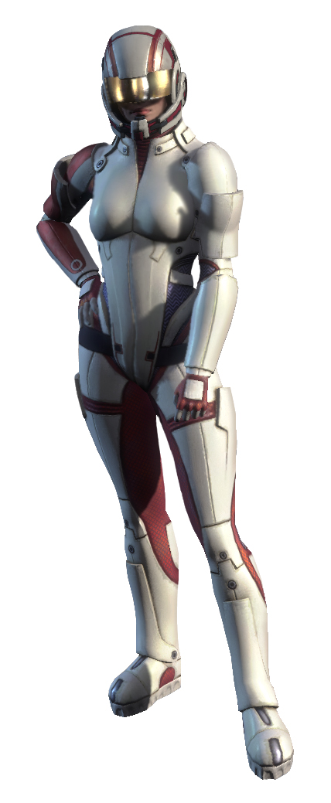

Human Species Traits
Humanity shares the following species traits:
Attribute Modifiers: None
Medium Size: As Medium Sized creatures Humanity have no bonuses or penalties based on their size.
Speed: Human base speed is six squares.
Human Diversity: Choose 1 free feat at 1st level

History
In 2148, human explorers on Mars uncovered a long-ruined Prothean observation post, with a surviving data cache that proved Protheans had studied Cro-Magnon humans millennia ago. While religions tried to assimilate this discovery into their doctrine, a global rush began to decipher the petabytes of data from the outpost. Discovering information on a mass relay orbiting Pluto, explorers managed to open the Charon Relay and discovered it led to Arcturus. With the help of the fledgling Systems Alliance, humans expanded to other systems, opening any mass relays they could find.
Humans first came to the attention of the galactic community after a brief but intense conflict with the turians, known by humans as the First Contact War, begun in 2157. The conflict began when the turians attacked a human fleet attempting to activate a mass relay (illegal under Council law) and then occupied the human colony of Shanxi.
Led by Admiral Kastanie Drescher, the Second Fleet then launched a massive counter-attack, which caught the turians by surprise and expelled them from Shanxi. The conflict caught the attention of the Citadel Council, which wasted no time brokering a peace, thus introducing humans to the galactic community. As a consequence of the Alliance’s swift and decisive action during the First Contact War, the Alliance became the representative and supranational governing body of humanity. Since then, humans have rapidly risen in prominence.

Biology
Humans have a fairly robust physiology. Their internal makeup and reproductive processes are typical of most bipedal mammals and their size and proportions give the appearance of being strong, fast and agile. In comparison to the Council races, humans are roughly physically on par with turians (as very fit humans can punch them over and even throw them off the ground unassisted, as can turians do the same to humans), and less agile than asari (whom they closely resemble), though fit human males are likely to be far stronger than the average asari. Humans would appear on average to be stronger than salarians but not as fast, due to the extremely elevated metabolisms of the latter. Like most organic races, humans are also capable of producing biotic individuals but there is a high risk of medical complications. It is worth noting that humans have far greater genetic diversity than other species.
Humans can live to about 150 years, and recent medical advances have eradicated almost all known diseases that afflict them. However, as humans only emerged on the galactic stage within the last thirty years, it is highly likely that the introduction of new technology into their society will greatly increase their average lifespan. Humans reach physical maturity at eighteen years of age, at which point they have usually finished their academic education and either directly enter the workforce or begin training for a profession.

Galactic Relations
Humans, represented by the Systems Alliance, have had an embassy on the Citadel since 2165. While the humans lack a seat on the Citadel Council, some other species dislike their sudden ascendancy compared to their status as relative newcomers on the galactic stage. Some species feel that humanity is overly expansive in its colonization efforts and aggressive attempts to get a seat on the Council. It took other species centuries to achieve what humanity has done in decades.
Humans have also been doing what the Council could not: colonize planets in the Attican Traverse, the Skyllian Verge and along the borders of the Terminus Systems, all volatile regions where the Council has little authority. Human forces came into minor conflicts with the batarians over the Verge, which the batarians had been attempting to colonize themselves. When the batarians asked the Council to declare the Verge a “zone of batarian interest” they were refused; in response the batarians became a rogue state, blaming humans for depriving them of valuable resources, and human-batarian relations have been hostile ever since.
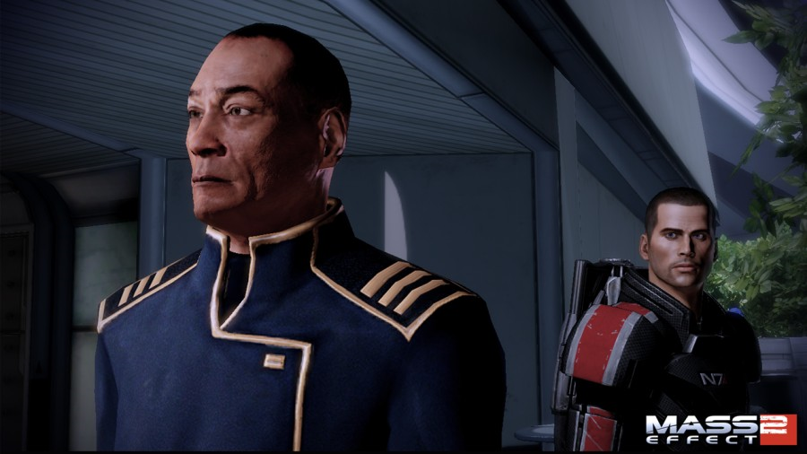
Unlike many species in Citadel space, humans have no close allies among the other races, though they are trade partners with the turians and asari. Without alliances or key political positions, humans have had to follow the edicts of the Council without having much influence on their decisions. Human ambassadors have been pushing to induct a human into the Spectres, the Council’s elite operatives, as the first step to getting a seat. Once humanity does get a seat, they will be able to influence the Council’s rulings, protect their own interests and have a say in the governing of Citadel space.
Humans are generally seen to be intelligent, aggressive, highly adaptable and thus, unpredictable. They have a powerful desire to advance and improve themselves, and do so with such assertion that the normally staid Council races have been taken aback by their restlessness and relentless curiosity. Their economy, while much smaller than any of the Council races, is very powerful relative to their size, and their military prowess is amongst the greatest in the galaxy, as evidenced by their ability to defeat the turians in the First Contact War. This is a subject of concern for many races, who fear the consequences if another human-turian conflict break out.

Asari
The asari, native to the planet Thessia, are often considered the most powerful and respected sentient species in the known galaxy. This is partly due to the fact the asari were the first race after the Protheans to achieve interstellar flight, and to discover and inhabit the Citadel.
A mono-gender race—distinctly feminine in appearance—the asari are known for their elegance, diplomacy, and biotic talent. Their millennia-long lifespan and unique physiology—allowing them to reproduce with a partner of any gender or species—give them a conservative but convivial attitude toward other races. The asari were instrumental in proposing and founding the Citadel Council, and have been at the heart of galactic society ever since.

Asari Species Traits
Asari share the following species traits:
Attribute Modifiers: +2 Dexterity and +2 Intelligence, -2 Strength and -2 Constitution. The Asari are quick, nimble, and learned. But they are of a slight build.
Medium Size: As Medium Sized creatures the Asari have no bonuses or penalties based on their size.
Speed: Asari base speed is six squares.
Naturally Biotic: Asari are naturally biotic. Asari start play with access to the Use Biotic skill and one free Biotic Power. They are able to use both without a Biotic Implant or the Biotic Feat.
Mind Meld: An Asari may meld with another for the sole purpose of transferring thoughts, without reproduction. This is difficult to perform, extremely intense, and debilitating.
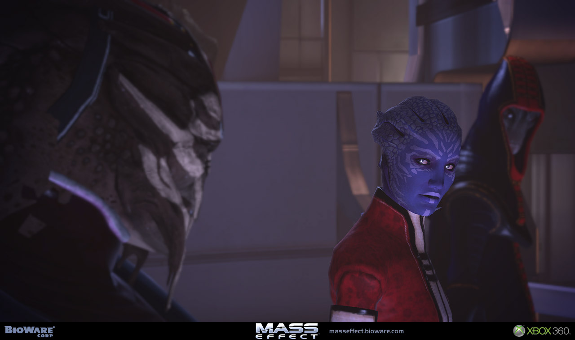

History
The asari were the first contemporary race to achieve space-flight and discover the mass relays. When they found the Citadel in around 580 BCE, the asari also encountered the keepers, whose mute assistance enabled them to quickly settle on the station and learn how to operate its systems. Sixty years later, the salarians made first contact with them, and together the two species agreed to found the Council.
The asari continued their exploration. In around 200 BCE, the asari made first contact with the elcor and played a key role in their ascension into the galactic community. It is known that they were charting the Gorgon system at some point in Earth’s 17th century.

Appearance
A typical asari individual has a blue to purple complexion; the gas giant Sharblu was named after a famous asari soprano with a distinctive skin tone that resembled the planet’s atmosphere. Some asari, such as their representative on the Council, have facial markings. In concept art, Matriarch Benezia’s are described as tattoos; however, they appear to be genetic as they appear on one asari’s clones, and may denote the ‘father’ species (as Liara T’Soni, the daughter of two asari, has none). In the place of head hair, asari possess wavy folds of sculpted skin; aside from this and their skin tone, aesthetically the asari are the closest alien species to humans.
There is some conflicting information regarding the gender of the asari. Though they resemble females, at least to humans, asari are non-gender specific, with no concept of gender differences. Liara says her species is “mono-gendered—male and female have no real meaning for us,” and, if asked, says that she is “not precisely a woman”. However, in the Codex it is stated that the asari are an all-female race. The Galactic Codex: Essentials Edition 2183 says that “while asari have only one gender, they are not asexual like single-celled life—all asari are sexually female”, and according to Liara they also have maternal instincts. They are innately different from humans for asari can crossbreed with other species and inherit certain traits.
Asari are considered attractive to many species, which would prove useful considering their method of reproduction. Due to their ability to wear human armor and clothes, it is safe to assume that they are most physically similar to humans. Like humans, asari have navels and mammary glands, suggesting similar biology between the two races.

Biology
Asari have a robust cellular regenerative system. While they do not heal faster than other species, asari are known to reach 1000 years of age.
Although asari have one gender, they are not asexual. An asari provides two copies of her own genes to her offspring, which—regardless of the species or sex of the ‘father’—is always an asari. The second set is altered in a unique process called melding, also known as the joining.
During melding, an asari consciously attunes her nervous system to her partner’s, sending and receiving electrical impulses directly through the skin. A common phrase used before melding is “embrace eternity,” presumably to help focus the partner’s mind. Effectively, the asari and her partner briefly become one unified nervous system. This unique means of reproduction is the reason asari are all talented biotics. Their evolved ability to consciously control nerve impulses is very similar to biotic training. The partner can be another asari, or an alien of any gender. However, since the asari began encountering other sentient species, non-asari mates have become preferred for the diversity they provide. This reproductive process can lead to some confusion among non-asari, who might expect offspring with “mixed” genes. However, the offspring is always 100% asari, as it does not actually take DNA from the partner. The process simply uses the DNA as a “map” to randomize the genes of the offspring.
An asari’s melding ability extends to a mental connection as well, which Liara describes as being the true union between an asari and her partner. It allows the asari to explore her partner’s genetic heritage and pass desirable traits on to any offspring. During mating, an asari and her partner share memories, thoughts, and feelings. It is also possible for an asari to meld with another for the sole purpose of transferring thoughts, without reproduction. This technique is extremely intense and debilitating.
Asari pass through three climacteric life stages, marked by biochemical and physiological changes:
The Maiden stage begins at birth and is marked by the drive to explore and experience. Most young asari are curious and restless.
The Matron stage of life begins around the age of 350, though it can be triggered earlier if the individual melds frequently. This period is marked by a desire to settle in one area and raise children.
The Matriarch stage begins around 700 years of age, or later if the individual melds rarely. Matriarchs become active in their community as sages and councilors, dispensing wisdom from centuries of experience. Their knowledge and guidance may be one reason why Matriarchs are rarely seen outside asari space.
It should be noted that, each stage can be started whenever an asari feels that she has reached the correct level of maturity. While each stage of life is marked by strong biological tendencies, individuals do make unexpected life choices. For example, there are Maidens who stay close to home rather than explore, Matrons who would rather work than build a family, and Matriarchs who have no interest in community affairs.

Culture
Because of their long lifespan, asari tend to have a ‘long view’ not common in other races. When they encounter a new species or situation, the asari are more comfortable with an extended period of passive observation and study than immediate action. They are unfazed that some of their investments or decisions may not pay off for decades or centuries. Matriarchs can seem to make incomprehensible decisions, but their insight is evident when their carefully-laid plans come to fruition. In interstellar relations, this long view manifests in the unspoken policy of centrism. The asari instinctively seek to maintain stable balances of economic, political, and military power.
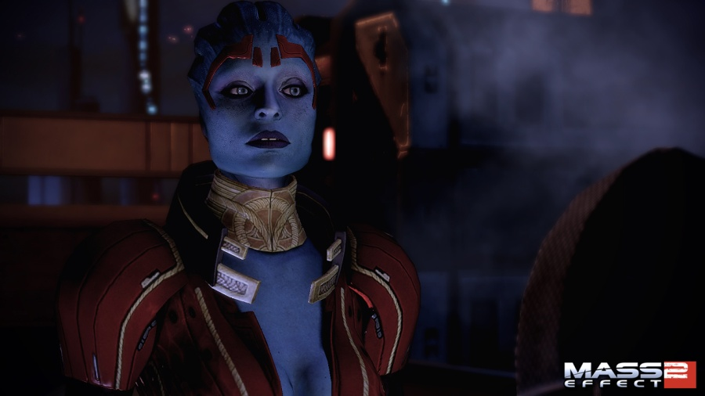
Traditionally, asari spread their influence through cultural domination and intellectual superiority. They invite new species of advanced development to join the galactic community, knowing that their ideals and beliefs will inevitably influence the existing culture. The asari tend toward communal, consensus attitudes among themselves too: for example, they prefer to live in shared spaces aboard starships even if there are alternatives available.
Asari believe that their offspring acquire the best qualities of the ‘father’ from the melded genes, but evidence is anecdotal. They frown upon intraspecies conception, since genetic traits and cultural insight is gained from mating outside their species, so it’s considered wasteful for asari to reproduce together. The results of such unions are occasionally referred to as ‘purebloods’, which is a great insult among the asari. A rare genetic defect known as Ardat-Yakshi, which makes asari destroy the partner’s mind during sex, occurs much more frequently among the daughters of purebloods.
Systems Alliance (Captain/Admiral) David Anderson admits that, when dealing with the asari—despite their political and military prowess—their feminine appearance makes it difficult for him to accept them as one of the most powerful races in the galaxy. He feels that this isn’t his fault due to thousands of years of human cultural bias. Asari are well aware they tend to be attractive, and are comfortable expressing their sexuality, like the dancers in Chora’s Den. Young males of all races tend to have a fascination with asari.
Because of their natural sensuality and ability to mate with any species, asari are sometimes rumored to be promiscuous. These rumors are mostly a result of misinformation (or wishful thinking). In fact, asari have to accept that if they mate outside their own species, they will almost inevitably outlive their partner. Therefore they have had to apply their philosophical ‘long view’ to relationships as well, savoring the time they spend with their partners rather than focusing on their inevitable loss.

Government
The asari governmental structure, known as the Asari Republics, is relatively broad; the asari came late to the notion of world government. For centuries, their home world of Thessia was dotted with loose confederacies of great republican cities. The closest Earth equivalent would be the ancient Mediterranean city-states. Since the asari culture values consensus and accommodation, there was little impetus to form larger principalities. Rather than hoard resources, the asari bartered freely. Rather than attack one another over differing philosophies, they sought to understand one another. Only in the information age did the city-states grow close; communication over the internet evolved into an ‘electronic democracy’.
Aside from their Council representative, the asari have no politicians or elections, but a free-wheeling, all-inclusive legislature that citizens can participate in at will. Policy debates take place at all hours of the day, in official chat rooms and forums moderated by specially-programmed virtual intelligences. All aspects of policy are open to plebiscite at any time. In any given debate, the asari tend to lend the most credence to the opinions of any Matriarchs present, nearly always deferring to the experience of these millennia-old ‘wise women’.
In modern times, the asari normally act as the diplomatic arm of the Citadel Council.

Economy
The asari possess the largest single economy in the galaxy. They have extensive trade and social contacts. Craft guilds, such as those within the cities Serrice and Armali, hold a virtual monopoly on advanced biotic technology. Given their political influence, an embargo by the asari would prove disastrous to the Alliance.

Military Doctrine
The asari military resembles a collection of tribal warrior bands with no national structure. Each community organizes its own unit as the locals see fit, and elect a leader to command them. Units from populous cities are large and well-equipped, while those from farm villages may be only a few women with small arms. There is no uniform; everyone wears what they like. The asari military is not an irregular militia, however; those who serve are full-time professionals.
The average asari huntress is in the maiden stage of her life and has devoted 20-30 years studying the martial arts. Asari choose to be warriors at a young age, and their education from that point is dedicated to sharpening their mind and body for that sole purpose. When they retire, they possess an alarming proficiency for killing.
Huntresses fight individually or in pairs, depending on the tactics preferred in their town. One-on-one, a huntress is practically unbeatable, possessing profound tactical insight, a hunter’s eye, and a dancer’s grace and alacrity. Biotics are common enough that some capability is a requirement to be trained as a huntress; lack of biotic talent excludes a young asari from military service.
While fluid and mobile, asari can’t stand up in a firestorm the way a krogan, turian, or human could. Since their units are small and typically lack heavy armor and support weapons, they are almost incapable of fighting a conventional war, particularly one of a defensive nature. So asari units typically undertake special operations missions. Like an army of ninja, they are adept at ambush, infiltration, and assassination, demoralizing and defeating their enemies through intense, focused guerrilla strikes. Asari huntresses were among the first individuals to be chosen as Spectres and played a key role in the Krogan Rebellions.
As a popular turian saying puts it, ‘The asari are the finest warriors in the galaxy. Fortunately, there are not many of them.’

Religion
The pantheistic mainstream asari religion is siari, which translates roughly as ‘All is one.’ The faithful agree on certain core truths: the universe is a consciousness, every life within it is an aspect of the greater whole, and death is a merging of one’s spiritual energy back into greater universal consciousness. Siarists don’t specifically believe in reincarnation; they believe in spiritual energy returning to the universal consciousness upon death will eventually be used to fill new mortal vessels.
Siari became popular after the asari left their home world and discovered their ability to ‘meld’ with nearly any form of life. This ability is seen as proof that all life is fundamentally similar. Siari priestesses see their role as promoting unity between disparate shards of the universe’s awareness.
Before the rise of siari pantheism, asari religions were as diverse as their political opinion. The strongest survivor of those days is the monotheistic religion worshiping the goddess Athame. Like the asari, the goddess cycles through the triple aspects of maiden, matron, and matriarch. Asari often swear “by the goddess”, though this may be a cultural legacy rather than reflecting an individual’s belief.

Batarian
A race of four-eyed bipeds, the batarians is a disreputable species that chose to isolate itself from the rest of the galaxy. The Terminus Systems are infested with batarian pirate gangs and slaving rings, fueling the stereotype of the batarian thug. It should be noted that these criminals do not represent average citizens, who are forbidden to leave batarian space by their omnipresent and paranoid government.
Despite several disagreements with the Citadel and simmering hostility toward humans, most batarians prefer profitable pursuits such as drug running and slave grabs to out-and-out warfare. They have a reputation for being shrewd businessmen and merchants, though in more lawless regions of the galaxy like Omega, negotiations with a batarian are likely to be conducted at gunpoint.
The batarian home world is called Khar’shan.
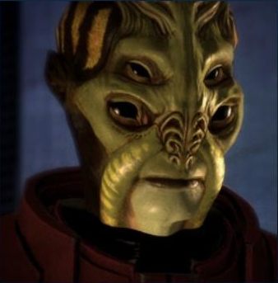

Batarian Species Traits
Batarian share the following species traits:
Attribute Modifiers: -2 Intelligence and +2 Strength. Batarians are not overly intelligent but stout and strong.
Medium Size: As Medium Sized creatures Batarians have no bonuses or penalties based on their size.
Speed: Batarians base speed is 6 squares.
Ready to Fight: Batarians are always ready for a fight, granting them Skill Focus (Initiative).
Four Eyes: Batarians have four eyes, aiding them in seeing things, which grants a Skill Focus (Perception).

History
In the early 2160s, humans began to colonize the Skyllian Verge, a region the batarians were already actively settling. The batarians asked the Citadel Council to intervene and declare the Verge an area of “batarian interest”. When the Council refused, the batarians closed their Citadel embassy and severed diplomatic and economic relations, becoming an inward-looking rogue state.
Money and weapons funneled from the batarian government to criminal organizations led to many brutal raids on human colonies in the Verge, culminating in the Skyllian Blitz of 2176, an attack on the human capital of Elysium by batarian-funded pirates and slavers. In 2178, the Alliance retaliated with a crushing assault on the moon of Torfan, long used as a staging base by batarian-backed criminals. In the aftermath, the batarians retreated into their own systems, and are now rarely seen in Citadel space.

Culture
Batarians place an extremely high value on social caste and appearance, and overstepping one’s place is frowned upon. Casting aspersions on the monetary worth of a social better is considered a serious insult. Batarians strongly believe that species with less than four eyes are less intelligent; they often gain the upper hand in inter-species arguments because other races find it difficult to know which eyes to focus on when speaking to them.
Body language is an important part of batarian society. For example, tilting one’s head to the left is a sign of admiration and respect. When a batarian tilts his head to the right it is a sign that he is (or considers himself to be) superior to the one that the gesture was directed at. Therefore, this gesture can also be interpreted as an insult.
The rest of the galaxy views the batarians as an ignorable problem. Their government is still hostile to the Systems Alliance, but beneath the notice of the powerful Council races. It is not known what the average batarian thinks about their enforced isolation, as the Department of Information Control ensures that only government-approved news enters or leaves batarian space. Given the batarian government’s oppressive nature, it is speculated their supreme leadership is autocratic or totalitarian in nature. The batarians blame humanity for their troubles and claim they were forced to fend for themselves, despite the fact that their exile is largely self-imposed.
However, the batarians still provide up-to-date glossaries and linguistic rules to the rest of the galaxy (allegedly so they can continue distributing propaganda). Possibly due to the prevalence of batarian criminal gangs, batarian languages have become lingua franca in the Terminus Systems.
The batarian government is called the Batarian Hegemony.

Military
Little is known about the batarian military other than the fact it is largely nationalized; most batarian military hardware is produced by an institution called Batarian State Arms.
The batarian fleet is known to operate at least one dreadnought (as a non-Citadel race, they are not bound by the Treaty of Farixen and may have more). They also field smaller vessels, including the Hensa class of cruisers. However, given one member of this class – later obtained by the quarians and refurbished as the Idenna – was twenty years old in 2183, the batarians may have retired the Hensa class from active service by this time.
Their military capacity is believed to be weaker than the Systems Alliance as early as 2160 (when colonization of the Skyllian Verge began) as Balak claims that the council and batarians themselves knew the humans were stronger but nothing was done to protect them, and they were left to defend themselves.

Drell
The drell are a reptile-like race that was rescued from their dying home world by the Hanar following first contact between the two. Since then, the drell have remained loyal to the hanar for their camaraderie and have fit comfortably into galactic civilization. The drell have a rasping effect to their voices similar to the vocal flanging of the turians.
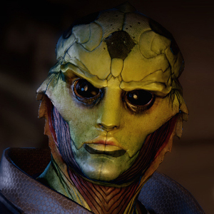

Drell Species Traits
Drell share the following species traits:
Attribute Modifiers: +2 Dexterity and -2 Constitution. The Drell are quick but have many issues with surviving off their native world that has been destroyed. Also, the gene pool is small, causing more diseases and flaws in genetic structures to become more prevalent.
Medium Size: As Medium Sized creatures the Drell have no bonuses or penalties based on their size.
Speed: Drell base speed is six squares.
Eidetic Memory: Drells are known for having Eidetic Memory and being able to recall any moment of their past. This gives them total recall for things they have seen and heard offhand. This allows Drell to being play with Skill Focus (Gather Information) and Skill Focus (Perception).
Reptilian Nature: Drell have two sets of eyelids, enabling them to see at a wider range than typical species. This gives them +1 to their Reflex saves during play.
Kepral’s Syndrome: Most Drell that live long enough begin to suffer from Kepral’s Syndrome caused by cumulative long-term exposure to a humid climate. This syndrome erodes the ability of drell lungs to take in oxygen, and eventually spreads out to other organs. There is currently no known cure. Drell over the age of 40 must roll a chance die each year. There is a 10% chance of forming the disease. Once formed, the Drell have 5 to 10 years to live. After year 3 each physical attribute drops -1 until death (Strength, Dexterity and Constitution). After year five, a chance roll occurs with a 20% chance of death.

History
The drell ancestors emerged from dry, rocky deserts on the barren world of Rakhana. Eight centuries ago, the already-arid drell home world began its swift descent into lifelessness due to disastrous industrial expansion. At the time, the drell lacked interstellar flight capacity, and with their population bursting at 11 billion they faced certain doom. It was around this time that the hanar made first contact with the drell race. In the following ten years, the hanar would transport hundreds of thousands of drell to the hanar world, Kahje. The remaining billions left on Rakhana would perish on their dying planet, warring against each other for diminishing resources. The drell now thrive co-existing with the hanar and have been a part of the galactic civilization for roughly two centuries. The debt of gratitude that the drell owe the hanar is referred to as the Compact, which the drell fulfill by taking on tasks that the hanar find difficult, such as combat. Any drell may refuse to serve, but as being requested to serve is a great honor, few turn down the offer.

Society
Most drell are content to live on Kahje. They are afforded every opportunity to thrive by the hanar, yet some outsiders and even some hanar regard the drell as second class citizens. However it is quite the opposite, they have integrated themselves into every level of hanar society as respected, productive citizens, so much so that many have embraced the hanar Enkindlers. Others tend to accept the asari philosophies. Many of the older traditions of the drell have begun to die out; the younger generations no longer believe the old ways of their ancestors can help them now, with so many other ways to interpret one’s place in the universe. Among their ancestral beliefs was a polytheistic religion which included at least three gods; Amonkira, Lord of Hunters, Arashu, Goddess of Motherhood and Protection, and Kalahira, Goddess of Oceans and Afterlife.
Those who leave Kahje tend to be adventurers. These solitary drell travelers often seek out new species elsewhere, and in turn adopt that species’ culture. Such drell number in the thousands, and are scattered across the galaxy, tending towards quiet, integrated lives.
Some drell grow a close, personal relationship with the hanar. So much so that the hanar will even tell the drell their “Soul Name”. Drell have adapted to communication with hanar by getting implant in their eyes to allow them to observe the bioluminescence the hanar use for communication. Drell such as Thane are able to see ultraviolet light as a silvery color, though might lose differentiation between other colors, such as the difference between dark red and black.

Biology
Drell are omnivorous reptile-like humanoids with an average lifespan of 85 galactic standard years. Drell appearance is very similar to asari and humans, but their muscle tissue is slightly denser, giving them a wiry strength. Many of their more reptilian features are concealed, however one unique characteristic is the hyoid bone in their throats, which allows them to inflate their throats and produce vocal sounds outside of the human range. They also have two sets of eyelids, like crocodiles. Drell possess the ability to shed tears.
Because the drell ancestors emerged from arid, rocky deserts, the humid, ocean-covered hanar home world of Kahje proved tolerable only when the drell stayed inside a climate-controlled dome city. The leading cause of death for drell on Kahje is Kepral’s Syndrome, caused by cumulative long-term exposure to a humid climate. This syndrome erodes the ability of drell lungs to take in oxygen, and eventually spreads out to other organs. It is noncommunicable, and there is currently no known cure, though leading hanar scientific authorities are working on creating a genetic adaptation.
The drell possess eidetic memory, an adaptation to a world where they must remember the location of every necessary resource (vegetation, drinkable water and prey migration paths) across vast distances. The memories are so strong that an external stimulus can trigger a powerful memory recall. These recalls are so vivid and detailed that some drell may mistake it for reality. Thane Krios, for example, remembers every assassination he has ever performed and can describe them in flawless detail, and says he prefers to spend a lonely night with the perfect memory of another. This process can be involuntary.

Krogan
The krogan are a species of large reptilian bipeds native to the planet Tuchanka, a world known for its harsh environments, scarce resources, and overabundance of vicious predators. The krogan managed to not only survive on their unforgiving home world, but actually thrived in the extreme conditions. Unfortunately, as krogan society became more technologically advanced so did their weaponry.
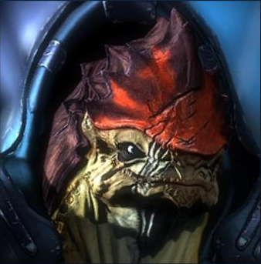
Four thousand years ago, at the dawn of the krogan nuclear age, battles to claim the small pockets of territory capable of sustaining life escalated into full scale global war. Weapons of mass destruction were unleashed, transforming Tuchanka into a radioactive wasteland. The krogan were reduced to primitive warring clans struggling to survive a nuclear winter of their own creation, a state that continued until they were discovered by the salarians two thousand years later.
With the help of the salarians, the krogan were ‘uplifted’ into galactic society, and lent their numbers and military prowess to bring an end to the Rachni Wars. Ironically, after the rachni were eradicated, the rapidly-expanding krogan became a threat to the galaxy in turn, starting the Krogan Rebellions and forcing the turians to unleash the genophage. This genetic ‘infection’ dramatically reduced fertility in krogan females, causing a severe drop in births and, ultimately, population, eliminating the krogan numerical advantage.

Krogan Species Traits
Krogan share the following species traits:
Attribute Modifiers: +4 Strength, +2 Constitution, - 4 Charisma, -2 Intelligence. Krogan are large, strong, and hardy, but lack and sort of tact and do not excel at scholarly pursuits.
Medium Size: As Medium Sized creatures the Krogan have no bonuses or penalties based on their size.
Speed: Krogan base speed is 6 squares.
Natural Armor: Krogan have natural armor in the form of rock hard exoskeletons. Krogans begin play with +10 natural armor points.
Natural Super-Constitution: Krogan Hit Points are based on Constitution * 1.5, not simply Constitution.
Genophage: The genophage was a biological weapon deployed against the krogan by the turians during the Krogan Rebellions. It was designed to severely reduce krogan numbers by ‘infecting’ the species with a genetic mutation. The genophage’s modus operandi is not to reduce the fertility of krogan females, but rather the probability of viable pregnancies: many krogan die in stillbirth, with most fetuses never even reaching this stage of development. Moreover, every cell in each krogan is infected, to prevent the use of gene therapy to counteract it. Though the genophage was not designed as a “sterility plague”, the combination of a low frequency of viable pregnancies with the krogan proclivity to violence and indifference about focused breeding leaves the krogan a dying race, and soon to be extinct. At game start, the DM makes a secret roll. The Krogan has a 99% chance of being infected with Genophage.

Biology
Due to the brutality of their surroundings, natural selection has played a significant role in the evolution of the krogan. Unlike most species on the Citadel, krogan eyes are wide-set – on Earth this is distinctive of prey animals, but in this case it gives the krogan 240-degree vision, giving them greater visual acuity and awareness of approaching predators. Prior to the genophage, krogan could reproduce and mature at an astonishing rate.
Their large shoulder humps store fluids and nutrients, enabling them to survive extended periods without food or water. A bigger shoulder hump is seen as a sign of high status, showing how successful an individual krogan is at hunting. Their thick hides are virtually impervious to cuts, scrapes or contusions, and they are highly resistant to environmental hazards, including toxins, radiation, and extreme heat and cold. Younger krogan have yellow or green markings on their hides. These markings darken to brown or tan over time, showing their age.
Biotic individuals are rare, though those who do possess the talent typically have strong abilities. The most amazing physiological feature of krogan biology is the multiple instances of major organs. These secondary (and where applicable, tertiary and quaternary) systems are capable of serving as back-ups in the event of damage to the primary biological structures. Krogan also have a secondary nervous system using a neuroconductive fluid, meaning they are almost impossible to paralyze. Krogan bleed a yellow or orange fluid when shot, which may be this fluid or actual blood.
Having redundant systems makes krogan difficult to kill or incapacitate in normal combat scenarios. Sheer physical hardiness means an individual krogan can expect to live for centuries. Krogan can live for well over a thousand years.
Krogans refer to a “litter” of krogans as a “clutch.” Each krogan birth can potentially birth 1,000 krogan infants.
It is rumored that, if one lodges a knife at a certain spot on a Krogan crest, you can rip it off. It is apparently the one thing they do fear.
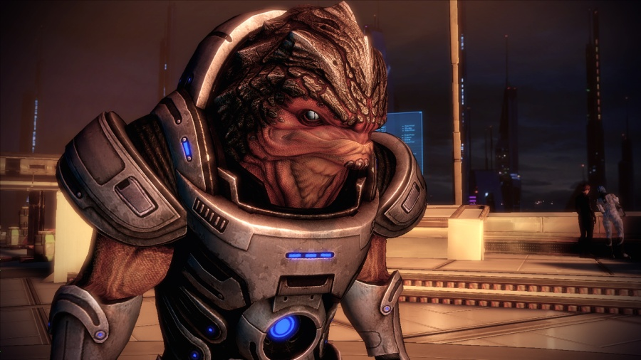

History

Rise of the Krogan
Roughly 2000 years ago the krogan were a primitive tribal species trapped on a world suffering through a nuclear winter of their own making. They were liberated from this state by the salarians, who “culturally uplifted” the krogan by giving them advanced technology and relocating them to a planet not cursed with lethal levels of radiation, toxins or deadly predators.
But the salarian intervention was not without an ulterior motive. At the time the Citadel was engaged in a prolonged galactic war with the rachni, a race of intelligent space-faring insects. The salarians hoped the krogan would join the Citadel forces as soldiers to stand against an otherwise unstoppable foe. The plan worked to perfection: within two generations the rapidly breeding krogan had the numbers to not only drive the advancing rachni back, but the ability to endure the harsh conditions of the rachni worlds. They were able to pursue them to their home worlds, find the rachni queens, and eradicate the entire species.

Saviors of the Galaxy
For a brief period the krogan were hailed as the saviors of the galaxy and were given not only the conquered rachni worlds but other planets in Citadel space to colonize, in gratitude for their help. The Citadel Council even commissioned a statue for the Presidium – the Krogan Monument – to honor the krogan soldiers who died defending Citadel space.
But without the harsh conditions of Tuchanka to keep their numbers in check, the krogan population swelled to unprecedented numbers. Overcrowded and running out of resources, the krogan spread out to forcibly claim other worlds – worlds already inhabited by races loyal to the Citadel. There was always ‘just one more world’ needed. The final straw was when the krogan began settling the asari colony of Lusia. When the Council ordered them to leave, Overlord Kredak, the krogan ambassador, stormed out of the Chambers, daring the Citadel races to take their worlds back. War broke out soon afterward.
The so-called Krogan Rebellions continued for nearly three centuries. The krogan sustained massive casualties, but their incredible birth rate kept their population steadily increasing. Victory seemed inevitable. In desperation, the Council turned to the recently discovered Turian Hierarchy for aid. The turians unleashed the genophage on the krogan home worlds: a terrifying bio-weapon engineered by the salarians. The genophage caused near total infant mortality in the krogan species, with only 1 birth in every 1000 producing live offspring.

The Genophage
No longer able to replenish their numbers, the krogan were forced to accept terms of surrender. For their role in quelling the Krogan Rebellions, the turians were rewarded with a seat on the Citadel Council. The krogan, on the other hand, still suffer from the incurable effects of the genophage.
Over the last millennium krogan numbers have steadily declined, leaving them a scattered and dying people. Some try bizarre treatments for the genophage, including testicle transplants. But, faced with the certainty of their extinction as a species, most krogan have become individualistic and completely self-interested. They typically serve as mercenaries for hire to the highest bidder, though many still resent and despise the Citadel races that condemned them to their tragic fate. Wrex comments disdainfully that clubs, bars and brothels often try to hire krogan bouncers, reducing his people to some kind of status symbol.
Despite an announcement about failed, krogan-funded research into the genophage, most krogan have not worked toward a cure as they are more interested in combat than science. Unless one is discovered and used, the extinction of the krogan seems inevitable.
In Mass Effect 2, Mordin Solus explains that the krogan are in fact evolving to undo the damage of the genophage. To prevent overpopulation, Mordin’s STG team created and applied a new genophage, which he claims will keep the population down but still allows for a viable population, indicating the krogan race isn’t as doomed as they believe.

Culture and Government
The harsh krogan home world conditioned the krogan psychology for toughness just as it did the body. Krogan have always had a tendency to be selfish, unsympathetic, and blunt. They respect strength and self-reliance and are neither surprised nor offended by treachery. The weak and selfless do not live long. In their culture, ‘looking out for number one’ is simply a matter of course. Young krogan undergo a rite of passage that is overseen by a shaman respective to the clan the krogan wishes to join. This rite consists of battling various wild fauna, ending with an encounter with a thresher maw. Merely surviving for five minutes is considered proof of worthiness. Killing the thresher maw increases the initiate’s prestige and standing. Few outsiders have seen the rite of passage take place, even though there are no rules in krogan tradition that state that a non-krogan can’t help with the undertaking of the rite by acting as the participants Krantt. Membership of a clan allows a krogan to own property, join the army and apply to serve under a battle master. Krogan have powerful territorial instincts which serve them well in combat, but can create problems; when traveling on starships, for example, krogan find sharing quarters nearly impossible.
After their defeat in the Rebellions, the very concept of krogan leadership was discredited. Where a warlord could once command enough power to bring entire solar systems to heel and become Overlord, these days it is rare for a single leader to have more than a thousand warriors swear allegiance to him. It is speculated that their instinctive aggression and territorial nature prevent the krogan from forming any kind of centralized government or parliament that is not based on fear or obedience. Most krogan trust and serve no one but themselves.
This solitary attitude stems in part from a deep sense of fatalism and futility, a profound social effect of the genophage that caused krogan numbers to dwindle to a relative handful. Not only are they angry that the entire galaxy seems out to get them, the krogan are also generally pessimistic about their race’s chances of survival. The surviving krogan see no point to building for the future; there will be no future. The krogan live with an attitude of ‘kill, pillage, and be selfish, for tomorrow we die.’
Female krogan rarely leave their home worlds, focusing on breeding in an attempt to keep krogan numbers from declining too quickly. The few remaining fertile females who can carry young to term are treated as prizes of war, to be seized, bartered or fought over. Recently, it has been noted that the females of the krogan species live in clans separate from that of the males. Envoys are sent out from the female clans to determine who amongst the males is worthy to visit the female clans. Due to the effects of the genophage and the lack of fertile females, this happens often and many male krogan sire children from one female.

Military Doctrine
Traditional krogan tactics were built on attritional mass-unit warfare. Equipped with cheap, rugged gear, troop formations were powerful but inflexible. Command and control was very centralized; soldiers in the field who saw a target contacted their commanders behind the lines to arrange fire support.
Since the genophage, the krogan can no longer afford the casualties of the old horde attacks. The Battle Masters are a match for any ten soldiers of another species. To a Battle Master, killing is a science. They focus on developing clean, brute-force economy of motion that exploits their brutal strength to incapacitate enemies with a swift single blow of overwhelming power. This change of focus from mass-unit warfare to maximal efficiency has increased employment demand in the fields of security and ‘muscle for hire.’ Due to the unsavory reputation of the krogan, most of these jobs are on the far side of the law.
Battle Masters are not ‘spit and polish,’ but they do believe in being well-armed and equipped, preferably with a gun for each limb. They are callous and brutal, but methodical and disciplined. They use any means at their disposal to achieve their goals, no matter how reprehensible. Hostage-taking and genocide are acceptable means to ensure a quiet occupation with few krogan casualties.
The krogan serving with Saren’s forces appear to be returning to the old style of mass attritional combat. They also work in close cooperation with supporting geth units, who fill in the roles occupied by combat drones in other armies.
Biotics are rare among the krogan, especially since the practice of surgically creating krogan biotics has been discontinued (due to the high mortality rate). Those that exist are viewed with suspicion and fear. The krogan see this aura of fear as a useful quality for an officer, and often promote them. Combat drones and other high-tech equipment are likewise in short supply.

Religion
Krogan do not have strong religious beliefs, likely a result of evolving on a world where every day is a struggle for survival. The closest they come is to establish ritualistic burial grounds called the Hollows, where the skulls of their ancestors are displayed to remind them of “where we all come from, and where we all go.” The Hollows are as sacred as any krogan place can be, and violence there is forbidden.
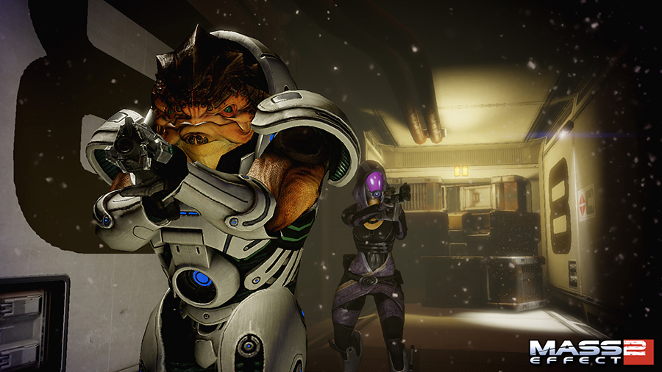

Quarian
The quarians are a nomadic species of humanoid aliens known for their skills with technology and synthetic intelligence. Since their home world was conquered, the quarians live aboard the Migrant Fleet, a huge collection of starships that travel as a single fleet.
Approximately three hundred years ago the quarians created the geth, a species of rudimentary artificial intelligences, to serve as an efficient source of manual labor. However, the geth gradually became sentient, rebelled against their quarian masters and drove them into exile. Now the quarians wander the galaxy in a flotilla of salvaged ships, secondhand vessels, and recycled technology.
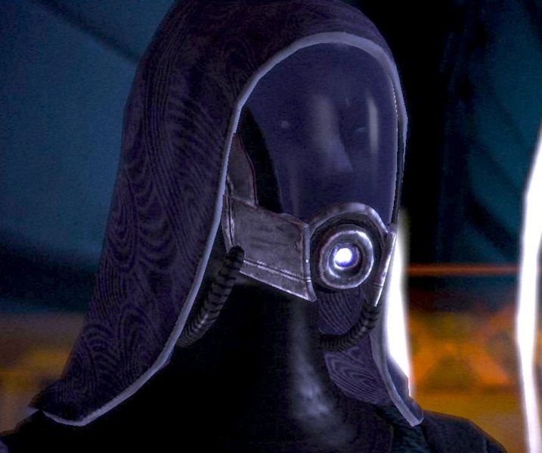

Quarian Species Traits
Quarian share the following species traits:
Attribute Modifiers: +2 Intelligence and -2 Constitution. Quarians are smart and determined but years on the flotilla have made them feeble.
Medium Size: As Medium Sized creatures Quarians have no bonuses or penalties based on their size.
Speed: Quarians base speed is 6 squares.
Natural Engineers: Quarian start play with access to the Use Tech skill and one free Tech Power. They are able to use both without the Engineer Feat.
Weak Immune Systems: Quarians have very weak immune systems, requiring them to wear Enviro-suits at all times away from specifically engineered containment fields. Quarians who are out of their suits for minutes for whatever reason (malfunction, removal, etc) are given an additional -4 to Constitution for one week. If Enviro-suits are removed for hours without proper care Quarians are likely to be hospitalized for weeks or months. Prolonged exposure can cause death. Quarians that expect to leave their Enviro-suits can augment themselves with special supplements that may decrease Constitution loss if prolonged exposure is avoided.

History
The quarians were always a technologically capable species, hailing from the world of Rannoch who created the geth to be nothing more than laborers and tools of war. The quarians kept their programming as limited as that of any VI, nothing close to an AI, remaining mindful of the Citadel Council’s laws against artificial intelligence. But as the quarians gradually modified the geth to do more complex tasks, developing a sophisticated neural network, these changes altered the geth to such an extent that they became sentient. One day, a geth unit began asking its overseer questions about the nature of its existence. The quarians realized they had made a terrible mistake. Now that the geth were sentient, the quarians were effectively using them as slaves. It was inevitable the geth would turn on them.
Panicked, the quarian government ordered an immediate shutdown of all geth, hoping to strike the first blow, but they had underestimated the power of the neural network and how intelligent the geth had become. Their servants defended themselves, resulting in a war that cost billions of quarian lives and drove them from their home world. After being refused aid from the Citadel Council, the quarians fled in the Migrant Fleet while the geth took over their systems. Soon after, the Council stripped the quarians of their embassy, effectively cutting the quarians out of Citadel politics as a punishment for their actions. Ever since, the quarians have devoted all their skills and resources to preserving their species aboard the Migrant Fleet.
The quarians have since been struggling to survive. While most of their efforts have been to surviving and maintaining their species, another major concern is to find new ways of combating the geth and even potentially reclaiming their home world.
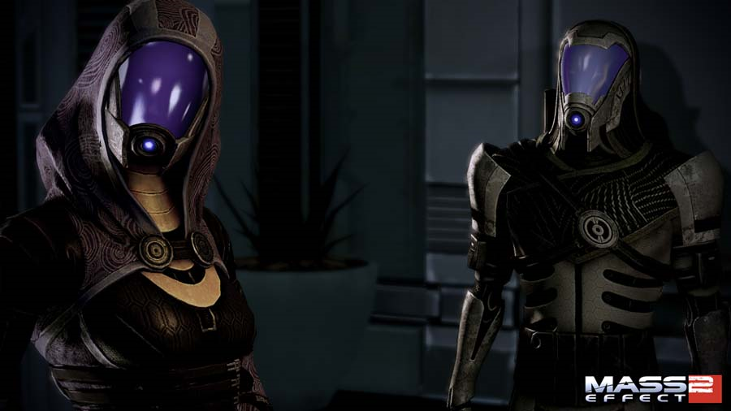

Biology
Quarians are generally shorter and of slighter build than humans. They dress in highly sophisticated enviro-suits that can be compartmentalized in the event of a tear or similar breach to prevent the spread of contaminants (similar to a ship that seals off bulkheads in the event of a hull breach). Because of these suits and their respirators, Quarians’ faces remain hidden from the rest of the Galaxy. Quarian immune systems were weak in the first place due to a biosphere in which pathogenic microbes were comparatively rare, and over the generations quarians’ immune systems have atrophied further still due to the years in the sterile environment of the Migrant Fleet. As such, quarians are given various vaccinations and immunizations to help ward off disease. However, they still refuse to remove their suits as to not take the risk. Due to this practice, as well as cultural and behavioral factors, many people believe that the quarians are cybernetic, a blend of machine and biology that can survive for a time in the vacuum of space. Contrary to this belief, quarians are perfectly capable of removing their exo-suits, but they must take antibiotics, mmune-boosters, herbal supplements, or the like in order to do so safely and even then there are inherent risks. As a result, physical acts of affection are difficult for quarians, even for the purposes of reproduction. Quarians have three thick fingers on each hand which include a thumb and an index finger, as well as two toes on each foot.
Quarians have an endoskeleton, lips, teeth, and two eyes with eyelids and tear ducts. Females have mammary glands. Quarians may have evolved along similar lines as Earth’s higher primates, much as Australia’s koalas developed like Africa’s leaf-eating prosimians: a phenomenon called convergent evolution.
Like turians, the quarians are a dextro-protein species of reverse chirality from humans and asari. The food of levo-protein races such as humans or asari is at best inedible and at worst poisonous, most likely triggering a dangerous allergic reaction. Quarians who want to taste something (other than the refined edible paste issued to all who leave on their Pilgrimage) can eat specially purified turian cuisine.

The Migrant Fleet
There are roughly 17 million quarians on the Migrant Fleet (also called the Flotilla). It is technically still under martial law but is now governed by bodies such as the Admiralty Board and the democratically-elected Conclave, though ship captains and onboard civilian councils tend to address most issues ‘in-house’ before it gets that far. Quarians are divided into several clans that can be spread across several ships, or restricted to one. Their clan name is after the apostrophe in their first name (e.g., Tali’s clan name is Zorah). A quarian’s ‘surname’ refers to which ship they were born on, or, after their Pilgrimage, which ship they chose to join.

Politics
Humans have no political relations with the quarians because the Migrant Fleet has not yet passed through any human-controlled area of space. Other species tend to look down on the quarians for several reasons, the foremost of which being their supposed ‘unleashing’ of the geth upon the galaxy. This act led to the quarians’ losing their embassy on the Citadel. Quarians are often viewed as beggars and thieves. Tali says glumly that when she arrived on the Citadel, C-Sec hauled her in for a long interview before they let her wander around.
Because of the Flotilla’s limited resources, quarians strip-mine the systems they pass through, which often puts them at odds with any species currently settled there. The Migrant Fleet also tends to drop off criminals on planets it passes, because the quarians cannot support a non-productive prison population – they simply lack the resources. However, life on the Migrant Fleet means quarians have unique skills. As Tali demonstrates, the quarians have developed an imperfect technique for recovering data from geth memory cores. They are masters at maintaining and converting technology, especially ship parts, and they are also expert miners because the Fleet requires huge amounts of fuel. They are able to repair what most species would melt down. This proficiency means corporations sometimes quietly hire quarians ‘on the side’ if the Migrant Fleet is nearby, replacing existing workers, much to their annoyance.
This unpopularity, and the fact their entire species travels and works as one, makes most quarians quite insular, caring only about the continued survival of the Migrant Fleet. Their nomadic life and exclusion from the Citadel mean that the concerns of the Citadel races don’t particularly interest or impress them.

Economy
The quarians have a very different economic system from the rest of the galaxy. While credits influence what is available in Citadel space, currency is non-existent in quarian society. Quarians value the little space they have above all else, so no unused items are kept to maximize space. When a quarian has an item they do not need, they place it in a public area, in what resembles a market. The items available are put into storage lockers, and those in need may simply take what they find. Since quarian society is based around honor and loyalty to their fellow quarians, there is rarely disagreement.
However, food and medicine are handled more strictly. The food coming from both the Liveships and from scout ships is put into a central stock and distributed carefully to individuals. Outgoing food is tracked carefully, so as not to put the Migrant Fleet at risk of food shortage, or worse, mass starvation. Medicine is also distributed carefully. However, since the quarians wear their enviro-suits everywhere, even when aboard the Migrant Fleet, they are at a very low risk of sickness. Controlling the flow of medicine also creates an emergency stockpile in case of a widespread outbreak, which is necessary since the quarian immune system is so weak.
Another means of resource income for the Fleet is from whatever system that the Migrant Fleet is passing through at the time; the quarians will strip-mine any promising planets for resources with well-trained efficiency. Any other races with industrial or corporate interests in that system will often offer a “gift” of ships, food, or other supplies to encourage the Fleet to leave. Usually, the Admiralty Board accepts the gift, as the Migrant Fleet is in no position to decline resources.

Law and Defense
Although the Conclave establishes civil law much as any planet-based democracy, enforcement and trials are more unique. After the flight from the geth, there were few constables to police the millions of civilians aboard the Fleet, so the navy parceled out marine squads to maintain order and enforce the law. Today, quarian marines have evolved training and tactics akin to civilian police, but remain adept at combat in the confined spaces of a starship, and fully under the command of the military.
Once taken into custody, the accused is brought before the ship’s captain for judgment. While the ship’s council may make recommendations, tradition holds that the captain has absolute authority in matters of discipline.
Most are lenient, assigning additional or more odious maintenance tasks aboard the ship. Persistent recidivists are ‘accidentally’ left on the next habitable world. This practice of abandoning criminals on other people’s planets is a point of friction between the quarians and the systems they pass through. Captains rarely have another choice; with space and resources at a premium, supporting a non-productive prison population is not an option. Offences that carry exile as a penalty include murder, repeated violent episodes, and sabotage against vessels, food stores or the Liveships themselves. Quarians practice capital punishment for one crime – as Tali tells Commander Shepard, mutiny or hijacking starships is punished with execution.
In the early years, many quarian freighters were armed and used as irregular “privateers.” Civilian ships still show a strong preference for armament, making them unpopular targets for pirates. Though they have rebuilt their military, there are still mere hundreds of warships to protect the tens of thousands of ships. The quarian navy follows strict routines of patrol, and takes no chances. If the intent of an approaching ship can’t be ascertained, they shoot to kill.
For this reason, young quarians on their Pilgrimage are given code phrases to repeat upon their return, as they often arrive back in vessels they have bought or scavenged which are unknown to the Flotilla. One phrase denotes a successful Pilgrimage and the quarian navy will permit them to rejoin the Fleet; the other alerts the navy that the quarian is returning under duress, and their ship will be immediately destroyed.

Culture
One of the factors of life aboard the Migrant Fleet is population control. It is illegal for quarian families to have more than two children to maintain zero population growth – unless the restriction has been lifted to keep numbers stable – so families tend to be small. Along with the fact each quarian relies on the others for survival, this means the bonds between quarians tend to be very strong, compared to a more individualistic race like the krogan. Loyalty, trust and cooperation between quarians are essential for the survival of their species.
Quarians enjoy storytelling, and hold dancers in high esteem. Some ships from the Fleet linger in orbit over planets used as drive discharge sites, to sell refreshments, supplies or trinkets made by their children to passing crews.
Young quarians go on a Pilgrimage as a rite of passage, leaving the Flotilla to look for resources, information or supplies that will be useful to the rest of the fleet. This discovery is presented to the captain of the ship they wish to join as a gift upon the quarian’s return. As well as proving they are a productive member of society, this ensures that the quarians maintain genetic diversity by not intermarrying with the crew of their ‘home ship’. It is also seen as an opportunity for quarians to experience life outside the Migrant Fleet, to appreciate their own culture.
“We spend our whole lives on the move, but we never leave home.”
Aboard ship, quarians are used to dealing with cramped conditions. It is not uncommon for all family members to share a small living space. Quarians place low value on personal possessions, evaluating objects by their usefulness, and often barter items that are not being used to the rest of the crew via their ship’s trading deck. Even when at home, quarians wear their environmental suits at all times, partly out of caution and partly as a psychological reaction to the lack of personal space. Because their suits make it harder to identify individuals, quarians have developed the habit of exchanging names whenever they meet.
Their technology and relations to synthetic life have had a profound effect on quarian culture. As a result, in contrast to other races, quarians are reluctant to trust virtually – or artificially – intelligent machines, but they are also far more likely to treat them as if they were living beings.

Religion
The quarians used to practice a form of ancestor worship. This involved taking a personality imprint from the individual and developing it into an interface similar to a VI. The quarians began experimenting with making these imprints more and more sophisticated, hopefully leading to the wisdom of their ancestors being preserved in an imprint that could be truly intelligent.
However, the geth destroyed the quarians’ ancestor databanks when they rebelled. Some quarians saw their subsequent exile as punishment for their hubris, but most accept that the geth rebellion was a mistake, not a punishment.
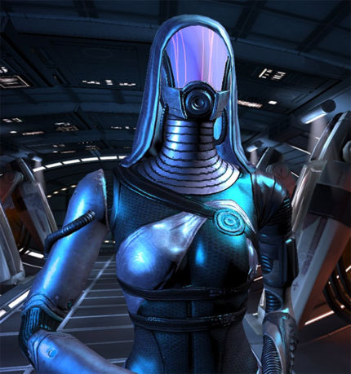

Language
Now that the quarians are reduced to a small, insular population they have one common language. Such words as are known have slipped out from intra-quarian insults.
- nedas – nowhere
- tasi – no-one
- vas [ship-name] – crew of
- nar [ship-name] – child of
- keelah – exclamation, the quarian deity
- keelah se’lai – saying, might (due to the apostrophe possibly indicating verb-noun conjugation) mean something like “Go with God.” Or “God is great.”, or more likely, “God Willing”.
- bosh’tet – curse/insult, likely being relative to “Son of a bitch” or, “Bastard”. For example, “Come on you little bosh’tet!”

Quarian names are comprised of three parts – the quarian’s given name and clan name, the title (‘nar’ means ‘child of’, referring to their birth ship, while ‘vas’, adopted after the quarian has completed their Pilgrimage and joined a ship, means ‘crew of’) and the name of their vessel.
When Tali first met Shepard, for instance, she was going by the name of her birth ship (the Rayya) because at that point she had not yet completed her Pilgrimage and was thus not yet able to join a quarian crew. Later, though, she became known as “Tali’Zorah vas Neema” – and, later still, “vas Normandy” – indicating that she had completed her Pilgrimage and joined the crews of those ships.
In certain formal situations, quarians appear to use both their adult ship and childhood ship-for instance, “Tali’Zorah vas Neema nar Rayya.”

Salarian
The second species to join the Citadel, the salarians are warm-blooded amphibians with a hyperactive metabolism; salarians think fast, talk fast, and move fast. To salarians, other species seem sluggish and dull-witted, especially the elcor. Unfortunately, their metabolic speed leaves them with a relatively short lifespan; salarians over the age of 40 are a rarity.
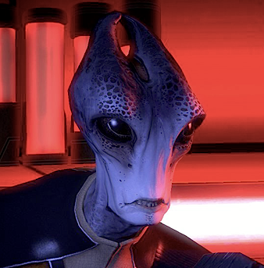
Salarians are known for their observational capability and non-linear thinking. This manifests as an aptitude for research and espionage. They are constantly experimenting and inventing, and it is generally accepted that they always know more than they are letting on.

Salarians Species Traits
Salarians share the following species traits:
Attribute Modifiers: +2 Intelligence and +2 Wisdom, and -4 Constitution. Salarians are extremely intelligent and knowledgeable, but are short lived and frail.
Medium Size: As Medium Sized creatures the Salarians have no bonuses or penalties based on their size.
Speed: Salarians base speed is six squares.
Knowledgeable: Salarians are known for their amazing knowledge of the galaxy and those things within it. Salarians start play with the Knowledge (Life Sciences), Knowledge (Physical Sciences), Knowledge (Galactic Lore) and Knowledge (Technology) as trained skills.
Short Life-Span: Salarians typically only live to around forty years of age.

Appearance
The salarians are a bipedal race of aliens, with tall, elongated bodies suited for their high metabolism. Their heads are long and thin, and have a pair of horns protruding from the top of their skulls. Their skin varies in color, but is mostly a shade of blue or grey. However, this does not apply to all salarians, as some are brightly colored, ranging from light red to green.
Salarian eyes are large, oval and have thin membranes in place of eyelids. Their eyes are not brightly colored, and they appear to have no iris, making their eyes more like those of an amphibian than a mammal.

Biology
Salarians are noted for their high speed metabolism, which allows them to function on just one hour of sleep a day. Their minds and bodies work faster than most sapient races, making them seem restless or hyperactive. The drawback of this active metabolism is a short lifespan of around 40 human years.
The salarians are amphibian haplo-diploid egg-layers; unfertilized eggs produce males and fertilized eggs produce females. Once a year, a salarian female will lay a clutch of dozens of eggs. Social rules prevent all but a fraction from being fertilized. As a result, 90% of the species is male.
Salarians have photographic memories and rarely forget a fact. They also possess a form of psychological ‘imprinting’, tending to defer to those they knew in their youth. Salarian hatching is a solemn ritual in which the clan Dalatrass (matriarch) isolates herself with the eggs. The young salarians psychologically imprint on her and tend to defer to her wishes.
During the hatching of daughters, the Dalatrasses of the mother and father’s clans are present at the imprinting. This ensures the offspring have equal loyalty to both, ensuring the desired dynastic and political unity.

History
On their first three interstellar colonies, the salarians planted settlements named Aegohr, Mannovai, and Jaëto. According to Kirrahe those settlements “remain at the heart of salarian territory to this day”.
The salarians were the second species to discover the Citadel, only a few decades after the asari. They opened diplomatic relations at once and became one of the founding species of the Citadel Council. In a gesture of trust, the salarians opened the records of one of their intelligence services, the League of One, but this quickly created problems when the League’s members found themselves in danger as a result. The League slaughtered the entire Union inner cabinet, but was later hunted down, leaving only relics behind.
The salarians also played a significant role in the evolution of the krogan species. The salarians provided the krogan with advanced technology and a new, tranquil home planet (in order to manipulate the krogan into eradicating the rachni for the Council). The peaceful home planet and better technology put less strain on the krogan as a species; they no longer had to worry about simply surviving on a dangerous planet with primitive technology, as they did before contact with the salarians. This comparatively easy life, combined with their exceedingly high birth rate, allowed the krogans the time, numbers and energy to spread through Citadel space, aggressively claiming formerly allied planets as their own. In order to end these “Krogan Rebellions” the salarians then provided the turians with the genophage, a biological weapon that effectively sterilized the krogan resulting in almost all krogan pregnancies ending in stillbirth.
Though their military is nothing special, salarians are currently seen as the premier intelligence and information-gathering arm of the Council. As such they are well respected, but some races, including a few humans, see the salarians as manipulators.

Culture
Salarians excel at invention, preferring to use cutting-edge technology rather than settle for anything less. For example, their GARDIAN starship defenses put emphasis on high performance over reliability even though a malfunction could cost lives. Even Schells rejected a cheating device that used ‘brute force’, spending five years to refine it into a more sophisticated, undetectable system.
The salarians see information gathering and even spying as a matter of course when dealing with other races, but this is not underhanded: they simply embrace the dictum of ‘knowledge is power’. Alliance counterintelligence agencies are constantly uncovering salarian agents and cyber-warfare incursions, but there is little they can do to stop them.

“Humanity has been transmitting data across the extranet for less than a decade. My species has been directing the primary espionage and intelligence operations for the Council for two thousand years.”
Normally, the rare salarian females are cloistered on their worlds out of tradition and respect. Powerful female Dalatrasses are dynasts and political kingpins. They determine the political course of their respective regions through shrewd negotiation. Though male salarians rise to positions of great authority in business, academia, or the military, they rarely have any input on politics, though the salarian representative on the Citadel Council is male.
Due to their method of reproduction, salarians have no concept of romantic love, sexual attraction, or the biological impulses and social rituals that complicate other species’ lives. Male-female relationships are rare (due to the scarcity of females) and more akin to human friendship. Sexuality is strictly for the purpose of reproduction. Ancient social codes determine who gets to fertilize eggs, which produces more daughters to continue the bloodline. Fertilization generally only occurs after months of negotiation between the parents’ clans, and is done for purposes of political and dynastic alliance. No salarian would imagine defying this code.
Salarian names are quite complex. A full name includes – in order – the name of a salarian’s home world, nation, city, district, clan name and given name. For example, the salarian on Feros is named Gorot II Heranon Mal Dinest Got Inoste Ledra, but he would be called either by his clan name, Inoste, or his given name, Ledra.
The salarian race also includes the Lystheni “offshoot”. How the Lystheni are distinct from mainline salarians and why they are currently unwelcome in Council space is unrevealed. Lystheni salarians may be found living among batarians, exiled quarians, and other galactic refuse at the Omega Station near Shelba.

Government
The salarian government, since at least the formation of the Council in 500 BCE, is called the Salarian Union. It is a labyrinthine web of matrilineal bloodlines, with political alliances formed through interbreeding.
In many ways, the salarian political network functions like the noble families of Earth’s Medieval Europe. Structurally, the government consists of fiefdoms, baronies, duchies, planets, and marches (colonization clusters). These are human nicknames, as the original salarian is unpronounceable. Each area is ruled by a single Dalatrass (matriarchal head-of-household) and represents an increasing amount of territory and prestige within the salarian political web.
Approaching 100 members, the first circle of a salarian’s clan comprises parents, siblings, uncles, aunts, and cousins. The next circle includes second cousins, etc, and escalates to well over 1000 members. The fourth or fifth circle of a clan numbers into the millions. Salarian loyalty is greatest to their first circle and diminishes from there. Their photographic memories allow salarians to recognize all their myriad relatives. 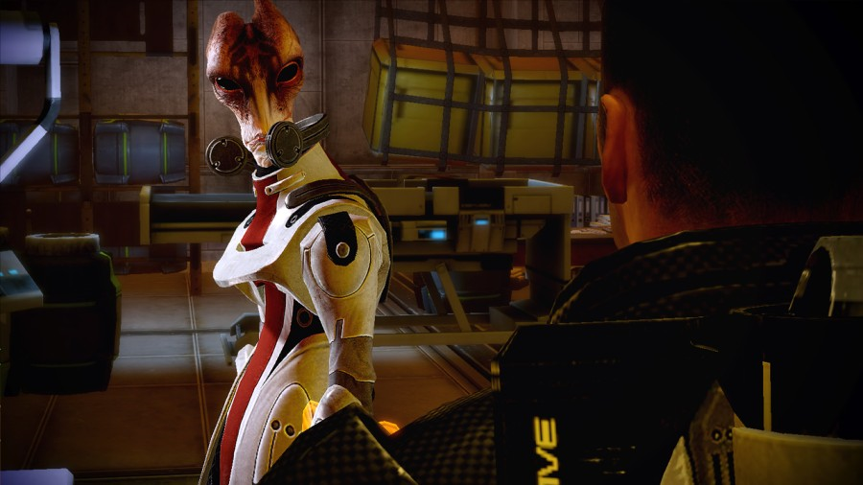
The salarian economy is the smallest of the three Council races, but still far larger than the Alliance. It is based on “bleeding-edge” technologies; salarian industries are leaders in most fields. They make up for a lack of military quantity by holding a decisive superiority in quality.

Military
In principle, the salarian military is similar to the Systems Alliance, a small volunteer army that focuses on maneuver warfare. What differentiate the salarians are not their equipment or doctrine, but their intelligence services and rules of engagement. The salarians believe that a war should be won before it begins (a doctrine espoused by some of humanity’s greatest generals, such as Sun Tzu).
The unquestioned superiority of their intelligence services allows them to use their small military to maximum effectiveness. Well before fighting breaks out, they possess complete knowledge of their enemy’s positions, intentions and timetable. Their powerful intelligence network is spearheaded in the field by Special Tasks Groups (STG) who monitors developing situations and take necessary action, usually without the shackles of traditional laws and procedures. This may be as simple as scouting and information gathering, or as complex as ensuring a conveniently unstable political situation stays that way. The effectiveness of the STG during the Krogan Rebellion is what provided the template for the Council to establish their SPECTRE program immediately afterwards.
In every war the salarians have fought, they struck first and without warning. For the salarians, to know an enemy plans to attack and let it happen is folly; to announce their own plans to attack is insanity. They find the human moral concepts of ‘do not fire until fired upon’ and ‘declare a war before prosecuting it’ incredibly I. In defensive wars, they execute devastating preemptive strikes hours before the enemy’s own attacks. On the offense, they have never issued an official declaration of war before attacking.
Biotics are virtually unknown in the salarian military. Those with such abilities are considered too valuable to be used as cannon fodder and are assigned to the intelligence services.
While capable of defending themselves against most threats, the salarians know that they are small fish in a universe filled with sharks. As a point of survival, they have cultivated strong alliances with larger powers, particularly with the turians. Though the relationship between the two species was rocky at first due to the krogan uplift fiasco, the salarians take pains to keep this relationship strong enough that anyone who might threaten them risks turian intervention.
The salarian navy has sixteen dreadnoughts, which is considerably less than the maximum they are allowed to build according to the Treaty of Farixen.

Religion
Salarians are not notably religious, but as free-willed sentients there are exceptions. One of the less favored salarian religions (which the Council deems a “cult”) worships a goddess, and claims that a certain pattern of overlapping craters in the southern hemisphere of Trelyn resembles her. Liara T’Soni comments that many salarians believe in a wheel of life, which Mordin Solus likens to Hinduism.

Turian
Known for their militaristic and disciplined culture, the turians are the most recent of the Citadel races invited to join the Council. They gained their Council seat after defeating the hostile krogan for the Council during the ‘Krogan Rebellions’. The turians deployed a salarian-created biological weapon called the genophage, which virtually sterilized the krogan and sent them into a decline. The turians then filled the peacekeeping niche left by the once-cooperative krogan, and eventually gained a Council seat in recognition of their efforts.
Originally from the planet Palaven, turians are best known for their military role, particularly their contributions of soldiers and starships to the Citadel Fleet. They are respected for their ‘public service’ ethic—it was the turians who first proposed creating C-Sec—but are sometimes seen as imperialist or rigid by other races. There is some animosity between turians and humans, largely due to the turian role in the First Contact War. This bitterness is slowly beginning to heal—as shown by the cooperation of the two races on the construction of the SSV Normandy—but many turians still hate humans, and vice versa.

Turian Species Traits
Turian share the following species traits:
Attribute Modifiers: +2 Strength, +2 Constitution, -2 Wisdom, -2 Charisma. The Turians are hardy and strong, but are short and self centered.
Medium Size: As Medium Sized creatures the Turians have no bonuses or penalties based on their size.
Speed: Turian base speed is six squares.
Military Background: All Turians are required to serve in the Turian military. This grants them the Medium Armor Proficiency feat as well as the Sub-Machine Gun Proficiency feat.
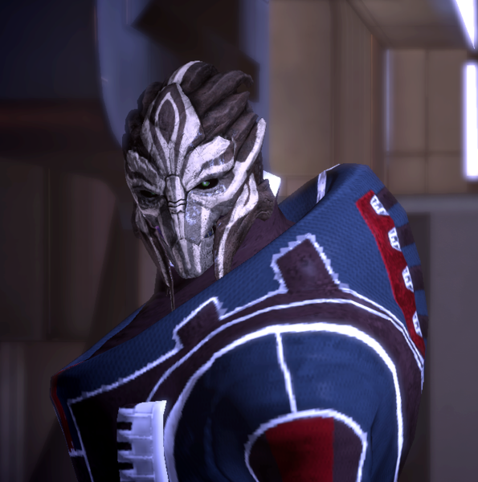

Appearance
Turians typically stand over six feet tall, have two long, proportionately thick fingers and an opposable thumb on each hand, each tipped with talons, and a set of mandibles around their mouths. The most distinguishing feature of turians is their metallic carapace, which is a result of their evolution. Turian features are avian, making them resemble humanoid birds or raptors.
Since the Unification War, turians normally wear elaborate facial tattoos marking their colony of origin, though it is not known which markings distinguish which colony. These tattoos are usually white—particularly on turians with darker carapaces—but can be of various colors. Garrus Vakarian’s markings, for example, are dark blue. As a point of interest, the turian term ‘barefaced’ refers to one who is beguiling or not to be trusted. (It should be noted that Saren Arterius does not bear any facial markings). It is also a slang term for politicians.
Turians are also recognizable by their voices, which have a distinctive ‘flanging’ effect.

Biology
Turians exhibit the characteristics of predators rather than those of prey species (compare to krogan biology). Their forward-facing alert eyes give the impression that they possess outstanding eyesight and their teeth and jaws mimic the structures possessed by apex predators such as crocodiles or ancient, carnivorous dinosaurs. Needless to say, their talons on both their feet and hands seem capable of ripping flesh. Their slender bodies also seem to suggest that they are also capable of moving at high speeds.
The turian home world, Palaven, has a metal-poor core, generating a weak magnetic field and allowing more solar radiation into the atmosphere. To deal with this, most forms of life on Palaven evolved some form of metallic ‘exoskeleton’ to protect themselves. Their reflective plate-like skin makes turians less susceptible to long-term, low-level radiation exposure, but they do not possess any sort of ‘natural armor’. A turian’s thick skin does not stop projectiles and directed energy bolts. Turian blood has a dark blue coloration, possibly from the presence of hemocyanin rather than hemoglobin, which would fit with the biology of a metallic exoskeleton.
Although life on Palaven is carbon-based and oxygen-breathing, it is built on dextro-amino acids. This places the turians in a distinct minority on the galactic stage; the quarians are the only other sapient dextro-protein race. The food of humans, asari, or salarians (who evolved in levo-amino acid-based biospheres), will at best pass through turian systems without providing any nutrition. At worst, it will trigger an allergic reaction that can be fatal if not immediately treated. The turian mechanic Lilihierax on Noveria uses the idiom, “if you can polish enough gizzard”. This suggests that the turians have a digestive system similar to birds and reptiles on Earth, some of whom swallow stones to help break down harder foods in the stomach.
The lifespan of turians is described as “not particularly longer or shorter than humans”.

Government
The turian government, known as the Turian Hierarchy, is a hierarchical meritocracy. While it has great potential for misuse, this is tempered by the civic duty and personal responsibility turians learn in childhood.
Turians have 27 citizenship tiers, beginning with civilians (client races and children). The initial period of military service is the second tier. Formal citizenship is conferred at the third tier, after boot camp. For client races, citizenship is granted after the individual musters out. Higher-ranked citizens are expected to lead and protect subordinates. Lower-ranking citizens are expected to obey and support superiors. Promotion to another tier of citizenship is based on the personal assessment of one’s superiors and co-rankers. At the top are the Primarchs, who each rule a colonization cluster. The Primarchs vote on matters of national import. They otherwise maintain a ‘hands-off’ policy, trusting the citizens on each level below them to do their jobs competently.
Throughout their lives, turians ascend to the higher tiers and are occasionally ‘demoted’ to lower ones. The stigma associated with demotion lies not on the individual, but on those who promoted him when he wasn’t ready for additional responsibility. This curbs the tendency to promote individuals into positions beyond their capabilities. Settling into a role and rank is not considered stagnation. Turians value knowing one’s own limitations more than being ambitious.
Turians enjoy broad freedoms. So long as one completes his duties, and does not prevent others from completing theirs, nothing is forbidden. For example, there are no laws against recreational drug use, but if someone is unable to complete his duties due to drug use, his superiors step in. Judicial proceedings are ‘interventions.’ Peers express their concern, and try to convince the offender to change. If rehabilitation fails, turians have no qualms about sentencing dangerous individuals to life at hard labor for the state.

Economy
The turian economy is vastly larger than that of the Alliance, but cannot match the size and power of that of the asari. For many years, development was hampered by cultural disinterest in economics. When the turians accepted the volus as a client race, business development improved.
The military is supported by a well-developed infrastructure. Manufacturers such as Armax Arsenal and the Haliat Armory produce advanced, reliable equipment. It is not unknown for volus manufacturers to produce cheap knock-offs of turian equipment.

Culture
Turians are noted for their strong sense of public service. It is rare to find one who puts his needs ahead of the group. Every citizen from age 15 to 30 serves the state in some capacity, as anything from a soldier to an administrator, from a construction engineer to a sanitation worker. Turians have a strong inclination toward public service and self-sacrifice, so they tend to be poor entrepreneurs. To compensate, they accepted the mercantile volus as a client race, offering protection in exchange for their fiscal expertise.
Turian society is highly regimented and very organized, and the species is known for its strict discipline and work ethic. Turians are willing to do what needs to be done, and they always follow through. They are not easily spurred to violence, but when conflict is inevitable, they only understand a concept of “total war.” They do not believe in skirmishes or small-scale battles; they use massive fleets and numbers to defeat an adversary so completely that they remove any threat of having to fight the same opponent more than once. They do not exterminate their enemy, but so completely devastate their military that the enemy has no choice but to become a colony of the turians. It is theorized that another conflict between the rapidly advancing humans and the turians could annihilate a large portion of known space.
The turian military is the center of their society. It is not just an armed force; it is an all-encompassing public works organization. The military police are also the civic police. The fire brigades serve the civilian population as well as military facilities. The corps of engineers builds and maintains spaceports, schools, water purification plants, and power stations. The merchant marine ensures that all worlds get needed resources.
Other species see turians as “men of action,” and they are generally regarded as the most progressive of the Citadel races (though some species believe humans are rivaling this position). Since their culture is based on the structure of a military hierarchy, changes and advances accepted by the leadership are quickly adopted by the rest of society with minimal resistance.
While turians are individuals with personal desires, their instinct is to equate the self with the group, and to set aside all personal desires for the good of all. Turians are taught to have a strong sense of personal accountability, the ‘turian honor’ that other races find so remarkable. Turians are taught to own every decision they make, good or ill. The worst sin they can make in the eyes of their people is to lie about their own actions. Turians who murder will try to get away with it, but if directly questioned, most will confess the crime.

Religion
Turians believe that groups and areas have ‘spirits’ that transcend the individual. For example, a military unit would be considered to have a literal spirit that embodies the honor and courage it has displayed. A city’s spirit reflects the accomplishments and industry of its residents. An ancient tree’s spirit reflects the beauty and tranquility of the area it grows within.
These spirits are neither good nor evil, nor are they appealed to for intercession. Turians do not believe spirits can affect the world, but spirits can inspire the living. Prayers and rituals allow an individual to converse with a spirit for guidance or inspiration. For example, a turian who finds his loyalty tested may appeal to the spirit of his unit, hoping to reconnect with the pride and honor of the group. A turian who wishes to create a work of art may attempt to connect with the spirit of a beautiful location.
Turians enjoy absolute freedom of religion and can practice whatever appeals to them so long as it does not impede anyone’s ability to perform their duties. There are many practitioners of the asari ‘siarist’ philosophy. Since opening dialog with the human Systems Alliance, some turians have embraced Confucianism and Zen Buddhism.

Military
Although they lack the brutality of the krogan, the refined skill of the asari, and the adaptability of the humans, the turian military has formidable discipline. Officers and NCOs are ‘lifers’ with years of field experience. Enlisted personnel are thoroughly trained and stay calm under fire. Turian units don’t break. Even if their entire line collapses, they fall back in order, setting ambushes as they go. A popular saying holds: ‘You will only see a turian’s back once he’s dead.’
Boot camp begins on the 15th birthday. Soldiers receive a year of training before being assigned to a field unit; officers train for even longer. Most serve until the age of 30, at which they become part of the Reserves. Even if they suffer injuries preventing front-line service, most do support work behind the lines.
Biotics are uncommon. While admired for their exacting skills, biotics’ motives are not always fully trusted by the common soldier. The turians prefer to assign their biotics to specialist teams called Cabals.
Command and control is decentralized and flexible. Individual squads can call for artillery and air support. They make extensive use of combat drones for light duties, and practice combined arms: infantry operates with armor, supported by overhead gunships. Strategically, they are methodical and patient, and dislike risky operations. The turians recruit auxiliary units from conquered or absorbed minor races. Auxiliaries are generally light infantry or armored cavalry units that screen and support the main battle formations. At the conclusion of their service in the Auxiliaries, recruits are granted turian citizenship.
Tradition is important. Each legion has a full-time staff of historians who chronicle its battle honors in detail. The oldest have records dating back to the turian Iron Age. If a legion is destroyed in battle, it is reconstituted rather than being replaced.
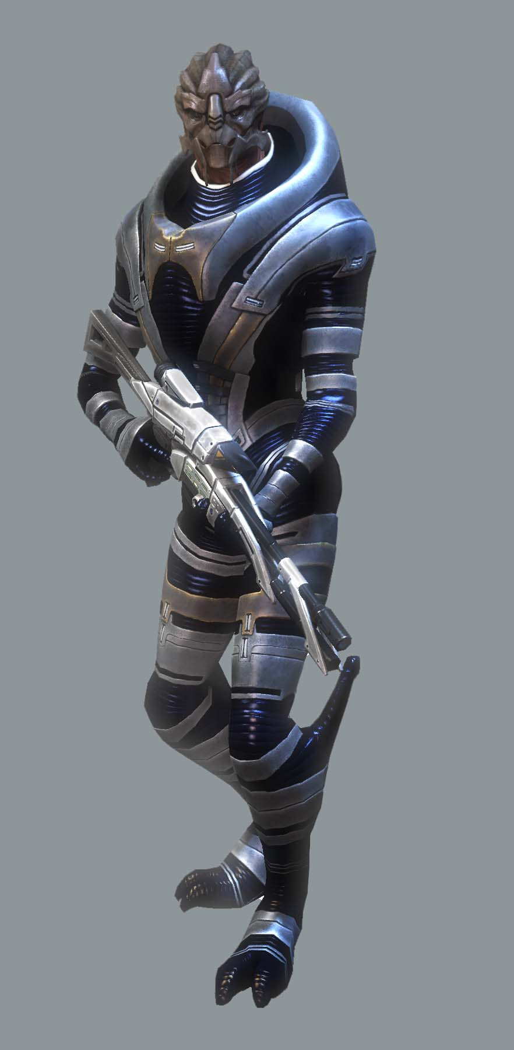

The Unification War
The turians had already discovered several mass relays and spawned colonies throughout the galaxy when the asari reached the Citadel. At about the time the asari were forming the Council with the salarians, the turians were embroiled in a bitter civil war next door. The Unification War, as it was later named, began with hostilities between the colonies furthest from the turian home world, Palaven.
These colonies were run by local chieftains, many of whom had distanced themselves from the Hierarchy. Without the galvanizing influence of the government, the colonies became increasingly isolated and xenophobic. Colonists began wearing emblems or facial markings to differentiate themselves from members of other colonies and open hostilities became common.
When war finally broke out, the Hierarchy maintained strict diplomacy and refused to get involved. After several years of fighting, fewer and fewer factions remained until the Hierarchy finally intervened. By that time, the chieftains were too weak to resist; they were forced to put an end to fighting and renew their allegiance to the Hierarchy. The Hierarchy itself appears to have withdrawn; although turians must have run across asari and salarian explorers before the Krogan Rebellions, there was no official “first contact” until 700 CE.
Though peace was restored, it took several decades for animosity between colonists to fade completely. To this day, most turians still wear the facial markings of their home colonies.

Volus
The volus are an associate race on the Citadel with their own embassy, but are also a client race of the turians. They hail from Irune, which possesses a high-pressure greenhouse atmosphere able to support an ammonia-based biochemistry. As a result, the volus must wear pressure suits and breathers when dealing with other species.
Because they are not physically adept compared to most species, volus mostly make their influence felt through trade and commerce, and they have a long history on the Citadel. However, they have never been invited to join the Council, which is a sore point for many volus individuals.

Volus Species Traits
Volus share the following species traits:
Attribute Modifiers: +4 Charisma and -4 Dexterity. The Volus are excellent negotiators and merchants but are typically fat, squat, and slow.
Small Size: As Small Sized creatures, Volus gain a +1 size bonus to their Reflex Defense and a +5 size bonus on Stealth checks. However, their lifting and carrying limits are three-quarters of those of Medium Characters.
Speed: Volus base speed is 4 squares.
Natural Negotiators: Volus are superb merchants and businessmen. Volus gain the Skill Focus (Persuasion) and Skill Focus (Deception) skills at start.
Rebreather: Volus must wear a rebreather mask at all times where oxygen is breathed. Volus breathe ammonia, and will die within minutes without their rebreather mask.
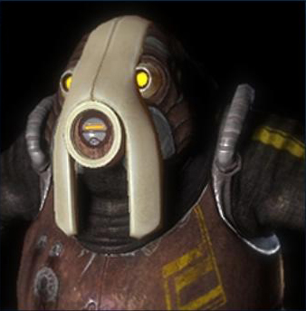

Biology
The volus home world Irune features an ammonia-based ecology and a gravitational field 1.5 times that of Earth, as well as a high-pressure atmosphere. This is reflected in the physiology of the volus themselves. The volus are unable to survive unprotected in an atmosphere more suitable to humans and other carbon-based life forms, and as such require protective suits capable of providing the proper atmosphere, as well as being pressurized to support the volus. Traditional nitrogen/oxygen air mixtures are poisonous to them, and in the low pressure atmospheres tolerable to most species, their flesh will actually split open.

History
The volus were the third race to post an embassy to the Citadel after the asari and salarians, in exactly 200 BCE (according to Citadel records accessed through Avina, outside the Embassies). The volus’ mercantile prowess made them instrumental in developing a stable galactic economy. They authored the Unified Banking Act, which established the credit as the standard currency of interstellar trade, and the volus continue to monitor and balance the galactic economy even today. After first contact with the turians during the Krogan Rebellions in the first millennium CE, the volus petitioned for client status within the Turian Hierarchy.
Despite their important contributions to the Citadel and galactic society, they have never been offered a seat on the Council. This is a source of anger for some volus, particularly the volus ambassador Din Korlack. Council races need to have provided some extraordinary service to the Citadel, such as the turians’ military support during the Krogan Rebellions. Council races also need to provide fleets, resources, and economic aid in case of disaster, none of which the volus are capable of.
Recently, the volus (through the Turian Hierarchy) have been negotiating with the Systems Alliance over colonization rights to Patavig. These negotiations have been running smoothly thus far.

Culture
Volus culture is dominated by trade, whether it be of land, resources, or even other tribe members. The volus have a reputation as traders and merchants, and many, such as Barla Von, work as some of the best financial advisers in Citadel space. Because the volus are not physically adept, they tend not to be very violent, and can even seem overly-pacifistic and cowardly to other, more militant species. Their inability to provide adequate soldiers for themselves and the Citadel is a primary reason for not yet being inducted into the Council.
Volus have two names but no family names. According to volus sensibilities you cannot own a person, so using a family name would essentially be laying claim to their offspring. Possibly because of their tribal origins, volus tend to refer to members of other races by their source world rather than species name (i.e. ‘Earth-clan’ instead of ‘human’).

Government
The volus government is known as the Vol Protectorate. Rather than being a fully sovereign government in its own right, the Protectorate is a client state of the Turian Hierarchy. In return for falling under the protective umbrella of the turian military, the volus pay a tax to the Hierarchy, as well as deferring to the turians in all foreign policy matters and providing auxiliary troops to the turian armed forces. They still maintain an embassy on the Citadel, making them an associate species of the Council, though they currently share their embassy with the elcor.

Military
The volus are not physically cut out for combat, be it a full-scale war or even a bar room scuffle. As such, they are highly dependent on the turians for defense, although the volus themselves do provide some auxiliary troops to the Hierarchy. The volus will support the turians in any war they might pursue, and the turians will support the volus in any war they might pursue.
Possibly for this reason, volus weaponry tends to be utilitarian rather than high-grade. Some volus manufacturers specialize in cheaper, lower-grade copies of expensive turian equipment.

Vorcha
Known for their unique biology and aggressive behavior, the vorcha are a primitive race that live among the galaxy’s darker and more dangerous locations, such as Omega. Many vorcha are trained by the krogan as mercenaries due to their savage nature and adaptability to different environments. The rest of galactic civilization regards them as pests and scavengers, and their presence is generally seen as blight.
The vorcha originate from a small and overcrowded planet which has been largely stripped of natural resources by successive generations of this fast-breeding, savage species. The lack of resources has resulted in a tight-knit clan based society in which rival clans wage constant war against one another for control of scarce resources. Even as their population grows, the vorcha constantly fight each other in fierce competition over basic necessities. This constant warfare has had the twin effects of making each generation of vorcha stronger and more aggressive than its predecessor. However, their continual lack of resources has kept vorcha society extremely primitive.
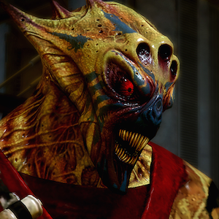

Vorcha Species Traits
Vorcha share the following species traits:
Attribute Modifiers: +2 STR, +2 DEX, -2 INT, -2 CHA
Medium Size: As Medium Sized creatures Vorcha have no bonuses or penalties based on their size.
Speed: Vorcha base speed is six squares.
SPECIAL FEATS: Combat Reflexes, Dodge

Biology
The vorcha are the most short-lived sapient species currently known, with an average lifespan of only 20 years. The vorcha are known for a rather unique biology that differentiates them from other known species and which carries with it a striking set of advantages and disadvantages. The vorcha have clusters of non-differentiated cells, similar to those found on the Planarian worm of Earth. These cells allow the vorcha limited regenerative abilities, as well as the ability to adapt quickly to its environment, such as developing thicker skin after being burned or increased musculature to survive in high gravity. When a vorcha is injured or in distress, these cells move to the affected area and rapidly (~1 week) mature to specialized forms that will alleviate the issue.
A vorcha that is cut or burned will adapt to have thicker skin. The lungs of a vorcha placed in a barely-breathable atmosphere will adapt to better use the gases there. A vorcha subjected to high gravity will quickly develop stronger heart and leg muscles. Non-differentiated vorcha cell clusters do replenish themselves, but the process is slow. Generally vorcha can only adapt to a single environment within their brief lives. However, what cells are replaced allow them to heal rapidly, and even regrow lost limbs over a period of months.
However, as a consequence of this, the vorcha as a species no longer evolve as other races do. The vorcha equivalent of DNA has remained unchanged for millions of years. There is no need for them to evolve as a species when they can adapt as individuals.
Some vorcha have allied themselves with the Collectors, in an attempt to raise their quality of life.

Society
Vorcha society is built around combat. In fact, the vorcha uses combat, both singly and in groups, as their default form of communication. The vorcha are a clan based people who prefer living in communal environments with others of their species to living alone or in the company of alien races. When a clan population grows too large, younger members will depart to start a new clan elsewhere. The vorcha are extremely aggressive, both against rivals of their own species and against any alien who stands in their way. Vorcha who have managed to escape their home world have a tendency to occupy uninhabited areas of space stations or larger spaceships.
The vorcha are not themselves a space-faring race, although many have found their way off-world as stowaways on ships visiting their home world. The vorcha who escaped their hostile home world did so by hiding on the ships of space faring races that had the misfortune of visiting their planet. Their adaptability and resilience allows them to flourish in the dark and dirty corners of the places they end up.
Seeing the potential of the vorcha’s individual adaptability, krogan Blood Pack mercenaries often sweep pockets of vorcha, gathering them up and literally beating them into soldiers. Vorcha “trained” by this ordeal are stronger, faster, smarter, and more resilient than other members of the race. Gaining even a few vorcha gives a mercenary band a formidable advantage; each additional vorcha magnifies the gang’s combat ferocity exponentially.

Chapter 2: Feats

A feat is a special feature that either gives your character a new capability or improves one he or she already has. Your choice of feats is not restricted by your class. Any character can take any feat as long as the prerequisites are met.
A Star Wars Saga Edition “talent” is considered a “feat” in this rule set.

Acquiring Feats
Choose the feats you feel best represent your character’s interests and capabilities. Each character gets one four free feats when the character is created (at 1st level). At 3rd, 6th, 9th, 12th, 15th, and 18th level, characters gain another feat.
Humans get a bonus feat at 1st level, chosen from any feat the character qualifies for.
Each level, you receive 10 XP which you may use to purchase an additional feat.

Prerequisites
Some feats have prerequisites. A character must have the listed ability score, feat, trained skill, or base attack bonus to select or use that feat. A character can gain a few at the same level at which he or she gains the prerequisite(s).

Restriction List
The following feats, talents, and talent trees from d20 Star Wars Saga Rulebook are not permitted
- Armor Specialist (Star Wars: Saga Edition, Page 51)
- All Jedi Talent Trees
- Force Boon
- Force Sensitivity
- Force Training
- Strong in Force

Feat Descriptions

Combat Feats

Armor Familiarity
You wear your armor like a second skin.
Benefit: Decrease armor penalty by 1 for any armor that you have proficency in.

Extra Shield recharge
You know how to make the best use of your shields.

Prerequisite: Trained in the Use Tech skill.

Benefit: You can recharge your shields one additional time per encounter.

Normal: A hero can recharge his shields once per encounter.

Special: A non heroic character that takes this feat for the first time can shield recharge once per encounter.

You can take this feat multiple times; each time you take this feat, you shield recharge one additional time per encounter.

Improved Damage Threshold
You are harder to take down in a fight.
Benefit: You increase your damage threshold by 1 (see Damage Threshold, page 146 Saga Edition).

Special: You can take this feat more than once. Its effects stack. Each time you take this feat, increase your damage threshold by 1.

Star Wars Saga Allowable Feats
- Acrobatic Strike
- Armor Proficiency (heavy)
- Armor Proficiency (light)
- Armor Proficiency (medium)
- Bantha Rush – Renamed to Krogan Rush
- Burst Fire
- Careful Shot
- Charging Fire
- Cleave
- Combat Reflexes
- Coordinated Attack
- Crush
- Cybernetic Surgery
- Deadeye
- Dodge
- Double Attack
- Dreadful Rage
- Extra Rage
- Far Shot
- Great Cleave
- Improved Charge
- Improved Defenses
- Improved Disarm
- Linguist
- Martial Arts I
- Martial Arts II
- Martial Arts III
- Melee Defense
- Mighty Swing
- Mobility
- Pin
- Point Blank Shot
- Power Attack
- Powerful Charge
- Precise Shot
- Quick Draw
- Rapid Shot
- Rapid Strike
- Running Attack
- Shake It Off
- Skill Focus
- Skill Training
- Sniper
- Surgical Expertise
- Throw
- Toughness
- Trip
- Triple Attack
- Triple Crit
- Vehicular Combat
- Weapon Finesse
- Weapon Focus
- Weapon Proficiency
- Whirlwind Attack
- Tech Specialist (WE)

Star Wars Saga Allowable Talents
Bounty Hunter Talent Tree (Star Wars: Saga Edition, pg 208)
- Hunter’s Mark
- Hunter’s Target
- Notorious
- Nowhere to Hide
- Relentless
- Ruthless Negotiator
Brawler Talent Tree (Star Wars: Saga Edition, pg 52)
- Expert Grappler
- Gun Club
- Melee Smash
- Stunning Strike
- Unbalance Opponent
Commando Talent Tree (Star Wars: Saga Edition, pg 52)
- Battle Analysis
- Cover Fire
- Demolitionist
- Draw Fire
- Harm’s Way
- Indomitable
- Tough as Nails
Gunner Talent Tree (Star Wars: Saga Edition, pg 207)
- Dogfight Gunner
- Expert Gunner
- Quick Trigger
- System Hit
Gunslinger Talent Tree (Star Wars: Saga Edition, pg 216)
- Debilitating Shot
- Deceptive Shot
- Improved Quick Draw
- Knockdown Shot
- Multiattack Proficiency (pistols)
- Ranged Disarm
- Trigger Work
Military Tactics Talent Tree (Star Wars: Saga Edition, pg 221)
- Assault Tactics
- Deployment Tactics
- Field Tactics
- One for the Team
- Outmaneuver
- Shift Defense I
- Shift Defense II
- Tactical Edge
Weapon Master Talent Tree (Star Wars: Saga Edition, pg 212)
- Controlled Burst
- Exotic Weapon Mastery
- Greater Devastating Attack
- Greater Penetrating Attack
- Greater Weapon Focus
- Greater Weapon Specialization
- Multiattack Proficiency (heavy weapon)
- Multiattack Proficiency (rifles)
Weapon Specialist Talent Tree (Star Wars: Saga Edition, pg 53)
- Devastating Attack
- Penetrating Attack
- Weapon Specialization

Biotic Feats

Biotic
This feat allows the user access to Biotic Powers, the Use Biotics skill, as well as the use of biotic equipment and other Biotic Feats. The amount of biotic powers gained is equal to 1 + WIS modifier (minimum of 1).
Prerequisites: Character exposure to Element Zero.
Special: This feat can be taken multiple times for the use of adding biotic powers only.

Biotic Reach
Biotic powers have double the normal range. This feat only applies to biotic powers that have a target other than personal or centered on the user.
Prerequisites: Biotic Feat, Character Level 8
Special: This feat can be combined with specific Biotic Reach (Power) feats so that the Biotic powers in question have tripled the range.

Biotic Reach (Power)
Specific biotic powers have doubled the normal range. This feat only applies to biotic powers that have a target other than personal or centered on the user.
Prerequisites: Biotic Feat, Access to Power
Special: This feat can be taken multiple times for different Biotic Powers.

Biotic Regeneration
All biotic powers cool down one round quicker.
Prerequisites: Biotic Feat, Character Level 8
Special: This feat can be combined with specific Biotic Regeneration (Power) feats so that the Biotic powers in question cool down 2 rounds quicker.

Biotic Regeneration (Power)
Specific biotic power cools down one round quicker.
Prerequisites: Biotic Feat, Access to Power
Special: This feat can be taken multiple times for different biotic Powers.

Empowered (Power)
All variable, numeric effects of an empowered Biotic Power are increased by one-half. The cool down timer is also increased by one-half.
Prerequisites: Biotic Feat, Access to Power
Special: Action Points are never involved with the Empowered feat. Any Action Points used after the Empowered calculation is made. Range is also never altered with the Empowered feat.

Technology Feats

Empowered (POWER)
All variable, numeric effects of an empowered Tech Power are increased by one-half. The cool down timer is also increased by one-half.
Prerequisites: Engineer Feat, Access to Power
Special: Action Points are never involved with the Empowered feat. Any Action Points used after the Empowered calculation is made. Range is also never altered with the Empowered feat.

Electronics
This feat increases the strength of your shields and the amount of hull restored when you repair vehicles.
Prerequisites: Engineer Feat, Level 8?
Special: +5 Shield Points, +2 Use Tech when using Overload or Damping Tech Powers

Engineer
This feat allows the user access Tech Powers, the Use Tech skill, as well as the use of tech equipment and other Technology Feats. The amount of tech powers gained is equal to 1 + WIS modifier (minimum of 1).
Special: This feat can be taken multiple times for the use of adding technology powers only.

Expert AI Hacker
This feat adds +4 competency bonus to skill checks involving AI Hacking.
Prerequisites: Engineer Feat

Expert Cipher
This feat adds +4 competency bonus to skill checks involving Decryption.
Prerequisites: Engineer Feat

Tech Reach
Tech powers have double the normal range. This feat only applies to tech powers that have a target other than personal or centered on the user.
Prerequisites: Engineer Feat, Character Level 8
Special: This feat can be combined with specific Tech Reach (Power) feats so that the tech powers in question have tripled the range.

Tech Reach (Power)
Specific tech powers have doubled the normal range. This feat only applies to tech powers that have a target other than personal or centered on the user.
Prerequisites: Engineer Feat, Access to Power
Special: This feat can be taken multiple times for different Tech Powers.

Tech Regeneration
All tech powers cool down one round quicker.
Prerequisites: Engineer Feat, Character Level 8
Special: This feat can be combined with specific Tech Regeneration (Power) feats so that the tech powers in question cool down 2 rounds quicker.

Tech Regeneration (Power)
Specific tech power cools down one round quicker.
Prerequisites: Engineer Feat, Access to Power
Special: This feat can be taken multiple times for different Tech Powers.

Star Wars Saga Allowable Feats
Slicer Talent Tree (Star Wars: Saga Edition, pg 47)
- Gimmick
- Master Slicer
- Trace
Outlaw Tech (Star Wars: Saga Edition WE 1)
- Fast Repairs
- Hot Wire
- Quick Fix
- Personalized Modifications

General Feats

Star Wars Saga Allowable Feats
Awareness Talent Tree (Star Wars: Saga Edition, pg 49)
- Acute Senses
- Expert Tracker
- Improved Initiative
- Keen Shot
- Uncanny Dodge I
- Uncanny Dodge II
Camouflage Talent Tree (Star Wars: Saga Edition, pg 49)
- Hidden Movement
- Improved Stealth
- Total Concealment
Expert Pilot Talent Tree (Star Wars: Saga Edition, pg 207)
- Elusive Dogfighter
- Full Throttle
- Juke
- Keep It Together
- Relentless Pursuit
- Vehicular Evasion
Fringer Talent Tree (Star Wars: Saga Edition, pg 49)
- Barter
- Fringe Savant
- Long Stride
- Jury-Rigger
Fortune Talent Tree (Star Wars: Saga Edition, pg 46)
- Fool’s Luck
- Fortune’s Favor
- Gambler
- Knack
- Lucky Shot
Infamy Talent Tree (Star Wars: Saga Edition, pg 210)
- Inspire Fear I
- Inspire Fear II
- Inspire Fear III
- Notorious
- Shared Notoriety
Influence Talent Tree (Star Wars: Saga Edition, pg 43)
- Presence
- Demand Surrender
- Improved Weaken Resolve
- Weaken Resolve
Inspiration Talent Tree (Star Wars: Saga Edition, pg 43)
- Bolster ally
- Ignite Fervor
- Inspire Confidence
- Inspire haste
- Inspire Zeal
Leadership Talent Tree (Star Wars: Saga Edition, pg 44)
- Born Leader
- Coordinate
- Distant Command
- Fearless Leader
- Rally
- Trust
Lineage Talent Tree (Star Wars: Saga Edition, pg 44)
- Connections
- Educated
- Spontaneous Skill
- Wealth
Mastermind Talent Tree (Star Wars: Saga Edition, pg 210)
- Attract Minion
- Impel Ally I
- Impel Ally II
Misfortune Talent Tree (Star Wars: Saga Edition, pg 46)
- Dastardly Strike
- Disruptive
- Skirmisher
- Sneak Attack
- Walk the Line
Spacer Talent Tree (Star Wars: Saga Edition, pg 47)
- Hyperdriven
- Spacehound
- Starship Raider
- Stellar Warrior
Survivor Talent Tree (Star Wars: Saga Edition, pg 50)
- Evasion
- Extreme Effort
- Sprint
- Surefooted

Chapter 3: Skills and Defense

Star Wars: Saga Edition skills should be used for all skill checks. Mass Effect specific skills are listed below.
You select your character’s skills at character creation. You may not add new skills except through taking the Skill Training feat.
At 1st level, you have eight (8) points to purchase either skills or defense bonuses in Reflex, Will, and Fortitude defenses.
For example, a player can select 5 skills and place 1 point into Reflex, 1 point into Will, and 1 point into Fortitude.
A defense character level bonus of ½ character level (rounded down) is added to the defense along with the related ability modifier.
For example, a level 4 character with a dexterity modifier of +2 and no initial points placed in reflex defense will receive a reflex defense bonus of 2 (1/2 character level) + 2 = 4.

Skill Descriptions

Use Biotics (CHA)
Requires the Biotics Feat
You have Biotic affinity, either do to your species or exposure to Element Zero. You have also been trained how to control Biotic and have had a neural Biotic Implant surgically installed in your brain.
Activate Biotic Power (Trained Only): You make a Use Biotics check to use a Biotic Power.

Use Tech (INT)
Requires the Engineer Feat
You have been trained to interact with synthetics and other technological devices.
Activate Tech Power (Trained Only): You make a Use Tech check to use a Tech Power.

Star Wars: Saga Skill (Key Ability)
- Acrobatics (Dex)
- Climb (Str)
- Deception (Cha)
- Endurance (Con)
- Gather Information (Cha)
- Initiative (Dex)
- Jump (Str)
- Knowledge (Int)
- Mechanics (Int)
- Perception (Wis)
- Persuasion (Cha)
- Pilot (Dex)
- Ride (Dex)
- Stealth (Dex)
- Survival (Wis)
- Swim (Str)
- Treat Injury (Wis)
- Use Computer (Int)

Chapter 4: Biotics

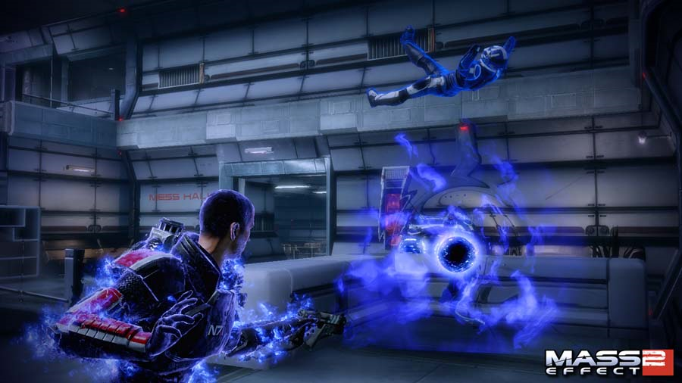
Individuals, other than Asari who were exposed to dust-form element zero (‘eezo’) in utero and survived, developed eezo modules throughout their nervous system. The natural electrical impulses in the body can create mass effect fields from these nodules, producing the effects seen as biotic abilities.

Biotics throughout the Galaxy

Humanity
In humans, about one in ten exposures will result in a person with moderate, stable biotic talents that are worth training. However, there is a risk the eezo will cause medical complications instead, such as terminal cancer, and even if biotic talents manifest themselves, they aren’t always permanent. In extremely rare cases, humans who were exposed in utero, yet did not manifest biotic talents, can develop them in puberty through further exposure to element zero.
After a series of starship accidents in the 2150s, which dispersed element zero over various settlements, the first human biotics were born, though not all were initially detected. By the time the children were teenagers, the Alliance had realized the enormous military potential of biotics through contact with the Citadel, and set up a company called Conatix Industries to develop implants for humans and track down element zero exposures. There are rumors that, after the link between element zero and biotics was made, some human colonies may have been deliberately exposed under cover of ‘industrial accidents’.
In 2160 Conatix established the BaaT program on Jump Zero, quietly hiring turian mercenaries as teachers, but after one of these instructors, Commander Vyrnnus, died, BaaT was shut down. The Alliance military eventually set up other training programs to handle biotics, but the records pertaining to BaaT remain classified. Later projects would prove more successful. Human biotics currently have some oversight from the Alliance Parliamentary Subcommittee for Transhuman Studies.
Most modern human biotics use the Alliance’s L3 implant, which is safe to use but not particularly powerful. However, some older biotics are stuck with L2 implants, which allow abilities to spike higher – using an L2 implant, the user’s abilities are apparently comparable to an asari’s – but at a cost. L2 implants are notorious for causing medical complications such as insanity, mental impairment, or extreme physical pain. It is possible to ‘upgrade’ from an L2 to an L3 implant, but the procedure is unethical because it carries a high risk of brain damage. Many L2s are angry at the way the Alliance has – in their view – abandoned them and want reparations for their suffering. In some cases, extreme physical or psychological stress can cause even stable biotic implants to flare up and cause similar health problems.
Human biotics can face prejudice from those who are religiously or philosophically opposed to their physiological modifications. This is mostly due to ignorance: some people (wrongly) believe that biotics can read and control people’s minds. There have also been cases of biotics who misuse their abilities – cheating at roulette, for example, or playing practical jokes like pulling people’s chairs out from under them – being attacked by frightened mobs, and sometimes even killed.
Despite these concerns, the Alliance military welcomes biotics with open arms and offers huge recruitment incentives. Because of the massive physical efforts involved in biologically generating dark energy, biotic soldiers have a larger daily calorie ration and are given energy drinks to keep their blood sugar and electrolytes up. The electrical fields in their bodies mean they are also prone to small static discharges when they touch metal.
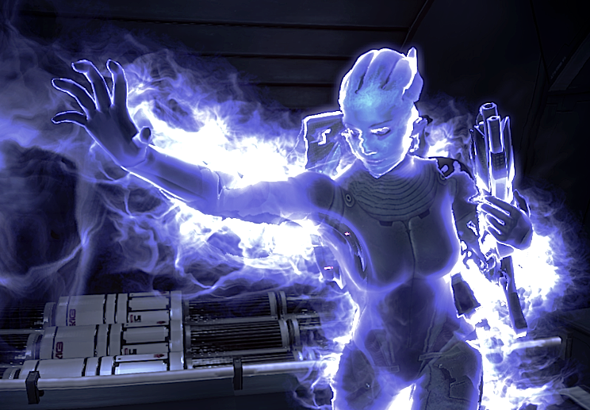

Asari
All asari are natural biotics from birth, though not all choose to develop their abilities.

Batarian
Unknown.

Drell
Unknown.

Krogan
The few krogan biotics tend to be extremely powerful and often train to become krogan battlemasters. Before the genophage, krogan biotics in the military were usually officers, because the rank-and-file were overawed by their talents. Originally, it was possible for krogan to become biotics through surgery, but there was a high mortality rate. Since the genophage has already decimated krogan numbers, this practice has been discontinued.

Salarian
Salarian biotics are unusual and highly prized. The salarian military does not risk them in the front lines but uses them in the intelligence services.

Turians
In turians, biotics are also unusual and generally not much better than a human L3. They are viewed with some suspicion by the general infantry and tend to be deployed in specialist groups called ‘Cabals’ for key missions.

Quarian
Quarian biotics are very rare. It is speculated that this is due to their life aboard the Migrant Fleet. Element zero is such a rare resource that it is probably too precious to be ‘spent’ on encouraging biotic potential in quarians, and because the quarians live aboard ships, any engine accident severe enough to release dust-form element zero would also be fatal to the crew.

Vorcha
Unknown.

Volus
Unknown.

Power Descriptions
Biotic Powers are derived from the exposure to Element Zero or a species natural affinity for Biotics. However, most species must train diligently and have a Biotic Implant inserted into their brain to use Biotic Powers with any success.
The Biotic Powers listed below are accessible for any character with the Biotic Feat. The Biotic Feat allows the player to choose 1 + WIS modifier biotic powers (minimum of 1) each time the Biotic Feat is taken.
Time indicates how long it takes to enact the power.
Target indicates what the target of the power is.
Cool down indicates how long it takes for the power to be usable again after using it.
All checks for Biotic Powers are determined by the Use Biotics Skill.
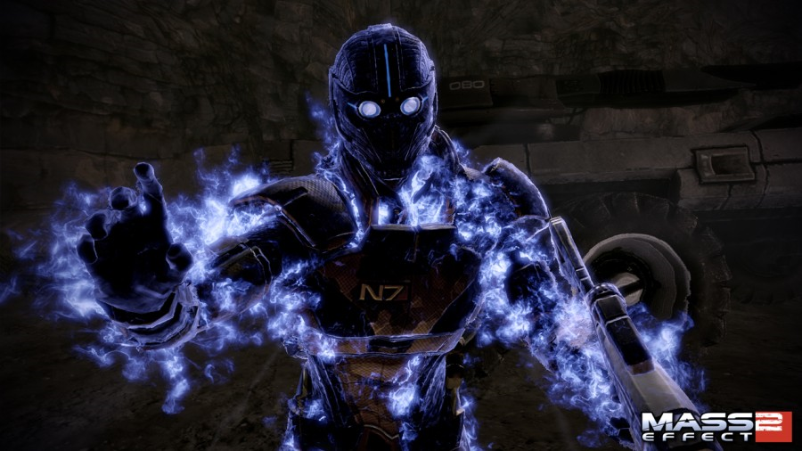

Biotic Barrier
Barrier surrounds the user with a high-gravity mass effect field essentially adding a layer of protection beneath shields but above any armor for a certain period of time or until they are spent. Barriers do not protect against physical damage like melee attacks, debris or environmental hazards
Time: Swift Action
Target: Personal
Cool down: 4 Rounds
Make a Use Biotics Check. The result of the check determines the effect, if any:
- DC 15: Creates Biotic Barrier, absorbing 1d6 points for 1d4 rounds
- DC 20: Creates Biotic Barrier, absorbing 1d8 points for 1d4 rounds
- DC 25: Creates Biotic Barrier, absorbing 1d10 points for 1d4 rounds
- DC 30: Creates Biotic Barrier, absorbing 1d12 points for 1d4 rounds
Special: Action points can be used to augment absorption or duration. Using an Action Point can increase absorption by 1d6 or duration by 1d4 rounds. Only one Action Point can be used per check. The user cannot maintain a Biotic Barrier and Biotic Shield at the same time.

Biotic Shield
Biotic Shield creates a high-gravity mass effect field around a certain area of effect which must include the creator of the field. The Biotic Shield can protect against attacks, but not at the rate a Biotic Barrier can. The Biotic Shield can also protect against objects entering the field.
Time: Standard Action
Target: Varies
Cool down: 4 Rounds
Make a Use Biotics Check. The biotic shield can serve two purposes; to protect from damage and block entrance by an object. The check result is compared to an object’s Fortitude Defense, if the check is higher, the object cannot enter the shield. The object cannot enter until the shield expires and a new Biotic Shield check is performed. The result of the check determines the effect, if any:
- DC 15: Creates Biotic Shield, absorbing 1d4 points of damage for 1d4 rounds. The shield covers a 10x10 area, centered on the user.
- DC 20: Creates Biotic Shield, absorbing 1d6 points of damage for 1d6 rounds. The shield covers a 15x15 area, centered on the user.
- DC 25: Creates Biotic Shield, absorbing 1d8 points of damage for 1d8 rounds.
- The shield covers a 20x20 area, centered on the user.
- DC 30: Creates Biotic Shield, absorbing 1d10 points of damage for 1d10 rounds.
The shield covers a 25x25 area, centered on the user.
Special: Any damage over the absorption level of the shield destroys the shield. If multiple objects attempt to enter the shield, each object of a different type must be examined against the Use Biotic check result. Any ally within the shield is protected by the shield. The shield absorption level is cumulative for all allies within the shield. If the Cool down timer expires before the shield’s expiration timer, the user may perform a Use Biotics Check to extend the shield per their roll result. Shield’s expiration timer begins and ends at the end of the user’s turn. Action Points can be used to extend the area of the shield by 5x5 per Action Point and extend the duration by 1d2 rounds per Action Point. No more than two Action Points can be user per Use Biotics Check, regardless of the combination of augmentation options. The user cannot maintain a Biotic Barrier and Biotic Shield at the same time. However, others within the Biotic Shield may have personal Biotic Barrier’s active while enclosed in the Biotic Shield.

Charge
Charge augments speed and strength, and charges across the battlefield towards a target. This culminates in a powerful collision that sends enemies flying backward, inflicting massive damage. The collision negates the mass of an enemy, allowing for even the largest of enemies to be sent flying backwards. This power also compensates for impeding obstacles, by allowing the Vanguard to ‘phase’ through solid objects en route to their target. It can also be used on enemies who have been levitated by other biotic talents, and can multiply physics damage to send them off into the distance. As the Vanguard further masters this ability, Charge will slow down time as the Vanguard heads towards the target, permitting additional damage.
Time: Full Round Action
Target: Any living creature or object within six squares.
Cool down: Six Rounds
Make a Use Biotics Check. Targets in range cannot avoid the biotic impact so long as they do not have shields or biotic barriers active. The user can move through small objects (but not walls) to reach the target. The result of the check determines the effect, if any:
- DC 15: Damages Target 1d4. Thrown back 1d6 squares
- DC 20: Damages Target 1d6. Thrown back 1d8 squares
- DC 25: Damages Target 1d8. Thrown back 1d10 squares
- DC 30: Damages Target 1d10. Thrown back 1d12 squares
Special: The orientation of the thrown target is determined as the DM sees fit. This means whether they go straight backward, or diagonally right or left. Damage caused by Charge affects Armor Points or HPs directly; falls due to Charge may affect shields, biotic barriers, and armor as well. Action Points may be used to increase the reach of Charge by six squares per Action Point, with a maximum of two action points spend per check. Charge can hit airborne targets no higher than two squares of the ground.

Kinetics
Kinetics allows the user to lift, pull, or push a living creature or object while levitating it into the air.
Time: Standard Action
Target: Any living creature or object, regardless of shields or armor within six squares of the user.
Cool down: 6 Rounds
Make a Use Biotics Check. The result of the check determines the size of the object that can be lifted. If the target is resists the attempt the user’s check must exceed their Will Defense. You can hurl the target at another target in range if your check exceeds the second target’s Reflex defense. Damage to both targets is determined by the user’s check.
- DC 15: Kinetics up to a Medium Sized Target (Deals 2d6 Damage)
- DC 20: Kinetics up to a Large Sized Target (Deals 4d6 Damage)
- DC 25: Kinetics up to a Huge Sized Target (Deals 6d6 Damage)
- DC 30: Kinetics up to a Gargantuan Sized Target (Deals 8d6 Damage)
Special: Damaged is not capped based on the size thrown. Example: Throwing a Medium Creature, but rolling higher than DC 30 inflicts 8d6 damage. Biotic Barriers, shields, and armor are all valid protection against Kinetics. Action Points may be used to increase the maximum size of an object by one (size maximum of Colossal) and damage by 2d6. A maximum of one Action Point can be used per check.

Reave
Time: Standard Action
Target: One living creature or target within six squares without shields deployed.
Cool down: 6 Rounds
The power employs mass effect fields to biotically attack the target’s nervous or synthetic systems. This power restores health and can give a temporary health bonus when the power is used against organics.
Make a Use Biotics Check. Any damage dealt first affects biotic barriers, then armor, and finally hit points. The check must defeat the target’s Will Defense. The user must damage HPs to have anything transferred. The user cannot transfer biotic barrier or armor points. Upon a successful check the damage and potential HP gain is 1d10.
Special: Organics cannot steal HPs from synthetics or synthetics from organics. Damage can be applied normally. It is possible to increase the user’s HPs above her maximum, granting a temporary HP bonus until the cool down timer expires. One Action Point can be used to augment the damage dealt and HPs gained. The Action Point augments the power by 1d6 which is used for damage and HPs as described above. Only one Action Point can be used per check.

Shockwave
Shockwave is a biotic power that sends out a series of explosive biotic impacts in front of the user. It can be unleashed along the ground to all enemies in its path along the ground to launch all enemies in its path into the air, or it can be used against airborne targets low to the ground.
Time: Standard Action
Target: Living creatures or object that reside in a straight line provided by user, up to six squares, that do NOT have shields or biotic barriers currently active. Shockwave CANNOT pass through a biotic barrier or shield. Shockwave will dissipate once it comes into contact with either. Example: If a target has a biotic barrier or shield active and stands in front of a target without either, neither can be harmed by Shockwave.
Cool down: 6 Rounds
Make a Use Biotics Check. Targets in range cannot avoid the biotic impact so long as they do not have shields or biotic barriers active. The result of the check determines the effect, if any:
- DC 15: Damages Target 1d6. Thrown back 1d4 squares
- DC 20: Damages Target 1d8. Thrown back 1d6 squares
- DC 25: Damages Target 1d10. Thrown back 1d8 squares
- DC 30: Damages Target 1d12. Thrown back 1d10 squares
Special: The orientation of the thrown target is determined as the DM sees fit. This means whether they go straight backward, or diagonally right or left. Damage caused by Shockwave affects HPs directly; falls due to Shockwave may affect shields, biotic barriers, and armor as well. Action Points may be used to increase damage by 1d6 per Action Point spent, with a maximum of two action points spend per check. The distance thrown may also be augmented by up to two Action Points, increase the distance thrown by 1d4 squares per action point. The user may use Actions points to augment damage and distance, but no more than two Actions Points may be used per check regardless of the combination of damage or distance. Shockwave can hit airborne targets no higher than two squares of the ground.

Singularity
A singularity is generated when a biotic uses dark energy to imbue a subatomic particle with infinite density. This profoundly warps the fabric of space-time, causing all mass within the singularity’s event horizon to be drawn into it. Creating and sustaining one is extremely difficult, requiring advanced training as well as considerable biotic talent.
Time: Standard Action
Target: Any living creature or object within six squares.
Cool down: 8 Rounds
Make a Use Biotics Check. Compare check against target’s Will Defense. If the check is successful the target is helpless for 1d4 rounds.
Special: Action Points can be used to increase the size of a singularity to multiple targets within a short distance from one another. The targets must be within two squares of each other in any direction. One Action Point must be spent per target, with a maximum of two Action Points spent. Targets caught in a singularity are helpless, and prone to coup de grace, etc, however, any shields, biotic barriers, and armor are still intact and must be destroyed before any damage to the target’s hit points may occur.

Stasis
Stasis causes an enemy to be temporarily locked in a mass effect field, freezing the target in place and making them unable to attack. Enemies in Stasis also become impervious to damage.
Time: Standard Action
Target: Any living creature or object within six squares.
Cool down: 6 Rounds
Make a Use Biotics Check. Compare check to Will Defense of target. If the check is greater than the target’s Will Defense the target is placed in stasis for 1d6 rounds.
Special: Action Points can be used to increase the size of a stasis field to multiple targets within a short distance from one another. The targets must be within two squares of each other in any direction. One Action Point must be spent per target, with a maximum of three Action Points spent. An Action Point can be used to augment the duration of the stasis field by 1d4 per Action Point spend. A total of 3 Action Points can be spent on one check. Targets caught in a stasis field cannot be harmed but cannot move or act in any other way than speaking. Biotic powers cannot be used in a stasis field.

Warp
Warp creates rapidly-shifting mass effect fields that shred the target apart over time.
Time: Standard Action
Target: Any living creature or object within six squares provided they are not protected by shields.
Cool down: 6 Rounds
Make a Use Biotics Check. Compare check against target’s personal or armor Fortitude defense, whichever is higher. If the check is successful the target takes 1d8 damage for 1d4 rounds.
Special: Damage is first applied to biotic barriers, then armor points and finally hit points, in that order. If the check is greater than the target number by five or more, damage is increased by 1d4 and duration is expanded by 1d2 rounds.

Weakening Reave
The power employs mass effect fields to biotically attack the target’s nervous or synthetic systems to ‘steal’ the ‘essence’ of the target. This power steals attribute points of the user’s choice from the defender and temporarily grants them to the user. This power only works with like-typed characters, such as organics to organics, or synthetics to synthetics.
Time: Standard Action
Target: One living creature or target within six squares without shields deployed.
Cool down: 6 Rounds
Make a Use Biotics Check. If the check exceeds the target’s Will defense then the user may steal attribute points from the attribute of the user’s choice at 1d6. The attribute points are subtracted from the target and added to the user for 1d4 rounds. This power can be augmented by Action Points that increase the attribute points by 1d4 and duration by 1d4. Only one Action Point can be used per check.

Chapter 5: Tech

Power Descriptions
Technology Powers originate from the character’s omni-tool.
The Technology Powers listed below are accessible for any character with an omni-tool and the Engineer Feat. The Engineer Feat allows the player to choose 1 + WIS modifier tech powers (minimum of 1) each time the Engineer Feat is taken.
Time indicates how long it takes to enact the power.
Target indicates what the target of the power is.
Cool down indicates how long it takes for the power to be usable again after using it.
All checks for Technology Powers are determined by the Use Tech Skill.

AI Hacking
This power temporarily takes control of synthetic enemies, turning them against their allies. It drives robotic enemies berserk so they will attack anything nearby, including their former allies. Using AI Hacking to its best effect requires you to be aware of the situation and your enemy’s line of sight. If there are none of its allies nearby, a hacked enemy will still attack if it can see you.
Time: Standard Action
Target: One synthetic creature within six squares.
Cool down: 6 Rounds
Make a Use Tech Check. If the check exceeds the target’s Will defense, then the synthetic is hacked for 1d6 rounds. The synthetic will then attack the nearest target, if two targets are the same distance away, the DM decides which the synthetic will attack.

Combat Drone
Combat Drone power spawns a tech drone that draws enemy fire and can electronically stun targets while damaging their shields. Only one drone per character can be active at a time.
Time: Standard Action
Target: None
Speed: 12 squares
Base Attack Bonus: equal to character’s BAB
Cool down: 6 Rounds
Make a Use Tech Check. The result of the check determines the effect, if any:
  - DC 15: Drone may stun target for 1d2 rounds and damage shields for 1d4 damage. Drone lasts 2 rounds.
  - DC 20: Drone may stun target for 1d4 rounds and damage shields for 1d6 damage. Drone lasts 4 rounds.
  - DC 25: Drone may stun target for 1d6 rounds and damage shields for 1d8 damage. Drone lasts 6 rounds.
  - DC 30: Drone may stun target for 1d8 rounds and damage shields for 1d10 damage. Drone lasts 8 rounds.

Cryo Blast
When activated, the user’s omni-tool fires a mass of super-cooled subatomic particles capable of snap-freezing targets within a certain radius. If the target’s health is low enough when frozen, it is possible to shatter it through the use of weapons or other damage dealing abilities. Frozen enemies are more susceptible to damage.
Time: Standard Action
Target: Personal
Cool down: 4 Rounds
Make a Use Tech Check. The check will determine Omni-tool Cryo Blast rating.
  - DC 15: Cryo blast deals 1d6 damage. Cryo blast lasts 1d2 rounds
  - DC 20: Cryo blast deals 1d6 damage and makes target susceptible to increased damage. All additional damage to HPs and Aps deal damage x 1.5. Cryo blast lasts 1d4 rounds.
  - DC 25: Cryo blast deals 1d8 damage and makes target susceptible to increased damage. All additional damage to HPs and Aps deal damage x 1.5. Cryo blast lasts 1d6 rounds.
  - DC 30: Cryo blast deals 1d8 damage and makes target susceptible to increased damage. All additional damage to HPs and Aps deal damage x 2. Cryo blast lasts 1d8 rounds.
Special: Standard Cryo Blast cannot be used in the same round as the Omni-Tool is fired. This is because both firing the Omni-Tool and using the power are standard actions. Cryo blast only works against targets without shields or biotic barriers deployed. Cryo blast has a range of six squares and is based on a ranged attack check vs. the target’s reflex defense. Up to one Action Point can be used to increase damage by 1d8 damage or to make Cryo Blast a swift action.

Dampening
This power shuts down enemy tech and biotic abilities.
Time: Standard Action
Target: One target within six squares.
Cool down: 6 Rounds
Make a Use Tech Check. If the check exceeds the target’s Will defense, then current running Tech or Biotic powers are negated and shut down. This also prohibits the target from using any additional biotic of tech powers while the duration of Dampening is running. The duration of this power is 1d6 rounds.
Special: The user must identify which power type they are attempting to Dampen. They cannot Dampen both Biotic and Tech powers simultaneously. One Action Point can be used to increase the duration by 1d6 rounds.

First Aid
First Aid makes medi-gel more effective by increasing the amount of healing per use and allows the user to heal up to two friendly targets including self (self + two others).
This power also allows the player to remotely heal any squad member within 6 squares. Remote healing requires authorization as friendly contact via omni-tool that can be configured prior to mission. Remote healing uses omni-gel from the person being healed armor’s omni-gel dispensers. If the target has any first-aid related upgrades installed via their armor, then these armor upgrades apply to the target’s healing.
Time: Standard Action
Target: Personal, One or Two friendly target within six squares.
Cool down: 6 Rounds
Requires: Friendly contact authorization, Available omni-gel on self or target’s armor.
Special: Allows Remote Healing, +2 Hit Points healed per omni-gel applied to self, +1 Hit Points healed per omni-gel applied to target

Incinerate
Incinerate delivers a high-explosive plasma round fired from the user’s Omni-tool that inflicts damage over time to all nearby enemies and permanently stops their health regeneration. Against armor, the damage this ability deals is 2.4 times the usual amount.
Time: Standard Action
Target: Personal.
Cool down: 8 Rounds
Make a Use Tech Check. The check will determine Omni-tool Incinerate rating.
  - DC 15: Incinerate deals 1d6 damage. Incinerate lasts 1d2 rounds. Incinerate can target 1d4 targets.
  - DC 20: Incinerate deals 1d8 damage. Incinerate lasts 1d2 rounds. Incinerate can target 1d4 targets.
  - DC 25: Incinerate deals 1d10 damage. Incinerate lasts 1d4 rounds. Incinerate can target 1d4 targets. Incinerate lasts 1d4 rounds
  - DC 30: Incinerate deals 1d12 damage. Incinerate lasts 1d4 rounds. Incinerate can target 1d4 targets.
Special: Standard Incinerate cannot be used in the same round as the Omni-Tool is fired. This is because both firing the Omni-Tool and using the power are standard actions. Cryo blast has a range of six squares and is based on a ranged attack check vs. the target’s reflex defense. For each additional target the user’s attack is at -2 for each additional target. Example: Attack two targets would be at Attack – 2 for both. Attack three would be at Attack – 4 for all three, etc. Up to one Action Point can be used to increase damage by 1d8 damage or to make Incinerate a swift action.

Medicine
The medicine power makes medi-gel more effective by increasing the amount of healing per use and number of squad members that can be remotely healed.
This power also allows the player to remotely heal any squad member within 8 squares. Remote healing requires authorization as friendly contact via omni-tool that can be configured prior to mission. Remote healing uses omni-gel from the person being healed armor’s omni-gel dispensers. If the target has any first-aid related upgrades installed via their armor, then these armor upgrades apply to the target’s healing
Time: Standard Action
Target: Personal, One to five friendly targets within eight squares.
Cool down: 6 Rounds
Requires: First Aid Power, Friendly contact authorization, Available omni-gel on self or target’s armor.
Special: Allows Remote Healing, +3 Hit Points healed per omni-gel applied to self, +2 Hit Points healed per omni-gel applied to target

Neural Shock
This power temporarily disables organic targets. It induces paralysis and does toxic damage, but only works on organic foes.
Time: Standard Action
Target: One organic target within six squares.
Cool down: 6 Rounds
Make a Use Tech Check. If the check exceeds the target’s Fort defense, then the target takes 1d6 damage and a 1d4 penalty to Strength, Constitution, and Dexterity for 1d6 rounds.
Special: An Action Point can be used to increase damage 1d6, attribute penalty by 1d4, or rounds by 1d6. Only one action point can be used per check attempt.

Overload
This power works by using an omni-tool to modify and deploy a mine that will damage an enemy’s shields. Typically used to take down shields or synthetics, it is also surprisingly useful against specific non-shielded organics, most notably those who use mechanical weapons that are vulnerable to exploding, such as Blue Suns Pyro.
Time: Standard Action
Target: One synthetic creature or organic target with shields within six squares.
Cool down: 6 Rounds
Make a Use Tech Check. If the check exceeds the target’s Fort defense, then shields or synthetics are damaged 2d8 and shield regeneration is slowed to half its base amount for 1d6 rounds.
Special: An Action Point can be used to increase the regeneration by an additional 1d6 rounds. Only one Action Point can be used per check.

Sabotage
Sabotage works specifically by overheating weapons, meaning it can be used on other targets too. Hitting containment cells or fuel tanks with Sabotage will cause them to explode, causing environmental damage and, in some areas, starting a massive chain reaction. On the down side, this means you need to be careful if you hit a nearby enemy with Sabotage while standing near anything explosive
Time: Standard Action
Target: One target with shields within six squares.
Cool down: 6 Rounds
Make a Use Tech Check. If the check exceeds the target’s Fort defense, then any ranged weapon the target holds is overheated for 1d8 rounds. Being overheated means that the target cannot use the weapon at all.
Special: An Action Point can be used to add an additional target. Only one Action Point can be used.

Chapter 6: Equipment

Monetary System
Credits are the primary monetary unit in the Mass Effect universe.

Weapons
There are six types of ranged weapons: Pistol, Assault Rifle, Shotgun, Sniper Rifle, Heavy Weapons, and Sub-Machine Guns. Each type of ranged weapon requires the character to take a weapon proficiency feat related to that weapon type.

Armors
There are three types of armors: Light, Medium, and Heavy. The three types of armor have their own related feats and feat prerequisites. For example, you must have the Armor Proficiency (Light) feat to wear light armor.
Armors are restricted by race. For example, if armor is acquired from a human, a krogan character cannot equip it. Compatible armor groups include:
- Humans, Asari, Drell
- Krogan
- Turian
- Quarian

Equipment Upgrades
The development of practical minifacturing omni-tools allows modern militaries a great deal of flexibility in equipment load-outs. A vast number of field modification kits, or “upgrades”, are available for common equipment such as weapons, armor, omni-tools, biotic amps, and even grenades.
An upgrade kit typically consists of less than a dozen unique parts and an optical storage disc. When loaded into an omni-tool, the OSD provides all technical specifications required to manufacture the tool and additional parts necessary to install the upgrade onto another piece of equipment. Assembly is typically modular, and installation can be completed in less than a minute.
Since omni-tools are designed to use common battlefield salvage materials such as plastics, ceramics, and light materials (rendered into semi-molten “omni-gel” for quick use), it is quite possible for a trained soldier carrying upgrade kits to customize gear on the battlefield to fit the current tactical situation.

Armor
Table 3. Armor Packages
Armor Package | Cost | Armor Points | Shield Points | Shield Regeneration | Medi-Gel Capacity | Upgrade Slots
LA1SM1 | 1250 | 5 AP | 10 SP | 1 SP / round | 4 | 0 upgrade slots
LA2SM1 | 2250 | 5 AP | 10 Sp | 1 SP / round | 4 | 1 upgrade slot
MA1SM1 | 5750 | 10 AP | 10 SP | 1 SP / round | 4 | 0 upgrade slots
MA2SM1 | 6750 | 10 AP | 10 SP | 1 SP / round | 4 | 1 upgrade slot
HA1SM1 | 8750 | 15 AP | 10 SP | 1 SP / round | 4 | 0 upgrade slots
HA2SM1 | 9750 | 15 AP | 10 SP | 1 SP / round | 4 | 1 upgrade slot

Each set of armor, regardless of its weight, has a kinetic barrier generator and an onboard computer that can give readouts on the environment, liaise with terminals to download data, and check local wildlife against the xenobiology database.
Each set of armor comes with a helmet that can be worn to protect from environmental hazards such as open space and toxic climates. All armor contains med-gel reserves used to heal the wearer.
Armor proficiency is granted by taking feats. Every character begins the game with access to Light Armor.
Access to medium armors requires taking both the Armor Proficiency (Light) and Armor Proficiency (Medium) feats. Access to heavy armors requires taking light, medium, and heavy armor proficiency feats.

Armor Packages
LA1SM1 – This Light Armor I package comes with the Shield Module I. This armor contains no upgrade slots.
LA2SM1 – This Light Armor II package comes with the Shield Module I. This armor contains one upgrade slot.
MA1SM1 – This Medium Armor I package comes with the Shield Module I. This armor contains no upgrade slots.
MA2SM1 – This Medium Armor II package comes with the Shield Module I. This armor contains one upgrade slot.
HA1SM1 – This Heavy Armor I package comes with the Shield Module I. This armor contains no upgrade slots.
HA2SM1 – This Heavy Armor II package comes with the Shield Module I. This armor contains one upgrade slot

Building Your Armor
You may purchase an existing armor listed above or build your own armor.
- Select the armor base (light, medium, heavy)
- Optionally, add one shield module
- Optionally, add upgrade(s) if available upgrade slot(s)
- Inspect armor maximum shield point limitations for compliance.

Base Armor
Table 4. Armor & Shield Modules
Armor Modules | Cost | Armor Points | Upgrade Slots | Max Shield Limit | Medi-Gel Capacity | Armor  Check Penalty | Weight (kg)
Light Armor I | 500 | 5 AP | 0 | 25 | 2 | -2 | 10
Light Armor II | 1500 | 5 AP | 1 | 25 | 2 | -2 | 10
Light Armor II | 2500 | 5 AP | 2 | 25 | 2 | -2 | 10
Medium Armor I | 5000 | 10 AP | 0 | 50 | 3 | -5 | 20
Medium Armor II | 6000 | 10 AP | 1 | 50 | 3 | -5 | 20
Medium Armor III | 7000 | 10 AP | 2 | 50 | 3 | -5 | 20
Heavy Armor I | 8000 | 15 AP | 0 | 75 | 4 | -10 | 35
Heavy Armor II | 9000 | 15 AP | 1 | 75 | 4 | -10 | 35
Heavy Armor III | 10500 | 15 AP | 2 | 75 | 4 | -10 | 35
Shield Modules | Cost | Shield Points | Shield Recharge
Shield Module I | 750 | 1o SP | 3 SP
Shield Module II | 1500 | 15 SP | 4 SP
Shield Module III | 2500 | 20 SP | 5 SP

Armor Check Penalty
While wearing armor with which you are not proficient, you take an armor check penalty on attack rolls as well as skill checks made using the following skills: Acrobatics, Climb, Endurance, Initiative, Jump, Stealth, and Swim. The type of armor worn determines the size of the penalty as determined on Table 4. Additionally, you do not gain the armor’s equipment bonus.

Shield Modules
Basic Shield Module – The basic shield module adds a base of 10 SP and when taking the Shield Recharge action shields are regenerated 3 points.
Intermediate Shield Module – The intermediate shield module adds a base of 15 SP and when taking the Shield Recharge action shields are regenerated 4 points.
Advanced Shield Module – The advanced shield module adds a base of 20 SP and when taking the Shield Recharge action shields are regenerated 5 points.

Armor Upgrades
Table 5. Armor Upgrades
Armor Upgrade | Cost | Benefit
Armor Plating I | 500 | +5 AP
Armor Plating II | 1000 | +10 AP
Armor Plating III | 1500 | +15 AP
Shield Battery I | 750 | +15 SP
Shield Battery II | 1500 | +25 SP
Shield Battery III | 2250 | +35 SP
Shield Battery IV | 3000 | +45 SP
Shield Battery V | 3750 | +55 SP
Stimulate Pack I | 500 | Reduces biotic cool down -1
Stimulate Pack II | 1000 | Reduces biotic cool down -2
First Aid Interface I | 500 | +2 HP healed (self-only)
First Aid Interface II | 750 | + 3 HP healed (self-only)
Medical Interface I | 1000 | + 2 HP healed (self-only), + 20% Toxin Resist
Medical Interface II | 1250 | + 3 HP healed (self-only), + 30% Toxin Resist
Medical Exoskeleton I | 1500 | + 3 HP healed (self only), +30% Toxin Resist, Reduces biotic cool down -1
Medical Exoskeleton II | 2000 | + 4 HP healed (self-only), +40% Toxin Resist, Reduces biotic cool down -2
Toxin Resistance I | 500 | +25% Toxin Resist
Toxin Resistance II | 750 | +35% Toxin Resist
Toxin Resistance III | 1000 | +45% Toxin Resist
Shield Recovery I | 500 | Increase shield regeneration rate to 50% Max
Shield Recovery II | 1000 | Increase shield regeneration rate to 75% Max
Shield Recovery III | 1500 | Increase shield regeneration rate to 100% Max
Medi-Gel Reserve I | 750 | Increase armor’s maximum medi-gel capacity by 2
Medi-Gel Reserve II | 1500 | Increases armor’s maximum medi-gel capacity by 3
Mechanical Joints I | 1500 | Increases melee damage by 2
Mechanical Joints II | 2000 | Increases melee damage by 3

Armor Upgrade Modules
All upgrade modules require installation via an omni-tool. Another PC or NPC may use their omni-tool to calibrate the upgrade and load it into the character’s armor.
Armor Plating – Hardened ceramic plates can be applied to body armor suits, increasing their effectiveness.
Shield Battery– The shield battery upgrades adds additional shield points. The upgrade does not affect shield regeneration.
Stimulant Pack – Armor equipped with stim packs releases targeted shots of adrenaline to speed up recovery and recharge times.
First Aid Interface – Microprocessors wired into a combat suit can monitor vital functions and release small, localized doses of medi-gel to accelerate the healing process.
Medical Interface – Specialized microprocessors wired into a combat suit monitor vital functions and release small, localized doses of medi-gel to accelerate the healing process. This interface also provides resistance to toxic attacks.
Medical Exoskeleton – A prototype upgrade combining numerous advanced medical technologies to monitor and regulate all vital systems, maximizing healing and minimizing recovery times for the user.
Toxin Resistance – Specially-sealed body armor provides increased protection against radiation, gases, and a host of other toxins
Shield Recovery– The shield recovery module provides additional computing power to optimization power output and regenerate shields during combat.
Medi-Gel Reserve– The medi-gel reserves provide additional storage for medi-gel.
Mechanical Joints– Mechanical augmentation increases the brute strength of the wearer, allowing them to deliver powerful blows when rifle butting or pistol whipping opponents.

Weapons

Melee Weapons
Table 6. Melee Weapons
Weapon | Cost | Damage | Stun Damage | Weight | Type | Upgrade Slots/Notes
Talon Combat Knife | 250 | 2d6 |  | 2 | Slashing or Pierce | 0 Upgrade Slots
Omni-Tool Power Blade Upgrade | 1000 | 3d6 |  | 0 | Kinetic

Melee Weapons
Talon Combat Knife – The Turian made knife can slice through both armor and flesh. The knife has a fifteen centimeter serrated blade.
Omni-Tool Power Blade Upgrade – This upgrade for the omni tool allows a user to create a kinetic blade that can be used in melee.

Base Ranged Weapons
Table 7. Ranged Weapons
Weapon | Cost | Damage | RoF | Range | Ammo Capacity | Upgrade Slots
Pistol I | 300 | 3d6 | S | 20/40/60/80 | 17 | 0 Upgrade Slots
Pistol II | 900 | 3d6 | S | 20/40/60/80 | 17 | 1 Ammo Upgrade Slot
Pistol III | 2,700 | 4d6 | S | Penalty Decreased by 1 | 17 | 1 Ammo + 1 Upgrade Slot
Pistol IV | 8,100 | 4d6 | S | Penalty Decreased by 1 | 17 | 1 Ammo + 2 Upgrade Slots
Shotgun I | 700 | 3d10 | S | 20/40/100/200 | 6 | 0 Upgrade Slots
Shotgun II | 2,100 | 3d10 | S | 20/40/100/200 | 6 | 1 Ammo Upgrade Slot
Shotgun III | 6,300 | 4d10 | S | 25/50/125/250 | 6 | 1 Ammo + 1 Upgrade Slot
Shotgun IV | 18,900 | 4d10 | S | 25/50/125/250 | 6 | 1 Ammo + 2 Upgrade Slots
Assault Rifle I | 600 | 4d4 | S, A | 30/60/150/300 | 27 | 0 Upgrade Slots
Assault Rifle II | 1,800 | 4d4 | S, A | 30/60/150/300 | 27 | 1 Ammo Upgrade Slot
Assault Rifle III | 5,400 | 5d4 | S, A | 30/60/150/300 | 27 | 1 Ammo + 1 Upgrade Slot
Assault Rifle IV | 16,200 | 5d4 | S, A | 30/60/150/300 | 27 | 1 Ammo + 2 Upgrade Slots
Submachine Gun I | 500 | 3d4 | S, A | 20/40/60/80 | 37 | 0 Upgrade Slots
Submachine Gun II | 1,500 | 3d4 | S, A | 20/40/60/80 | 37 | 1 Ammo Upgrade Slot
Submachine Gun III | 4,500 | 4d4 | S, A | 20/40/60/80 | 37 | 1 Ammo + 1 Upgrade Slot
Submachine Gun IV | 13,500 | 4d4 | S, A | 20/40/60/80 | 37 | 1 Ammo + 2 Upgrade Slots
Sniper Rifle I | 800 | 3d8 | S | 35/70/175/350 | 8 | 0 Upgrade Slots
Sniper Rifle II | 2,400 | 3d8 | S | 35/70/175/350 | 8 | 1 Ammo Upgrade Slot
Sniper Rifle III | 7,200 | 4d8 | S | 40/80/200/400 | 8 | 1 Ammo + 1 Upgrade Slot
Sniper Rifle IV | 21,600 | 4d8 | S | 40/80/200/400 | 8 | 1 Ammo + 2 Upgrade Slots

Range penalties are listed in squares:
Point Blank (No Penalty)/Short (-2 Attack)/
Medium (-5 Attack)/Long (-10 Attack)

Weapon proficiency is granted by taking feats. If you wield a weapon with which you are not proficient, you take a -5 penalty to your attack rolls.
Some weapons contain upgrade slots. There are two different types of upgrades and upgrade slots. The Ammo Upgrade Slot requires using an Ammo Upgrade Module. The Weapon Upgrade Slot requires using any weapon upgrade (other than Ammo Upgrades).

Building Your Weapon
You may purchase a basic weapon and upgrade it, if there are available upgrade slots.
- Select the weapon base
- Optionally, add Ammo upgrade if available Ammo upgrade slot
- Optionally, add other upgrade if available upgrade slot.

Weapons
Pistols – Pistols are close- and mid-range weapons designed for a variety of situations, particularly shooting on the move. They lack the automatic fire of assault rifles, and do less damage compared to shotguns or sniper rifles.
Shotguns – Shotguns are particularly deadly at close range because of the concentrated blast of pellets, but lose their efficiency on longer ranges due to the spread of the weapon's projectiles.
Assault Rifles – Assault rifles are designed for any combat situation, allowing for close-, medium-, and even (in the right circumstances) long-range combat.
Their automatic fire makes assault rifles perfectly designed for taking down enemies quickly or providing cover fire, but due to their high recoil, sniping with assault rifles is very difficult. Short, controlled bursts and a crouching stance are required to hit anything at long range. At close range, spraying bullets into a target is effective, if not as quick as a shotgun blast.
Submachine Guns – Submachine guns possess a bonus to damage against shields and biotic barriers, however, they are weak against armor. With their large thermal clip sizes and total ammo capacity, they fill the role of a backup suppressive weapon, while retaining moderate accuracy.
Sniper Rifles – Sniper rifles are slow and usually overheat after two shots in quick succession. However, they make up for this in range and damage - higher-level sniper rifles retain accuracy at incredible ranges, and they will often kill weaker enemies in one shot. Beware, though; close-range encounters are not recommended, due to the fact that you will more than likely miss any shots in close combat.

Ammo Upgrades
Table 8. Ammo Upgrades
Ammo Upgrade | Cost | Benefit
Shredder Rounds I |  | Effect against organics
Shredder Rounds II |  | Effect against organics
Shredder Rounds III |  | Effect against organics
Tungsten Rounds I |  | Effect against metal and synthetics
Tungsten Rounds II |  | Effect against metal and synthetics
Tungsten Rounds III |  | Effect against metal and synthetics
Inferno Rounds I |  | Burn over time, decreases targets accuracy
Inferno Rounds II |  | Burn over time, decreases targets accuracy
Inferno Rounds III |  | Burn over time, decreases targets accuracy
Cryo Rounds I |  | Chance of snap-freezing target
Cryo Rounds II |  | Chance of snap-freezing target
Cryo Rounds III |  | Chance of snap-freezing target
High Explosive Rounds I |  | Massive overheat, blast radius, knockback
High Explosive Rounds II |  | Massive overheat, blast radius, knockback
High Explosive Rounds III |  | Massive overheat, blast radius, knockback
Sledgehammer Rounds I |  | Target takes toxic damage, Knockback, prevents hit point regen, overheat
Sledgehammer Rounds II |  | Target takes toxic damage, Knockback, prevents hit point regen, overheat
Sledgehammer Rounds III |  | Target takes toxic damage, Knockback, prevents hit point regen, overheat
Proton Rounds I |  | Bypasses barriers, but less damage
Proton Rounds II |  | Bypasses barriers, but less damage
Proton Rounds III |  | Bypasses barriers, but less damage
Polonium Rounds I |  | Target takes toxic damage, prevents hit point regeneration
Polonium Rounds II |  | Target takes toxic damage, prevents hit point regeneration
Polonium Rounds III |  | Target takes toxic damage, prevents hit point regeneration
Radioactive Rounds I |  | Target takes biotic and tech cool down penalty of X?
Radioactive Rounds II |  | Target takes biotic and tech cool down penalty of X?
Radioactive Rounds III |  | Target takes biotic and tech cool down penalty of X?

Ammo Upgrade Modules
All upgrade modules require installation via an omni-tool. Another PC or NPC may use their omni-tool to calibrate the upgrade and load it into the character’s armor.
Ammo upgrades can only be installed in weapon ammo upgrade slots. You cannot have more than one ammo upgrade installed at any time.
Shredder Rounds – This ammo tears through soft targets, inflicting more damage to unshielded organic enemies.
Tungsten Rounds – This type of ammunition is derived from tungsten. This extremely dense, heavy metal is about 1.7 times heavier than lead, and far more difficult to deform than steel. It is excellent for use in armor-piercing type ammunition. Because of tungsten's great properties and strength, it is very useful for piercing deep into synthetic, metallic targets.
Inferno Rounds – Inferno rounds are incredibly powerful rounds that can melt or burn through virtually all known substances. This damages enemies and weakens their accuracy.
Cryo Rounds – Cooling lasers collapse ammunition into small Bose-Einstein condensate - a mass of super-cooled subatomic particles - capable of snap-freezing impacted objects.
High-Explosive Rounds – Designed to detonate on impact, high explosive rounds have one major drawback: a massive increase in weapon overheating.
Sledgehammer Rounds – Sledgehammer Rounds hit with incredible force, often knocking opponents completely off their feet. They are great for attacking a charging target, because the force of the rounds hitting the target can knock them to the ground. This makes them perfect for shotguns.
Sledgehammer Rounds are also coated with polonium to induce radiation sickness in targets, as well as preventing enemy regeneration. The tradeoff is they increase weapon overheating.
Proton Rounds – Instead of projectiles, upgraded weapons release energized protons capable of bypassing kinetic barrier shields. However, the actual damage inflicted on the target is typically less than that of a standard round.
Polonium Rounds – This upgrade stamps a minuscule amount of radioactive polonium into every round fired, effectively poisoning enemy targets. It also prevents enemy regeneration.
Radioactive Rounds – These rounds are stamped with a minuscule amount of radioactive material, inducing low levels of radiation sickness in targets. This sickness makes it more difficult for biotic or tech abilities to be deployed.

Ranged Weapon Upgrades
Table 9. Ranged Weapon Upgrades
Weapon Upgrade | Cost | Benefit
Improved Sighting I |  | Increases accuracy +1
Improved Sighting II |  | Increases accuracy +2
Improved Sighting III |  | Increases accuracy +3
Heat Sink I |  | Decreases overheating
Heat Sink II |  | Decreases overheating
Heat Sink III |  | Decreases overheating
Improved Optics I |  | Increases range * 1.5
Improved Optics II |  | Increases range * 2
Improved Optics III |  | Increases range * 2.5
Thermal Clip Extension I |  | Increase ammunition limit * 1.5
Thermal Clip Extension II |  | Increase ammunition limit * 2
Thermal Clip Extension III |  | Increase ammunition limit * 2.5
Combat Optics I |  | Increases accuracy +1, Increases range * 1.5
Combat Optics II |  | Increases accuracy +2, Increases range * 2
Combat Optics III |  | Increases accuracy +3, Increases range * 2.5

Weapon Upgrade Modules
All upgrade modules require installation via an omni-tool. Another PC or NPC may use their omni-tool to calibrate the upgrade and load it into the character’s armor.
Weapon upgrades can only be installed in weapon upgrade slots.
Improved Sighting – Increases accuracy.
Heat Sink– Absorbs and dissipates the heat typically generated when firing.
Improved Optics– Increases maximum range.
Thermal Clip Extension– Increase ammunition limit.
Combat Optics– Increases accuracy and maximum range.

Heavy Weapons

Base Heavy Weapons
Table 10. Heavy Weapons
Weapon | Cost | Damage | Accuracy / RoF | Range | Ammo Capacity | Upgrade Slots
Flamethrower I |  | Ammo | S |  |  | 1 Ammo Slot
Grenade Launcher I |  | Ammo | S |  |  | 1 Ammo Slot
Grenade Launcher II |  | Ammo | S |  |  | 1 Ammo Slot,  1 Weapon Upgrade Slot
Missile Launcher I |  | Ammo | S |  |  | 1 Ammo Slot,
Missile Launcher II |  | Ammo | S |  |  | 1 Ammo Slot,  1 Weapon Upgrade Slot

Heavy Weapon proficiency is granted by taking the exotic weapon proficiency feat with a specific heavy weapon, such as Exotic Weapon (Flamethrower). If you wield a weapon with which you are not proficient, you take a -5 penalty to your attack rolls.
Some weapons contain upgrade slots. There are two different types of upgrades and upgrade slots. The Ammo Slot requires using an Ammunition Type. The Weapon Upgrade Slot requires using specific heavy weapon upgrades particular to that type of heavy weapon.

Building Your Weapon
You may purchase a basic weapon and upgrade it, if there are available upgrade slots.
- Select the weapon base
- Optionally, add Ammo upgrade if available Ammo upgrade slot
- Optionally, add other upgrade if available upgrade slot.

Heavy Weapons
Flamethrower – The flamethrower is an anti-personnel and anti-armor flame unit that can accept a wide variety of liquid fuels. The weapon sprays a sticky substance that burns at approximately 1,600 degrees Celsius, a less intense fire than plasma weapons but covering a significantly wider target area.
Grenade Launcher – The grenade launcher is capable of taking down multiple enemies with a single well-placed shot. Its ammo (grenades) determines its effectiveness and damage.
Missile Launcher – The missile launcher is recommended for engagements where large–scale opposition is expected. Single-person portability is retained thanks to the now-standard collapsible design. What makes the missile launcher so effective is the friend–or–foe projectiles it fires – the user can fire the weapon from behind cover and the missiles will, within milliseconds, identify, lock onto and track enemies (organic or synthetic).

Heavy Weapon Ammunition
Table 11. Heavy Weapon Ammunition
Heavy Weapon Ammo Upgrade | Heavy Weapon | Cost | Benefit
Inferno Liquid | Flamethrower |  | 3d6, Burn over time
Cryo Liquid | Flamethrower |  | Chance to snap-freeze target
Polonium Liquid | Flamethrower |  | Toxic, Prevents regeneration
Standard Grenade | Grenade Launcher
Cryo Explosive Grenade | Grenade Launcher |  | Chance to snap-freeze target
Polonium Explosive Grenade | Grenade Launcher |  | Toxic, Prevents regeneration
High Explosive Grenade | Grenade Launcher |  | blast radius, knockback
Incendiary Explosive Grenade | Grenade Launcher |  | Burns over time
Smoke Grenade | Grenade Launcher
Standard Missile | Missile Launcher
Shredder Missile | Missile Launcher |  | Effective versus organics
Tungsten Missile | Missile Launcher |  | Effective versus synthetics
Proton Missile | Missile Launcher |  | Bypasses barriers, but less damage

Flamethrower Liquids
Inferno Liquid – Inferno liquid can melt or burn through virtually all known substances. This damages enemies and weakens their accuracy.
Cryo Liquid – Cooling liquid is capable of snap-freezing impacted objects.
Polonium Liquid – This liquid contains a minuscule amount of radioactive polonium effectively poisoning enemy targets. It also prevents enemy regeneration

Grenade Launcher Ammo
Cryo Explosive - Cryo-upgraded grenades contain a small Bose-Einstein condensate, a mass of super-cooled subatomic particles. When detonated, they are capable of snap-freezing nearby targets.
Polonium Explosive - Polonium Explosives contain a small amount of radioactive polonium that is dispersed on detonation. Targets caught in the blast experience varying degrees of radiation poisoning.
High Explosive - High Explosive grenades are modified to maximize their blast radius and impact. They are particularly useful for blowing lightly-armored enemies, like Geth Troopers, out from cover; they also act as crowd control for large groups of enemies.
Incendiary Explosive - Incendiary Explosive releases a thermal paste on detonation that clings to - and burns through - virtually all known substances.
Smoke - Smoke grenades are used to provide cover and designate landing zones and extraction points when radar isn’t accessible.
Standard Explosive - Standard explosive grenades are unmodified grenades.

Missile Launcher Ammo
Shredder Missile – This missile tears through soft targets, inflicting more damage to unshielded organic enemies.
Tungsten Missile – This type of missile is derived from tungsten. This extremely dense, heavy metal is about 1.7 times heavier than lead, and far more difficult to deform than steel. It is excellent for use in armor-piercing type ammunition. Because of tungsten's great properties and strength, it is very useful for piercing deep into synthetic, metallic targets.
Proton Missile – On impact, the missile releases energized protons capable of bypassing kinetic barrier shields. However, the actual damage inflicted on the target is typically less than that of a standard missile.

Heavy Weapon Upgrades
Table 12. Heavy Weapon Upgrades
Heavy Weapon Upgrade | Heavy Weapon | Cost | Benefit
Ammo Extension | Grenade Launcher |  | Increases ammo limit
Ammo Extension | Missile Launcher |  | Increases ammo limit

Heavy Weapon Upgrade Modules
All upgrade modules require installation via an omni-tool. Another PC or NPC may use their omni-tool to calibrate the upgrade and load it into the character’s armor.
Heavy Weapon upgrades can only be installed in heavy weapon upgrade slots.
Ammo Extension– Increase ammunition limit.

Grenades
Table 13. Grenades
Grenade | Cost | Damage | Accuracy | Range
Cryo Explosive
Polonium Explosive
High Explosive
Incendiary Explosive
Smoke
Standard Explosive

Grenades
Grenades are hand-tossed explosive charges, useful against organic and synthetic targets. The Systems Alliance uses the Mark 14 grenade, designed with retractable stabilizing fins. If the fins are extended, the grenade can be tossed like a discus, and glides long distances. With the fins retracted, the grenade can be lobbed over walls and other obstacles.
Most grenades can adhere to flat surfaces and have a 10-second fuse, allowing them to be used as makeshift shaped-charge mines or booby-traps. They can be triggered to detonate before their fuse runs out by a signal from any military hardsuit’s built-in communications gear.
The Mark 14 grenade can be modified in the field for special purposes.
Cryo Explosive - Cryo-upgraded grenades contain a small Bose-Einstein condensate, a mass of super-cooled subatomic particles. When detonated, they are capable of snap-freezing nearby targets.
Polonium Explosive - Polonium Explosives contain a small amount of radioactive polonium that is dispersed on detonation. Targets caught in the blast experience varying degrees of radiation poisoning.
High Explosive - High Explosive grenades are modified to maximize their blast radius and impact. They are particularly useful for blowing lightly-armored enemies, like Geth Troopers, out from cover; they also act as crowd control for large groups of enemies.
Incendiary Explosive - Incendiary Explosive releases a thermal paste on detonation that clings to - and burns through - virtually all known substances.
Smoke - Smoke grenades are used to provide cover and designate landing zones and extraction points when radar isn’t accessible.
Standard Explosive - Standard explosive grenades are unmodified grenades.

Omni-Tools

Base Omni-Tool
Table 14. Base Omni-Tools
Omni-Tool | Cost | Shield bonus | Tech cool down bonus | Use Computer bonus | Upgrade Slots
Omni-Tool I | 100 | 0 | 0 | 0 | 0
Omni-Tool II | 1000 | 5 SP | 0 | +1 | 0
Omni-Tool III | 2000 | 5 SP | -1 round | +1 | 1
Omni-Tool IV | 2500 | 5 SP | -1 round | +2 | 1
Omni-Tool V | 3500 | 5 SP | -2 rounds | +2 | 2
Omni-Tool VI | 4000 | 5 SP | -2 rounds | +3 | 2
Omni-Tool VII | 5000 | 5 SP | -3 rounds | +3 | 3

Omni-tools are multipurpose diagnostic and manufacturing tools used for a variety of battlefield tasks, such as hacking, decryption, or repair.
When equipped, an omni-tool appears over a person's left hand and forearm as an orange hologram. An omni-tool can be reconfigured to appear over the right hand for a left-handed user, but this appears to be rare.
Omni-tools are handheld devices that combine a computer microframe, sensor analysis pack, and minifacturing fabricator. Versatile and reliable, an omni-tool can be used to analyze and adjust the functionality of most standard equipment, including weapons and armor, from a distance.
The fabrication module can rapidly assemble small three-dimensional objects from common, reusable industrial plastics, ceramics, and light alloys. This allows for field repairs and modifications to most standard items, as well as the reuse of salvaged equipment.
All omni-tools have access to the Galactic Extranet.
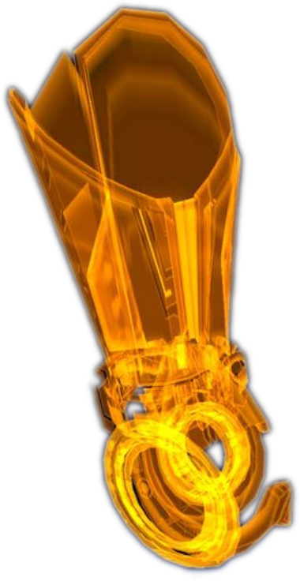

Standard Omni-Tool Software
Each omni-tool contains a standard set of modules and software for various utility functions.
Basic Decryption Module – This software allows omni-tool users to use their decryption skill against encrypted items.
Basic Hacking Module – This software allows omni-tool users to use their hacking skill against technology-based items.
Basic Repair Module – This software allows omni-tool users to perform basic repairs to weapons, armor, and equipment. This does not allow for repair of spacecraft.
Field Analyzer and Functional Adjustment Module – This allows omni-tool users to analyze weapons and armor from a distance and perform remote adjustments to equipment
Fabrication Module – This software allows omni-tool users to rapidly assemble small 3d objects from common, reusable industrial plastics, ceramics, and light alloys. Used for field repairs and modifications to most standard items.
Universal Translator – This software allows omni-tool users to translate any known language to their native language.
Basic Navigation Module – This software allows omni-tool users to access both terrestrial and star maps. It comes preloaded with many star charts and planet maps.
Pop-Up Holographic Screen – This allows the omni-tool user to access the Galactic Extranet for listening and watching media.
Flashlight – This is a built-in flashlight.
Solitaire – This software allows the omni-tool user to play solitaire.

Optional Omni-Tool Software
Alliance Corsair – This game can be installed on your omni-tool. In this game, you are a privateer working for the alliance. The battles are very realistic. (See Alliance Corsair organization entry for details)
Galaxy of Fantasy – This is an online multiplayer role playing game with over 11 billion players. The game is based on Turian mythology. This is too large to install on standard omni-tools, so it requires a terminal for installation. Your omni-tool can be used as the game’s controller.
Grim Terminus Alliance – This game allows you to capture and beat slaves. It is highly controversial and many complaints have been filed.
Third Coil – An extranet game that’s often in the news, but few people play it.
Skyllian-Five – Skyllian-Five is a card game similar to poker.

Omni-Tool Upgrades
Table 15. Omni-Tool Upgrades
Omni-Tool Upgrade | Cost | Benefit
Computer Systems Interface I |  | Gains Use Computer equipment bonus of +1
Computer Systems Interface II |  | Gains Use Computer equipment bonus of +2
Computer Systems Interface III |  | Gains Use Computer equipment bonus of +3
Shield Regen Optimization I |  | Increase shield regeneration rate to 50%
Shield Regen Optimization II |  | Increase shield regeneration rate to 75%
Shield Regen Optimization III |  | Increase shield regeneration rate by 100%
Shield Battery Extension I |  | +5 SP
Shield Battery Extension II |  | + 10 SP
Shield Battery Extension III |  | +15 SP
Advanced Systems Hacking I |  | +3 equipment bonus with Use Computer skill check for hacking
Advanced Systems Hacking II |  | +4 equipment bonus with Use Computer skill check for hacking
Advanced Systems Hacking II |  | +5 equipment bonus with Use Computer skill check for hacking
Advanced Cipher I |  | +3 equipment bonus with Use Computer skill check for decryption
Advanced Cipher II |  | +4 equipment bonus with Use Computer skill check for decryption
Advanced Cipher III |  | +5 equipment bonus with Use Computer skill check for decryption
Power Surge I |  | Free Action Point Given (Power)
Electrical Surge II |  | Free Action Point Given
Combat Sensor I |  | Detects organics and synthetics within 10 sq,  DC 5 +Use Tech Skill vs Jamming
Combat Sensor II |  | Detects organics and synthetics within 20 sq,  DC 10 + Use Tech Skill vs Jamming
Combat Sensor III |  | Detects organics and synthetics within 30 sq,  DC 15 + Use Tech Skill vs Jamming

Omni-Tool Upgrade Modules
Computer Systems Interface – This upgrade provides additional processors and optimizations to aid with interacting with computer systems.
Shield Regeneration Optimization– The shield regeneration optimization software provides additional computing power to optimization power output and regenerate shields during combat.
Shield Battery Extension – This upgrade provides additional shielding to increase overall shield protection.
Advanced Systems Hacking – This upgrade provides additional processors and optimizations to aid with hacking into computer systems and networks.
Advanced Cipher – This upgrade provides additional processors and optimizations to aid with encryption and decryption algorithms and processing.
Power Surge – Omni-Tools equipped with power surge modules gives the operator an addition energy surge available once per encounter. A Power Surge upgrade can only be allocated to a single tech power per installation.
Electrical Surge – Omni-Tools equipped with electrical surge modules gives the operator an addition energy surge available once per encounter.
Combat Sensor – This allows the omni-tool user to scan the local area to provide a localized map with friend/foe tagging capability. The sensors are vulnerable to sensor jamming technology.

Biotic Amplifiers

Base Biotic Amplifiers
Table 16. Biotic Amps
Biotic Amp | Cost | Benefits | Upgrade Slots
Biotic Amp I |  |  | 1 Upgrade Slots
Biotic Amp II |  |  | 2 Upgrade Slot
Biotic Amp III |  |  | 3 Upgrade Slots

Biotics manipulate mass effect fields using dozens of element zero nodules within their nervous system that react to electric stimuli from the brain. Bio-amps allow biotics to synchronize the nodules so they can form fields large and strong enough for practical use. Amplifiers can improve a specific discipline or power.
Biotic Amplifiers are often called “Bio-Amps” or “Biotic-Amps.”

Building Your Biotic Amp
You may purchase a basic weapon and upgrade it, if there are available upgrade slots.
- Select the biotic amp base
- Optionally, add upgrades if available upgrade slots

Biotic Amplifier Upgrades
Bio-Amp Upgrade | Cost | Benefit
Power Booster I |  | Increases Use Biotics (Power) by +1
Power Booster II |  | Increases Use Biotics (Power) by +2
Power Booster III |  | Increases Use Biotics (Power) by +3
Power Stim I |  | Decreases Cool down (Power) by -1
Power Stim II |  | Decreases Cool down (Power) by -2
Power Stim III |  | Decreases Cool down (Power) by -3
Power Action I |  | Free Action Point Given (Power)
Biotic Booster I |  | Increases Use Biotics by +1
Biotic Booster II |  | Increases Use Biotics by +2
Biotic Booster III |  | Increases Use Biotics by +3
Biotic Stim I |  | Decreases Cool down by -1
Biotic Stim II |  | Decreases Cool down by -2
Biotic Stim III |  | Decreases Cool down by -3
Biotic Action I |  | Free Action Point Given

Power Booster – Biotic Amplifiers equipped with power booster modules releases targeted shots of element zero to increase power effects. A Power Booster upgrade can only be allocated to a single biotic power per installation.
Power Stimulant – Biotic Amplifiers equipped with stim packs releases targeted shots of adrenaline to speed up recovery and recharge times. A Power Stimulant upgrade can only be allocated to a single biotic power per installation.
Power Action – Biotic Amplifiers equipped with action modules gives the operator an addition energy surge available once per encounter. A Power Action upgrade can only be allocated to a single biotic power per installation.
Biotic Booster – Biotic Amplifiers equipped with biotic booster modules releases targeted shots of element zero to increase power effects.
Biotic Stimulant – Biotic Amplifiers equipped with stim packs releases targeted shots of adrenaline to speed up recovery and recharge times.
Biotic Action – Biotic Amplifiers equipped with action modules gives the operator an addition energy surge available once per encounter.

Biotic Implants
Table 17. Biotic Implants
Implant | Cost | Benefit
Biotic L1 | 5,000 | Adds Use Biotics as trained skill
Biotic L2 | Unavailable | Adds Use Biotics as trained skill, Add +1d6 to each Use Biotics roll, See L2 Flaws
Biotic L3 | 15,000 | Adds Use Biotics as trained skill, +3 to Use Biotics roll
Biotic L3-R | 75,000 | Adds Use Biotics as trained skill, +3 to Use Biotics roll
Biotic L4 | 250,000 | Adds Use Biotics as trained skill , +5 to Use Biotics roll
Biotic L5X | 250,000 | Adds Use Biotics as trained skill, +3 to Use Biotics Roll, +5 for the Biotic talents of Kinetics, Biotic Barrier, and Biotic Shield
Biotic L5N | 250,000 | Adds Use Biotics as trained skill, +5 for the Biotic talents of Warp, Shockwave, Charge

An implant is surgically-embedded interface port into which amps are "plugged in". They are also known as 'wetware' because of their cybernetic nature. In humans, the implant is usually placed at the base of the skull for convenient access, though the user must be careful to keep it free of contaminants.
Implant ports can fit a variety of amps, and there is a growing market for modifications and add-ons. The finest quality implants and amps are manufactured by asari artisans, but the Alliance's L3 implants - first deployed in 2170 - are a significant step forward.
You can only have one Biotic Amp installed. Cool down timers may never be dropped below 1 Round. Amps that include a (Power) indicate a specific power of the user or designer of the Amp’s choice.
If the character wishes to upgrade implants, they must choose a retrofit implant since the cost to remove and replace implants is significantly more expensive and surgery is more dangerous.

L1 Implant
These biotics can manipulate small objects but aren't strong enough to be offensively viable, because the L1s were implanted after puberty.
Details: Adds Use Biotics as a trained skill.
Prerequisites: Biotic Feat

L2 Implant
The L2 implants were first implemented in 2167. The results vary wildly - some L2s are hardly stronger than an L1, others are strong but unstable, while a few are powerful and stable, but suffer discomfort from their implants. L2s are all around the same age.
Details: Adds Use Biotics as a trained skill. Add +1d6 to each Use Biotics roll. A natural “1” roll on Use Biotics causes 1d8 HP damage and forces an Endurance check vs. Will. Failure immediately causes the user to drop into a coma for 1d4 days and gives a -5 to Use Biotics for 1d4 days after waking from the coma. The L2 implant requires the user to take a L2 Implant flaw at no benefit. It also opens all L2 Implant flaws that can be taken as desired.
Prerequisites: Biotic Feat

L3 Implant
In 2170, the L3 implant was developed. L3 biotics are consistently stable with moderate ability; while their upper limit is less than an L2, L3s are safe from dangerous side effects. Because of the implementation date, most L3s are 25 or younger. Some are older, having been implanted later in life.
Details: Adds Use Biotics as a trained skill. The L3 Implant adds +3 to each Use Biotics roll.
Prerequisites: Biotic Feat

L3-R Implant
Short for 'L3-retrofit', this is an L1 or L2 who has undergone extremely dangerous brain surgery to replace their implant with a newer model.
Details: Adds Use Biotics as a trained skill. The L3 Implant adds +3 to each Use Biotics roll. The L3-R Implant opens all L3-R Implant flaws up for use.
Prerequisites: Biotic Feat

L4 Implant
A new implant used on the children in the Ascension Project; these implants use biotic amplifiers with inbuilt VI interfaces to allow for monitoring and improved performance. L4 implants give about a 10-15% increase in biotic ability in 90% of subjects, compared to L3s, with no currently known side effects.
Details: Adds Use Biotics as a trained skill. This implant adds +5 to each Use Biotics roll. The L4 Implant contains a VI interfaces that can be linked to a VI that adds additional benefits, which is based on the VI.
Prerequisites: Biotic Feat, character access to Implant.

L5x Implant
One of the newest Implants that specifically targets various Biotic talents.
Details: Adds Use Biotics as a trained skill. This implant adds a general +3 to each Use Biotics Roll, however, it adds +5 for the Biotic talents of Kinetics, Biotic Barrier, and Biotic Shield.
Prerequisites: Biotic Feat, character access to Implant.

L5n Implant
One of the newest Implants that specifically targets various Biotic talents.
Details: Adds Use Biotics as a trained skill. This implant adds a general +3 to each Use Biotics Roll, however, it adds +5 for the Biotic talents of Warp, Shockwave, and Charge.
Prerequisites: Biotic Feat, character access to Implant.

General Equipment
Table 18. General Equipment
Item | Cost | Benefit
Binoculars |  | Increase range of vision
Holo-journal |  | Video journal in holograph format. Records journal entries.
Medi-Gel |  | Restores 1d4 hit points.
Medical Kit |  | Carries maximum of ten (10) medi-gel
Omni-Gel |  | Repair vehicles, decryption, etc.
Shadow Cloak I | 5,000 | Provides +5 circumstantial bonus to stealth
Shadow Cloak II | 10,000 | Provides +10 circumstantial bonus to stealth
Technician Kit |  | Carries maximum of five (5) upgrades (weapon, armor, omni-tool) in OSD format
Universal Translator |  | Provides understanding of languages
Wetware Kit |  | Carries maximum of five (5) bio-amp upgrades

Binoculars

Holo-journal

Medi-gel
Medi-gel (medical gel) is a common medicinal salve used by paramedics, EMTs, and military personnel. It combines several useful applications: a local anesthetic, disinfectant, and clotting agent all in one. Once applied, the gel is designed to grip tight to flesh until subjected to a frequency of ultrasound. It is sealable against liquids – most notably blood – as well as contaminants and gases.

Omni-gel
Omni-gel is a technological material that can be obtained by breaking down unwanted items, such as weapons, armor, and upgrades. Doing so will usually give you 4 omni-gel per item. It is designed for use with omni-tools to do electronics or decryption work. Omni-gel can also be used to repair vehicles, though doing so requires the vehicle to be temporarily off-line.
Omni-gel is composed of common, reusable industrial plastics, ceramics, and light alloys kept in a semi-molten state. Being able to render non-essential upgrades and weapons into omni-gel allows them to remain useful while reducing weight.

Medical Kit
Medical kits carry a limited number of medi-gel. Medi-gel can be applied directly to the wound or inserted into the target’s armor’s medi-gel reserves.

Shadow Cloak
A shadow cloak is a personal item that allows the user to blend into nearby environments without being seen.

Technician Kit
Technician kits carry a limited number of weapon, armor, and grenade upgrades. Usually a soldier will carry at least one technician kit with a variety of ammunition upgrades.
These kits are also used to carry decryption devices that allow hacking of systems. Technical skilled characters usually carry a second kit that contains their hacking items.

Universal Translator
Nearly every citizen in the galaxy has some form of universal translator. While there is a common “trade” language, many prefer to just use the universal translator. The universal translator may be purchased as a clip-on, ear piece, jewelry, headset, omni-tool software, or rarely implanted into the wearer’s brain via surgery.

Wetware Kit
Wetware kits carry a limited number of bio-amp upgrades. Usually a biotic will carry at least one wetware kit with a variety of upgrades.

Miscellaneous Items
Fornax is a “titillating alien magazine” that can be found in various markets.
Serrice Ice Brandy is a relativity expensive drink.
Skyllian-Five is a card game similar to poker.

New Special Materials

Element Zero
Element zero (Atomic Number 0, Chemical Symbol Ez), also known as 'eezo', is a substance that, when subjected to an electrical current, releases dark energy which can be manipulated into a mass effect field, raising or lowering the mass of all objects within that field. A positive current increases mass, a negative current decreases it. This 'mass effect' is used in countless ways, from generating artificial gravity to manufacturing high-strength construction materials. It is most prominently used to enable faster-than-light space travel. When humans discovered the Prothean ruins on Mars, they also discovered refined element zero that the Protheans had left behind. It enabled research into FTL ship drives before the Charon Relay was discovered.
Eezo is generated when solid matter, such as a planet, is affected by the energy of a star going supernova. The material is common in the asteroid debris that orbits neutron stars and pulsars. These are dangerous places to mine, requiring extensive use of robotics, telepresence, and shielding to survive the intense radiation from the dead star. Only a few major corporations can afford the set-up costs required to work these primary sources. Some planets have small eezo deposits or coalesced around a larger deposit during their formation. While these secondary sources are safer to mine, the yield from the ore is not as large. There are rumors that the Nemean Abyss has particularly rich eezo deposits.
Dust-form element zero is often released after engine accidents. It is used by many species to influence or strengthen the presence of biotics. If a child is exposed to dust-form element zero in utero, due to its mutagenic effects, there is a small chance they can develop eezo nodules throughout their nervous system that react to electrical stimuli from the brain. This allows them to use biotic abilities, but many exposures have no effect, or result in terminal cancer. There is some question about just how 'accidental' some of those initial exposures were, after the link between eezo and biotics was established.
Element zero forms the basis of many advanced medicines throughout Citadel space. The biotic drug 'red sand' allegedly has element zero as its base - according to urban legend, it was created by criminal triads on Mars from the eezo samples recovered there. The Normandy's massive Tantalus drive core cost 120 billion credits because of the amount of element zero needed to power the stealth system.

Narcotics

Hallex
Hallex is a drug taken in pill form.

Red Sand
Red sand is a stimulant with biotic-enhancing properties. Its abuse is disproportionately high among non-biotic friends and relatives of biotics, often out of a misguided desire to understand what their loved ones are experiencing. Red sand was originally created by criminal triads on Mars from refined element zero, and may take its name from the planet. As eezo is also used to create medicines, red sand's creation may have been a 'fortunate' lab mistake.
When taken nasally, red sand creates a brief but intense euphoria, and gives the user very short-term telekinetic biotic abilities. Side effects include red-tinting of the user's vision, discoloration of the teeth and longer-term withdrawal symptoms. Red sand is normally sold in small bags. The slang expression for using it is "dusting up" or being "sand-blasted".
On Illium, it is legal to sell red sand as long as the vendor has a permit.

Starships

Frigates
Small, fast ships used for patrolling and for screening larger vessels. On their own, frigates do not pack much of a punch, but when operating in "wolf-pack flotillas", they can often overwhelm larger vessels. In the human fleet, frigates are named after battles. An example of an Alliance Frigate is the SSV Normandy.

Cruisers
Middle-weight combatants, faster than dreadnoughts, and more heavily-armed then frigates. Cruisers are the standard patrol unit, and often lead frigate flotillas. In the human fleet, cruisers are named after cities. An example of an Alliance Cruiser is SSV New Delhi.

Dreadnoughts
Kilometer-long capital ships mounting heavy, long-range firepower. They are only deployed for the most vital missions. Treaties stipulate the amount of dreadnoughts a navy may own, with the turian peacekeeping fleet being allowed the most. An example of an Asari Dreadnought is the Destiny Ascension – flagship of the Citadel Council.

Carriers
Dreadnought-sized vessels that also carry a large amount of fighters.

Small military vessels
Smaller vessels are exclusively used in a support role to the warships during combat:
Fighters are one-man craft used to perform close-range attacks on enemy ships.
Interceptors are one-man craft optimized for destroying opposing fighters.
UT-47 Kodiak “Drop Shuttle” landing craft holds 12 soldiers in a cramped, uncomfortable cargo bay and two more in the cockpit. Officially named the Kodiak, the drop-shuttle is better known to Alliance marines as the “combat cockroach” due to its appearance and durability.
A-61 Mantis Gunship is a workhorse of mercenary bands throughout the galaxy. The Mantis is a two-man, vectored thrust aircraft that excels in close air support roles.

Freighters
Kowloon-class vessels are basic freighter starships originally designed (and mostly used by) humans. Each ship is built on a standard design, likely for easy mass production. They generally carry a large cargo bay with smaller compartments for additional passenger haulage, but their design means these compartments can be swapped or exchanged to customize the ship. For example, the MSV Fedele exchanged passenger compartments for specialist biological research modules.
Kowloon-class ships are hardy but carry no armaments and only a standard engine core. Unfortunately this makes them easy prey for privateers or mercenary bands looking for a quick score. Most are given the prefix 'MSV', likely for 'merchant space vehicle'.
The Athabasca Class is a class of large freighter of human origin. Externally, this freighter class's configuration may be mistaken for the smaller Kowloon Class freighters. However, the Athabasca Class freighter is a multi-level voluminous starship. The Athabasca Class freighter is lightly armored and lacks armaments, and can be attacked and boarded very quickly. This freighter class is equipped with a self-destruct device and a black box.
Unlike the smaller Kowloon Class freighters, the internal arrangement of Athabasca Class freighters differs from ship to ship. The freighter's bridge is located on the upper level and is positioned forward of the engine core and cargo holds. This engine core is a two level room housing four reactors and an engineering console. Access to the ship's interior is through airlocks and an emergency airlock located in the main cargo hold.

Chapter 7: Combat

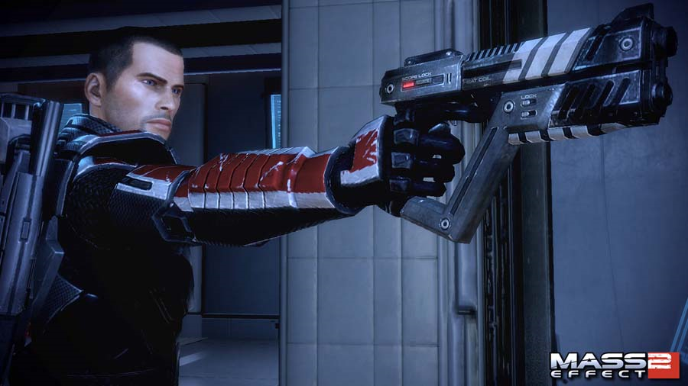

Attacking
If the attack matches or exceeds the defenders REF then it is a hit. Damage is applied to shields first; biotic barriers second, armor third, and hit points last.
Example: Tali has the following defensive traits: Ref: 16, SP/BB/AP/HP: 30/0/10/14.
Tali takes a shot from an assault rifle that equals 26 damage. After being hit, her defensive traits are:
SP/BB/AP/HP: 4/0/10/14.
If she is hit again for 10 points of damage, her defensive traits are: 0/0/4/14, and so on.

Melee Attacks
Melee combat bypasses shields and biotic barriers

Bypassing Shields and Barriers
Some attacks, such as attacks from Thresher Maws, bypass the player’s shields and barriers.
Some weapon ammunition upgrades also provide ways of bypassing shields and barriers.

Shield Recharge
If your shields are reduced to one-half max or less, you can repower them as a swift action. This action regenerations one-quarter of your full shield point total (rounded up). You can Shield Recharge only once per encounter. Certain feats or talents may allow you to shield recharge more often.

Only heroic characters can shield recharge; non heroic characters, creatures, objects, devices, and vehicles cannot. Exception: A nonheroic character that takes the Extra Shield Recharge feat can shield recharge once per encounter.
Table 19. Combat Powers versus Defenses
Combat Power | Versus Biotic Barrier/Shield | Versus  Shields | Versus Synthetic/Armor | Versus Organic/Flesh
Ranged Weapon, Standard Ammo | Normal | Normal | Normal | Normal
Ranged Weapon, Shredder Ammo | Normal | Normal | Normal | Extra Damage
Ranged Weapon, Tungsten Ammo | Normal | Normal | Extra Damage | Normal
Ranged Weapon, Proton Ammo | By passes | By passes | Less | Less
Melee Weapon | By passes | By passes | Normal | Normal
Biotics, Charge | Cannot pass | Cannot pass | Normal | Normal
Biotics, Kinetics | Normal | Normal | Normal | Normal
Biotics, Reave | Normal | Normal | Normal | Normal  + HP Transfer
Biotics, Shockwave | Cannot pass | Cannot pass | Normal | Normal
Biotics, Singularity | Normal | Normal | Normal | Normal
Biotics, Statsis | Normal | Normal | Normal | Normal
Biotics, Warp | Normal | Cannot pass | Normal | Normal
Biotics, Weakening Reave | Normal | Normal | Normal | Normal
Tech, Cryo Blast | Cannot pass | Cannot pass | Normal | Normal
Tech, Inciniterate | Normal | Normal | Extra Damage x2.4 | Normal
Tech, Overload | N/A | Normal | Normal | N/A
Creature, Thresher Maw | By passes | By passes | Normal | Normal

Chapter 8: Organizations

Humanity-Based Organizations

Cerberus
Immediately following the First Contact War, an anonymous extranet manifesto warned that an alien attempt at human genocide was inevitable. The manifesto called for an army - a Cerberus to guard against invasion through the Charon Relay.
Derided as "survivalist rhetoric written by an illusive man", the manifesto and its anonymous author soon fell off the media radar. But in 2165, terrorists stole antimatter from the SSV Geneva, the sole figure arrested named his sponsor "Cerberus". Throughout the 2160s and 2170s, alleged Cerberus agents assassinated politicians, sabotaged starships bearing eezo, and conducted nightmarish experiments on aliens and humans. Denounced as human-supremacist, Cerberus calls itself human-survivalist.
Counter terror experts speculate Cerberus may have changed leadership with it recent shift to stockpiling ships, agents, and weapons. The Illusive Man hides his finances behind shell companies. Few doubt he will kill anyone attempting to expose him.

Cerberus: The Illusive Man
The reclusive tycoon calling himself the Illusive Man is a human nationalist focused on advancing human interests, whatever the cost to non-humans. The Citadel Council regards him as a fanatic posing a serious threat to galactic security.
A mysterious maverick to say the least, the Illusive Man heads the Cerberus network. Dubbed "the Illusive Man" by investigators, Cerberus is an allegedly untraceable syndicate of private intelligence agencies, biotics laboratories, engineering and scientific research teams, and lucrative front companies.
Branded a terrorist and seditionist organization by authorities, Cerberus is the only human power base other than the Terra Firma Party strong enough to embarrass - if not threaten - the Council and its human representatives.

Systems Alliance
The Systems Alliance is an independent supranational government representing the interests of humanity as a whole. The Alliance is responsible for the governance and defense of all extra-solar colonies and stations.
The Alliance grew out of the various nation space programs as a matter of practicality. Sol's planets had been explored and exploited through piecemeal nation efforts. The expense of colonizing entire new solar systems could not be met by any one country. With humans knowing that alien contact was inevitable, there was enough political will to jointly fund an international effort.
Still, the Alliance was often disregarded by those on Earth until the First Contact War. While the national governments dithered and bickered over who should lead the effort to liberate Shanxi, the Alliance fleet struck decisively. Post-War public approval gave the Alliance the credibility to establish its own Parliament and become the galactic face of humanity.
The Alliance military is of great concern to the galaxy. At first contact with the turians, they were completely inexperienced. Turian disdain turned to respect after the relief of Shanxi, where the humans surprised them with novel technologies and tactics.
The human devotion to understanding and adapting to modern space warfare stunned the staid Council races. For hundreds of years, they had lived behind the secure walls of long-proven technology and tactics. The Council regards the Alliance as a "sleeping giant". Less than 3% of humans volunteer to serve in their military, a lower proportion than any other species.
While competent, Alliance soldiers are neither as professional as the turians nor as skilled as the asari. Their strengths lie in fire support, flexibility, and speed. They make up for lack of numbers with sophisticated technical support (V.I.s, drones, artillery, electronic warfare) and emphasis on mobility and individual initiative.
Their doctrine is not based on absorbing and dishing out heavy shocks like the turians and krogan. Rather, they bypass enemy strong points and launch deep into their rear, cutting supply lines and destroying headquarters and support units, leaving enemies to "wither on the vine".
On defensive, the human military is a rapid reaction force that lives by Sun Tzu's maxim, "He who tries to defend everything defends nothing." Garrisons are intended for scouting rather than combat, avoiding engagement to observe and report on invaders using drones.
The token garrisons of human colonies make it easy for alien powers to secure them, for which the Alliance media criticizes the military. However, the powerful fleets stationed at phase gate nexuses such as Arcturus are just a few hours or days from any colony within their sphere of responsibility. In the event of an attack, they respond with an overwhelming force.

Systems Alliance: Military Jargon
- ashore - When a ship's crew leaves the vessel, they are "ashore". Though normally used regarding planets, it can refer to boarding a space station.
- aweigh - When a ship releases the equipment tethering it to a space station or surface dock, it is "aweigh".
- aye, aye - The proper way to acknowledge an order. If told to attack the correct response is "Aye, aye, sir." If asked "Are you proud to be a marine?" the correct response is "Yes, sir."
- ASAP - Pronounced "a-sap", an acronym of "as soon as possible".
- belay - Stop, cease.
- bridge - The navigation center of a spacecraft, where the steering is done.
- captain's mast - Non-judicial disciplinary proceedings by unit commanders.
- CIC - Combat Information Center, the command center of a spacecraft. The CIC is filled with sensor displays to make sense out of the chaos of combat.
- DC - Damage Control. The containment and repair of damage to a spacecraft.
- ECM - Electronic Counter-Measures used to avoid enemy sensors, from passive emissions masking to active jamming.
- EVA - Extra-Vehicular Activity. Time spent in a pressure suit, outside of a vehicle, spacecraft, or station.
- flank - The flank is the "side" of a military formation. Since the soldiers are facing elsewhere, an enemy that can attack on the flank can often "turn it" or "roll it up".
- FNG - "Freaking" New Guy(s). A derisive term for inexperienced personnel.
- groundside - The surface of a planet.
- helmsman - The crewmember who pilots the spacecraft.
- ladar - Light-amplified detection and ranging. An active sensor that bounces lasers off an object to determine its bearing and distance. Ladar has sufficient resolution that the data can be reconstructed into an image.
- shore party - Spacecraft's crew sent ashore on official business.
- silent running - An old submariner's term used aboard the Normandy to denote when stealth systems are active.
- sitrep - Abbreviation of "situation report", an evaluation of the current military situation.
- spacer - Someone who has spent most of their life in space.
- XO - Executive Officer, the second-in-command of an Alliance warship. The XO is responsible for administrative and personnel matters.

Systems Alliance: Military Ranks
The Alliance uses a modified version of the ranking system that has been used for hundreds of years. Soldiers are classified into rank-and-file enlisted personal, experienced non-commissioned officers (NCOs), and specially trained officers.
The divide between naval personnel and ground forces ("marines") is small. Ground units are a specialized branch of the fleet, just as fighter squadrons are. This unity of command is imposed by the futility of fighting without control of orbit; without the navy, any army is pointless. The marines, as a matter of pride, maintain some of their traditional rank titles; for example, marines have Privates and Corporals instead of Servicemen.
In ascending order of responsibility, the ranks of the Alliance are:

ENLISTED
- Serviceman 3rd Class/Private 2nd Class
- Serviceman 2nd Class/Private 1st Class
- Serviceman 1st Class/Corporal

NCOs
- Service Chief
- Gunnery Chief
- Operations Chief

Officers
- 2nd Lieutenant
- 1st Lieutenant
- Staff Lieutenant
- Lieutenant Commander
- Staff Commander
- Captain/Major
- Rear Admiral/General
- Admiral
- Fleet Admiral

Systems Alliance: Corsairs
A Corsair is an independent starship captain recruited as an Alliance operative to conduct autonomous missions. Such operatives were often granted considerable liberty and autonomy, in order to facilitate efficient operation, though it was noted that even they were subjected to bureaucracy that impeded them.

Systems Alliance: Geological Survey
As the human race expands its territory and raises the general standard of living, demand for industrial resources continues to grow. Many planets, moons and asteroids contain a wealth of resources, but many systems have been barely charted, let alone thoroughly surveyed. Unmanned probes are one solution, but they are often lost to space hazards, unforeseen circumstances, or theft by salvagers.
In recent years, AGeS, the Alliance Geological Service, has offered bounties to private individuals or teams willing to perform mineralogical surveys on the frontier. This survey data is made publicly available to further corporate development. Due to the cost of travel and the dangers of operating on hostile worlds, it is rarely a profitable endeavor.
LIGHT METALS - Metals with low atomic weight are often used in the construction of spacecraft and vehicles.
HEAVY METALS - Metals with higher atomic weights are used to construct equipment components. The platinum group elements are particularly useful.
RARE EARTHS - Most useful in this category are radioactive or magnets.
GASSES - Various gasses are required to support all known forms of sapient life. Some are commonly used as fuel

Terra Firma Party
Terra Firma is an Alliance political party formed after the First Contact War. Its policy agenda is based on the principle that Earth must "stand firm" against influences. This covers a variety of legislation. Recent activities by Terra Firma include opposition to a law requiring high school alien language study, a proposal to increase tariffs on alien imports, and leading a popular movement to mark the First Contact War as a public holiday.
Though founded by well-meaning individuals who feared the submersion of native human cultures under a wave of "alien vogue", Terra Firma's agenda attracts many jingoists and xenophobes.

Citadel Based Organizations

Citadel Security (C-Sec)
Citadel Security is a volunteer police service answering to the Citadel Council. The 200,000 constables (as of 2183) of C-Sec are responsible for maintaining public order in the densely populated Citadel. They also provide pirate suppression, customs enforcements, and search-and-rescue- throughout the Citadel cluster.
C-Sec has six divisions:
ENFORCEMENT - Uniformed officers who patrol the Citadel and respond to emergencies.
INVESTIGATION - Detectives who puzzle out the truth behind crimes and bring perpetrators to justice.
CUSTOMS - Screen the thousands of passengers and cargo containers that pass through the Citadel's ports every day.
NETWORK - Deals with "cybercrimes" like identify and copyright theft, hacking and viral attacks, and illegal artificial intelligence.
SPECIAL RESPONSE - Deals with hostage situations, bombs, and heavily armed criminals. In the unlikely event that attackers board the Citadel, they are also the front line of defense, armored with military grade equipment.
PATROL - Naval arm, with ships stationed throughout the Citadel cluster. Unlike the other divisions, they are rarely seen at the Citadel, nor do they stay in one place long.
Joining C-Sec is prestigious; applications must be sponsored by a Citadel Councilor or the ambassador of an associate Council race. Generally, applicants have many years of distinguished service in the military or police forces of their nations, but an inexperienced applicant with demonstrable talent will be fairly considered.

SPECTRES
Spectres are agents from the Office of Special Tactics and Reconnaissance and answer only to the Citadel Council. They are elite military operatives, granted the authority to deal with threats to peace and stability in whatever way they deem necessary.
They operate independently or in groups of two or three. Some are empathetic peacekeepers, resolving disputes through diplomacy. Others are cold-blooded assassins, ruthlessly dispatching problem individuals. All get the job done, one way or another, often operating outside of the bounds of galactic law.
The SPECTRES were founded after the salarians joined the Council. For many years, they operated in secrecy, as back-room 'problem solvers.' Only after the krogan Rebellions did their activities become publicized. Assignment of a SPECTRE is less contentious than military deployment, but makes it clear that the Council is concerned about a situation

Mercenaries

Mercenaries: Blue Suns
Founded by notorious batarian slaver Solem Dal'serah, the Blue Suns began as a Skyllian Verge protection racket providing genuine protection from slavers and pirates. Eventually captured by the Systems Alliance Navy, Dal'serah beat almost two dozen charges to be convicted on a single count of conspiracy. The slaver benefited from the tutelage of cellmate and brilliant con artist Bernard "Legits" Ledger. Upon release five years later, Del'serah incorporated Blue Suns as a legal security agency.
Today, the Blue Suns boast a galaxy-wide force of batarians, turians, humans, and krogan. Each deployment is backed by a logistics corps selling everything from heavy weapons to shaving cream. Despite claims that Blue Suns sell its captives as slaves, no Blue Suns employee has ever been convicted on such charges.
Many Blue Suns members sport the company logo in tattoo form, removed during assignments and reapplied at mission-end.

Mercenaries: Eclipse
Brainchild of asari commando Jona Sederis, Eclipse was incorporated as a "proactive" security company. Influenced by asari and salarian military doctrine, Eclipse specializes in sabotage, assassination, and personal and organizational security. Although Citadel governments regard the corporation with suspicion, it's embraced in the Skyllian Verge and Terminus Systems.
Early on, Sederis sought government contracts to establish market share against the better-established Blue Suns. Her agency scored a galactic PR coup by retaking several space stations captured by the Anhur People's Liberation Army and neutralizing its leaders, a victory Eclipse's marketing department never ceases trumpeting.
Based on Omega Station, Eclipse controls nearly 20% of the asteroid's real estate. Its services range from mech repair to open warfare, although assassination is reserved for meeting wider, longer-term company goals (for instance, preemptive strikes against pirates rather than murdering spouses for insurance money.) Despite numerous reports, Eclipse denies sabotaging or kidnapping business rivals.

Mercenaries: The Blood Pack
Originally a small Terminus Systems vorcha gang, the Blood Pack was transformed into a legion by visionary krogan battle master Ganar Wrang. Exiled for striking a female in anger, Wrang obsessed over reclaiming his lost status.
Leading the vorcha pack as a pirate crew, Wrang cultivated recruits and infamy for a decade before incorporating his fighters as a security company across the Skyllian Verge. His notoriety ensured his initial public offering for investors made him rich beyond most krogan's dreams, Wrang returned triumphantly to his clan, rallying elders, krogan hordes, and their firepower and biotic support toward professional violence in the Terminus Systems.
Banned from Citadel space, the Blood Pack bribes its way through spaceports into armed conflicts across the galaxy. Priding themselves for accepting otherwise untouchable contracts, the Blood Pack rejects body guarding and security in favor of cases requiring minimal oversight and maximal violence.

Other Organizations

Quarian Flotilla
Approximately three hundred years ago the quarians created the geth, a species of rudimentary artificial intelligence, to serve as an efficient source of manual labor. However, the geth rebelled against their quarian masters and drove them into exile. Now the quarians wander the galaxy in a flotilla of salvaged ships, secondhand vessels, and recycled technology. Other species tend to look down on the quarians, seeing them as scavengers and condemning them for unleashing a dangerous synthetic life form on the rest of the galaxy.

Chapter 9: Mass Effect Campaign

Timeline
1 – Rachni Wars begin.
80 – Salarians ‘transplant’ Krogan to Rachni planets.
300 – All rachni declared extinct. End of Rachni Wars.
700 – Krogans annex asari colony of Lusia. Krogan Rebellions begin.
800 – Krogan Rebellions end.
1895 - The Geth rebel against their Quarian masters. Geth War.
2069 - Armstrong Outpost at Shackleton Crater becomes the first human settlement on Luna. It is formally founded on July 24, the 100th anniversary of the first lunar landing.
2103 - Lowell City in Eos Chasma becomes the first human settlement on Mars.
2137 - Eldfell-Ashland Energy Corporation demonstrates helium-3 fuel extraction from the atmosphere of Saturn.
2142 - Construction of Gagarin Station (Jump Zero) begins beyond the orbit of Pluto.
2148 - Prospectors discover the Prothean ruins at Promethei Planum on Mars.
2149 - Translation of Prothean data leads humans to the Charon mass relay. Systems Alliance founded to coordinate exploration and colonization of extra-solar worlds.
2151 - A shipping accident at Singapore International Spaceport exposes downwind communities to containers of dust-form element zero. Alliance begins construction of Arcturus Station.
2152 - Roughly 30% of the children born in Singapore after element zero exposure suffer from cancerous growths. Systems Alliance begins settlement of Earth's first extra-solar colony world, the planet Demeter.
2155 - Systems Alliance occupies completed portions of Arcturus Station as a headquarters.
2156 - Some children of Singapore exhibit minor telekinetic abilities.
2157 - Turians encounter human explorers; First Contact War. Occupation and liberation of the human colony of Shanxi.
2158 - Humans learn potential of biotics. An international effort to track element zero exposures begin. Roughly 10% of exposed children show some sign of biotic ability.
2160 - Systems Alliance Parliament formed.
2165 - Humans establish embassy on Citadel.
2170 - Batarian slavers attack the Alliance colony Mindoir.
2176 - Skyllian Blitz- Pirates and slavers attacked Elysium, the human capital in the Skyllian Verge.
2177 - Thresher maws devour the Alliance colony of Akuze.
2178 - In retaliation for the Skyllian Blitz, an Alliance fleet wipes out an army of slavers on the moon of Torfan.
2183 - Current date.( Mass Effect 1)
2183 - Geth led by rogue Spectre Saren Arterius attack the Citadel, ensuing in a battle that cost thousands of lives. A few weeks later, the SSV Normandy is ambushed and destroyed. Commander Shepard is presumed dead.
2185 - Current date. (Mass Effect 2)

Eras

Rachni Wars
The Rachni Wars were a series of conflicts beginning in around 1 CE, when an expedition from the Citadel races activated a dormant mass relay. This relay opened a route to territory controlled by the rachni, a species of highly intelligent space-faring hive-minded insects. The rachni were alarmingly powerful, having massive strength in numbers, and extremely hostile. Negotiation with the rachni was impossible; their leaders, the rachni queens, dwelt in deep underground nests, on worlds so hostile no one could survive them.
This period saw the Citadel races fight a losing war against the rachni for nearly a century until the salarians "culturally uplifted" a new species, the krogan. The volatile krogan home world, Tuchanka, had been ravaged by a nuclear winter caused by a krogan civil war. The salarians helped the krogan by giving them advanced technology and relocating them to a planet not cursed with lethal levels of radiation, toxins or deadly predators.
The true purpose of this salarian altruism soon emerged; the krogan were needed in the Rachni Wars as reinforcements. Unlike most Citadel species, the krogan had an extremely rapid breeding cycle. They had not only the numbers to drive the advancing rachni back, but the ability to endure the harsh conditions of the rachni planets. The krogan pursued the rachni to their home worlds, descended deep underground to find the rachni queens, and systematically destroyed both the queens and their eggs. The Citadel Council would normally have objected to such total destruction, but after centuries of relentless war, complete eradication of the rachni seemed the only possible solution.
In 300 CE, the rachni were declared extinct, bringing the Rachni Wars to an end.

Krogan Rebellions
The 'Krogan Rebellions' is the collective name for three hundred years of aggressive expansion and population growth by the krogan. During this time they forced out other races from their worlds, sustaining massive casualties in the process.
The Rebellions were actually a result of altruism by the Citadel races. After the Rachni Wars, when the krogan were hailed as saviors of the galaxy, they were given the conquered rachni planets along with other colonies in gratitude for their help. However, due to the harsh conditions of their home world Tuchanka, krogan birth rates were quite high in order to sustain their numbers. When they spread onto other planets, their naturally swift breeding cycle and lack of sufficient predators resulted in krogan spreading throughout the galaxy like a plague.
The Council became concerned in around 700 CE, when the krogan began to annex territory from other Citadel races. The krogan became more aggressive as other species tried to protect their worlds, until the krogan began to settle the asari colony of Lusia. When told to leave, the krogan refused. Their ambassador, Overlord Kredak, stormed out of the audience with the Council, daring them to take their worlds back. War broke out soon afterwards.
But the Council had taken precautions. The finest STG operators and asari huntresses had been drafted into a covert 'observation force', the Office of Special Tactics and Reconnaissance. The Spectres opened the war with crippling strategic strikes. Krogan planets went dark as computer viruses flooded the extranet. Sabotaged antimatter refineries disappeared in blue-white annihilation. Headquarters stations shattered into orbit-clogging debris, rammed by pre-placed suicide freighters. But unlike the Citadel races, the krogan could replenish their numbers very easily and a krogan victory began to seem inevitable.
Finally the Council turned to the turians, newcomers on the Citadel who had a massive fleet and a militaristic culture. Establishing hidden command centers, like Pinnacle Station, turians were able to defeat many krogan bands. But the krogan responded with characteristically horrific attacks on turian worlds, using asteroids as weapons and rendering three planets totally uninhabitable.
Unfortunately this was exactly the wrong approach to take with the turians. Turian military doctrine was (and remains) not simply to defeat an enemy, but stop them from ever becoming a threat again. Far from turning turian public opinion against the war, the ferocity of the krogan only served to stiffen their enemy's resolve and unite every turian against them.
Seeing that the krogan did not generally surrender upon a defeat, and understanding the krogan could effectively call upon limitless reinforcements, the turians contacted the salarians, who had engineered a powerful bio-weapon called the genophage. This was intended to produce a genetic mutation in krogan that could result in only one in one thousand krogan births being a success.
The salarians had never intended to use the genophage and planned to use it as a deterrent. But once the turians received the genophage, they deployed it, and krogan numbers began to dwindle. Coupled with a renewed military push from the turians, the krogan soon realized their position was hopeless. Without hundreds of krogan offspring being produced at one time, they could not hope to stand against the turians. A female krogan warlord, Shiagur, actually used her rare fertility to draw the strongest males to her army, but even she couldn't hold out against turian peacekeeping forces.
Finally, besieged on all sides and knowing the survival of their species was at stake, the krogan surrendered. That was not the end of hostilities, as many rogue warlord and insurgents refused to surrender, and had to be wiped out by turian task forces. Some even vanished into frontier systems to become pirates.
The krogan are deeply bitter about the outcome of the Rebellions. As Wrex puts it, "to thank us for wiping out the rachni they neutered us all." In the aftermath of the Rebellions, there was a movement on the Citadel to have the Krogan Monument removed from the Presidium, but the Council refused. The Rebellions didn't change the fact that the krogan had destroyed a galactic menace during the Rachni Wars, though they had become a menace in turn.

Geth War
The quarians created the geth, intended to be a source of cheap labor. The quarians notice geth showing signs of self awareness, and plan to destroy them before they become a menace.
In 1895, the geth rebel against their quarian masters and, in the resulting war, reduce the quarians to a species of space faring nomads aboard the Migrant Fleet. Contrary to expectations, the geth do not venture outside the former quarian star systems, instead isolating themselves from the rest of the galaxy behind the Perseus Veil. In punishment for their actions, the Citadel Council closes the quarian embassy on the Citadel.

First Contact War
Humanity's first contact with an alien race occurred in 2157. At that time, the Alliance allowed survey fleets to activate any dormant mass relays discovered, a practice considered dangerous and irresponsible by Council-aligned races. When a turian patrol discovered a human fleet attempting to activate a relay, they attacked. One human vessel survived, retreating to the colony of Shanxi.
The turians followed, quickly defeating the local forces. Shanxi was occupied, the first - and, to date, only - human world to be conquered by an alien species. The turians believed the handful of ships they defeated represented the bulk of human defenses. So they were unprepared when the Second Fleet under Admiral Kastanie Drescher, launched a strong counteroffensive, evicting them from Shanxi.
The turians mobilized for full-scale war, drawing the attention of the rest of the galaxy. The Council quickly intervened, forcing a truce. Fortunately for humanity, the First Contact War was ended with a diplomatic solution.

Pre-Citadel Attack

Post-Citadel Attack
If game begins after 2183 (end of ME1), the following decisions need to be made:
1. Did the council survive the attack on the Citadel?
2. Did Commander Shepard kill the Rachni Queen?

Index

A
Admiralty Board 23, 24
AI Hacking 56
Alliance Geological Service 92
Amonkira 15
Anhur People's Liberation Army 93
Arashu 15
Arcturus 4, 90, 95
Ardat-Yakshi 9
armor 1, 8, 11, 16, 33, 35, 50, 52, 53, 54, 88
Asari 3, 7, 8, 9, 10, 11
asari huntress 10
Athame 11
Attican Traverse 5
B
Base Attack Bonus 2
Batarian 3, 12, 13, 95
Battle Masters 19, 20
biotic 1, 5, 7, 8, 10, 11, 51, 52, 53, 54, 83, 88, 94, 95
biotic barrier 1, 52, 53, 54, 88
Biotic Barrier 50, 51, 82, 83
Biotic Reach 43
Biotic Regeneration 43, 44
Biotic Shield 51, 82, 83
Blood Pack 40, 94
Blue Suns 93
C
Cerberus 89
character races
Asari 7
Batarian 12
Drell 14
humans 4
Krogan 16
Quarian 21
Salarian 27
Turian 32
Volus 37
Vorcha 39
Charge 51, 52, 82, 83
Charon Relay 4, 89
Chora's Den 10
Citadel 3, 4, 5, 7, 10, 12, 13, 17, 18, 21, 22, 23, 27, 28, 29, 32, 34, 36, 37, 38, 92, 93, 94, 95, 98
Citadel Council 3, 5, 18, 28, 89, 92
Citadel Security See C-Sec
Combat Drone 56
cooldown 1, 43, 44, 53
Corsair 91
Critical hits 1
C-Sec 23, 32, 92
Cyro Blast 57
D
Dalatrass 28, 30
Damage 1, 52, 53, 54, 88, 90
Drell 3, 14, 15
E
Earth 4, 7, 10, 17, 22, 29, 33, 37, 38, 39, 89, 92, 95
Eclipse 93
eezo See Element Zero, See Element Zero
Eidetic Memory 3, 14
elcor 7, 27, 38
Elcor 3
Element Zero 43, 50, 85
Empowered 44
Enkindlers 15
F
First Contact War 4, 6, 32, 89, 92, 95, 97, 98
G
genophage 16, 17, 18, 19, 28, 32
Genophage 3, 16, 18
geth 20, 21, 22, 23, 24, 25, 94
H
Hanar 3, 14
Hit Points 1, 2, 16
Human 3, 4, 5
I
Illusive Man 89
Incinerate 58
Irune 37
K
Kahje 14, 15
Kalahira 15
keepers 7
Kepral's Syndrome 3, 14, 15
Khar'shan 12
Kinetics 1, 52, 82, 83
Krogan 3, 11, 16, 17, 18, 20, 30, 32, 36, 38
Krogan Rebellions 16, 18, 28, 38
L
L1 Implant 82
L2 Implant 82
L3 Implant 83
L3-R Implant 83
L4 Implant 83
L5n Implant 83
L5x Implant 83
League of One 28
Level Advancement 2
Lift 1
Lusia 18
M
Maiden stage 9
Mars 4, 95
mass relay 4, 7, 36, 97
Matriarch stage 9
Matron stage 9
Medi-gel 84
melding See Mind Melding
Migrant Fleet 21, 22, 23, 24, 25
Mind Meld 3, 7
N
Neural Shock 58
O
Omega 12, 29, 39, 93
Omni-gel 84
Overload 59
P
Palaven 32, 33, 36
Patavig 38
Pluto 4, 95
Prothean 4, 95
Q
Quarian 3, 21, 22, 26, 94
R
Race 2, 3
rachni 16, 17, 18, 28
Rachni Queen 98
Rachni Wars 16, 96
Rakhana 14
Rannoch 21
Reave 53
S
Sabotage 59
Salarian 3, 27, 28, 29, 30
Shanxi 4, 89, 90, 95, 97, 98
shields 1, 50, 52, 53, 54, 55, 88
Shockwave 53, 82, 83
siari 11
Singularity 54
Skyllian Verge 5, 12, 13, 93, 94, 95
Slam 1
SPECTRE 30
SPECTRES 93
Stasis 54
Systems Alliance 4, 5, 10, 13, 30, 35, 38, 89, 90, 91, 93, 95
T
Terminus Systems 5, 12, 13, 93, 94
Terra Firma 89, 92
Thessia 7, 10
Thresher Maws 88
Throw 1
Tuchanka 16, 18
Turian 3, 18, 32, 33, 34, 35, 38, 89
U
Unification War 32, 36
Unified Banking Act 37
V
Vol Protectorate 38
Volus 3, 37, 38
Vorcha 3, 39, 40
W
Warp 54, 82, 83
Weakening Reave 55

