cleric |  |  |  |  |  |  |  |  |  |  |  |  |  |  |  |  |  | Human |  |  |  |  |  |  |  |  |  | Cleric (Sightless) |  |  |  |  |  |  |  |  |  |  |  |  |  | 
Character |  |  |  |  |  |  |  |  |  |  |  |  |  |  |  |  |  | Race |  |  |  |  |  |  |  |  |  | Class
LE |  |  |  |  |  |  |  |  | Raughir |  |  |  |  |  |  |  |  |  |  |  |  | 5 |  |  | 10067/15000 |  |  |  |  |  |  |  |  |  |  |  |  | -
Alignment |  |  |  |  |  |  |  |  | Deity |  |  |  |  |  |  |  |  |  |  |  |  | Level |  |  | Experience |  |  |  |  |  |  |  |  |  |  |  |  | Penalty |  |  |  | Character Record Sheet © J. Hirvonen
M |  |  |  |  | 20 |  | M |  |  | 5’6” |  |  |  |  | 120lbs |  |  |  |  | Gaunt |  |  |  |  |  |  |  |  |  | Pitch Black |  |  |  |  |  |  |  |  |  |  | Pale Grey |  |  |  |  |  |  |  |  |  | Right
Gender |  |  |  |  | Age |  | Size |  |  | Height |  |  |  |  | Weight |  |  |  |  | Skin |  |  |  |  |  |  |  |  |  | Hair |  |  |  |  |  |  |  |  |  |  | Eyes |  |  |  |  |  |  |  |  |  | Handedness
 |  |  |  |  |  |  |  |  |  |  |  |  |  |  |  |  |  |  |  |  |  |  |  |  |  |  |  | Uruadum / Dogon Saunri
Past |  |  |  |  |  |  |  |  |  |  |  |  |  |  |  |  |  |  |  |  |  |  |  |  |  |  |  | Nationality / Region
Appearance |  |  |  |  |  |  |  |  |  |  |  |  |  |  |  |  |  |  |  |  |  |  |  |  |  |  |  | Clothing
Personality / Behavior |  |  |  |  |  |  |  |  |  |  |  |  |  |  |  |  |  |  |  |  |  |  |  |  |  |  |  | Notes
ABILITY SCORES |  |  |  |  |  |  |  |  |  |  |  |  |  |  |  | SAVING THROWS |  |  |  |  |  |  |  |  |  |  |  |  |  |  |  |  |  |  |  |  |  |  |  |  |  | HIT POINTS |  |  |  |  |  |  |  | 26/32
 |  |  |  | SCORE |  | MOD |  |  | TEMP SCORE |  |  | TEMP MOD |  |  |  |  |  |  |  |  |  |  | TOTAL |  |  | BASE SAVE |  |  | ABI MOD |  |  | MAGIC MOD |  |  | MISC MOD |  |  | TEMP MOD |  |  | LIFT OVER HEAD |  |  |  |  | LIFT OFF GROUND |  |  |  |  |  |  | PUSH / DRAG
STR |  |  |  | 14 |  | 2 |  |  |  |  |  |  |  |  |  | FORT |  |  |  | (CON) |  |  | 5 |  | = | 4 |  | + | 1 |  | + |  |  | + |  |  | + |  |  |  |  | 175 |  |  |  |  | 350 |  |  |  |  |  | 875
DEX |  |  |  | 12 |  | 1 |  |  |  |  |  |  |  |  |  | REF |  |  |  | (DEX) |  |  | 2 |  | = | 1 |  | + | 1 |  | + |  |  | + |  |  | + |  |  |  |  | 1 x MAX LOAD |  |  |  |  | 2 x MAX LOAD |  |  |  |  |  | 5 x MAX LOAD
CON |  |  |  | 12 |  | 1 |  |  |  |  |  |  |  |  |  | WILL |  |  |  | (WIS) |  |  | 8 |  | = | 4 |  | + | 4 |  | + |  |  | + |  |  | + |  |  |  |  | LOAD |  |  |  | SPEED |  | MAX  LOAD |  |  | MAX DEX |  | CHK PEN | RUN
INT |  |  |  | 16 |  | 3 |  |  |  |  |  |  |  |  |  | SAVING THROW MODIFIERS |  |  |  |  |  |  |  |  |  |  |  |  |  |  |  |  |  |  |  |  |  |  |  |  |  | 106 |  |  | L | 30 |  | 58 |  |  | - |  | - | -
WIS |  |  |  | 19 |  | 4 |  |  |  |  |  |  |  |  |  |  |  |  |  |  |  |  |  |  |  |  |  |  |  |  |  |  |  |  |  |  |  |  |  |  |  | SPEED |  |  | M | 20 |  | 116 |  |  | +3 |  | -3 | x4
CHA |  |  |  | 16 |  | 3 |  |  |  |  |  |  |  |  |  |  |  |  |  |  |  |  |  |  |  |  |  |  |  |  |  |  |  |  |  |  |  |  |  |  |  | 20 |  |  | H | 20 |  | 175 |  |  | +1 |  | -6 | x3
ARMOR CLASS |  |  |  |  |  |  | 17 |  |  | = | 10 |  | + | 5 |  | + | 1 |  | + | 1 |  | + |  | + |  |  |  |  | ARMOR & PROTECTION |  |  |  |  |  |  |  |  |  |  |  | TYPE |  |  | ARMOR BONUS |  |  | MAX DEX |  | CHECK PEN |  | SPELL FAIL |  | SPEED |  | WGT  LBS
 |  |  |  |  |  |  | NORMAL |  |  |  |  |  |  | ARMOR BONUS |  |  | SHIELD BONUS |  |  | DEX MOD |  |  | SIZE MOD |  | MISC MOD |  |  |  | Chainshirt, Masterwork |  |  |  |  |  |  |  |  |  |  |  | M |  |  | +4 |  |  | +4 |  | -1 |  | - |  | 30 |  | 25
 |  | - |  |  |  |  | 15 |  |  |  |  | AC MODIFIERS |  |  |  |  |  |  |  |  |  |  |  |  |  |  |  |  | Light Steel Shield, Masterwork |  |  |  |  |  |  |  |  |  |  |  | S |  |  | +1 |  |  | - |  | 0 |  | - |  | - |  | 6
 |  | ARCANE SPELL FAIL |  |  |  |  | FLAT FOOTED |  |  |  |  |  |  |  |  |  |  |  |  |  |  |  |  |  |  |  |  |  | Dastana |  |  |  |  |  |  |  |  |  |  |  | - |  |  | +1 |  |  | - |  | -1 |  | - |  | - |  | 2
 |  | -1 |  |  |  |  | 11
 |  | ARMOR CHECK PEN |  |  |  |  | VS TOUCH ATTACKS |  |  |  |  |  |  |  |  |  |  |  |  |  |  |  |  |  |  |  |  |  | PROFICIENT WITH  LIGHT ARMOR  MEDIUM ARMOR  HEAVY ARMOR  SHIELDS
 |  |  |  |  |  |  |  |  |  |  |  |  |  |  |  |  |  |  |  |  |  |  |  |  |  |  |  |  |  |  |  |  |  |  |  |  |  |  |  |  |  |  |  |  |  |  | ATTACK BONUS MODIFIERS
INITIATIVE |  |  |  |  |  | 1 |  |  | = | 1 |  | + |  |  |  |  | ATTACK BONUSES |  |  |  |  |  |  |  |  |  |  |  |  | BASE ATTACK BONUS |  |  |  |  |  |  |  |  |  |  | +3
 | INITIATIVE MODIFIERS |  |  |  |  |  |  |  |  | DEX MOD |  |  | MISC MOD |  |  |  |  |  |  |  |  |  |  | TOTAL  ATTACK BONUS |  |  |  |  |  | BASE  ATTACK BONUS |  |  |  |  |  | ABI MOD |  |  | SIZE MOD |  |  | MISC MOD |  | TEMP MOD
 |  |  |  |  |  |  |  |  |  |  |  |  |  |  |  |  | MELEE |  |  |  |  | (STR) |  | 5 |  |  |  |  | = | 3 |  |  |  |  | + | 2 |  | + |  |  | + |  | +
 |  |  |  |  |  |  |  |  |  |  |  |  |  |  |  |  | RANGED |  |  |  |  | (DEX) |  | 4 |  |  |  |  | = | 3 |  |  |  |  | + | 1 |  | + |  |  | + |  | +
 |  |  |  |  |  |  |  |  |  |  |  |  |  |  |  |  |  |  |  |  |  |  |  |  |  |  |  |  | = |  |  |  |  |  | + |  |  | + |  |  | + |  | +
 |  |  |  |  |  |  |  |  |  |  |  |  |  |  |  |  |  |  |  |  |  |  |  |  |  |  |  |  | = |  |  |  |  |  | + |  |  | + |  |  | + |  | +
WEAPONS |  |  |  |  |  |  |  |  |  |  |  | ATTACK BONUS |  |  |  |  | DAMAGE |  |  |  | CRITICAL |  |  | RANGE |  |  | SIZE |  | TYPE |  | WGT  LBS |  | NOTES & RELATED FEATS
Shortspear (Melee/Ranged) |  |  |  |  |  |  |  |  |  |  |  | +5/+4 |  |  |  |  | 1d6+2 |  |  |  | X2 |  |  | 20 |  |  | M |  | P |  | 3
Light Mace, Masterwork +1 |  |  |  |  |  |  |  |  |  |  |  | +6 |  |  |  |  | 1d6+2 |  |  |  | X2 |  |  | - |  |  | M |  | B |  | 4 |  | Masterwork Quality Gives +1 Att non-magical bonus
Punch Dagger |  |  |  |  |  |  |  |  |  |  |  | +5 |  |  |  |  | 1d4+2 |  |  |  | X3 |  |  | - |  |  | S |  | P |  | 1 |  | Posioned Drakkarian Greenleaf 1d6 Dmg
Darts |  |  |  |  |  |  |  |  |  |  |  | +4 |  |  |  |  | 1d4+2 |  |  |  | X2 |  |  | 20 |  |  | S |  | P |  | 1/2e |  | Total: 5
Quarterstaff |  |  |  |  |  |  |  |  |  |  |  | +5 |  |  |  |  | 1d6+2 |  |  |  | X2 |  |  | - |  |  | M |  | B |  | 4 |  | Ghoul’s Touch (30 Charges), Three Pronged
Light Crossbow, Masterwork |  |  |  |  |  |  |  |  |  |  |  | +5 |  |  |  |  | 1d8 |  |  |  | 19-20 |  |  | 80 |  |  | S |  | P |  | 4 |  | Bolts 10
WEAPON PROFICIENCIES |  |  |  |  |  |  |  |  |  |  |  |  ALL SIMPLE  ALL MARTIAL |  |  |  |  |  |  |  |  |  |  |  | COMBAT NOTES

SKILLS |  |  |  |  | SKILL POINTS PER LEVEL |  |  |  | 2 |  | + INT MOD |  |  |  |  | 6 |  | CLASS SKILL MAX RANKS = CHARACTER LEVEL + 3  CROSS-CLASS SKILL MAX RANKS = (CHARACTER LEVEL + 3) / 2 |  |  |  |  |  |  |  |  |  |  |  |  |  |  |  |  | 5/2 | ○ CAN BE USED UNTRAINED  ARMOR CHECK PENALTY APPLIES
 |  |  |  |  |  |  |  |  | SKILL MOD |  |  |  | RANKS |  |  | ABI MOD |  |  | MISC MOD |  |  | KEY ABILITY |  | CLASS |  |  |  |  |  |  |  |  |  |  |  |  |  |  |  |  | SKILL MOD |  |  | RANKS |  |  | ABI MOD |  |  |  | MISC MOD | KEY ABILITY |  |  |  |  |  | CLASS
 | Appraise ○ |  |  |  |  |  |  |  | 3 |  | = |  |  |  | + | 3 |  | + |  |  |  | INT |  |  |  |  |  |  |  | Knowledge (History ) |  |  |  |  |  |  |  |  |  |  | 4 |  | = | 1 |  | + | 3 |  | + |  |  | INT |  |  |  |  |  | 
 | Balance ○ |  |  |  |  |  |  |  | -1 |  | = |  |  |  | + | 1 |  | + | -2 |  |  | DEX |  |  |  |  |  |  |  | Knowledge |  |  | (The Rift/Planes) |  |  |  |  |  |  |  | 8 |  | = | 5 |  | + | 3 |  | + |  |  | INT |  |  |  |  |  | 
 | Bluff ○ |  |  |  |  |  |  |  | 3 |  | = |  |  |  | + | 3 |  | + |  |  |  | CHA |  |  |  |  |  |  |  | Knowledge |  |  | ( ) |  |  |  |  |  |  |  |  |  | = |  |  | + | 3 |  | + |  |  | INT |  |  |  |  |  | 
 | Climb ○ |  |  |  |  |  |  |  | 0 |  | = |  |  |  | + | 2 |  | + | -2 |  |  | STR |  |  |  |  |  |  |  | Listen ○ |  |  |  |  |  |  |  |  |  |  | 4 |  | = |  |  | + | 4 |  | + |  |  | WIS |  |  |  |  |  | 
 | Concentration ○ |  |  |  |  |  |  |  | 9 |  | = |  | 8 |  | + | 1 |  | + |  |  |  | CON |  |  |  |  |  |  |  | Move Silently ○ |  |  |  |  |  |  |  |  |  |  | -1 |  | = |  |  | + | 1 |  | + |  | -2 | DEX |  |  |  |  |  | 
 | Craft ○ __________________ |  |  |  |  |  |  |  |  |  | = |  |  |  | + | 3 |  | + |  |  |  | INT |  |  |  |  |  |  |  | Open Lock |  |  |  |  |  |  |  |  |  |  |  |  | = |  |  | + | 1 |  | + |  |  | DEX |  |  |  |  |  | 
 | Craft ○ __________________ |  |  |  |  |  |  |  |  |  | = |  |  |  | + | 3 |  | + |  |  |  | INT |  |  |  |  |  |  |  | Perform ○ |  |  |  |  |  |  |  |  |  |  | 3 |  | = |  |  | + | 3 |  | + |  |  | CHA |  |  |  |  |  | 
 | Craft ○ |  |  |  |  |  |  |  |  |  | = |  |  |  | + | 3 |  | + |  |  |  | INT |  |  |  |  |  |  |  | Profession |  |  |  |  |  |  |  |  |  |  |  |  | = |  |  | + | 4 |  | + |  |  | WIS |  |  |  |  |  | 
 | Craft ○ |  |  |  |  |  |  |  |  |  | = |  |  |  | + | 3 |  | + |  |  |  | INT |  |  |  |  |  |  |  | Profession |  |  |  |  |  |  |  |  |  |  |  |  | = |  |  | + | 4 |  | + |  |  | WIS |  |  |  |  |  | 
 | Decipher Script |  |  |  |  |  |  |  |  |  | = |  |  |  | + | 3 |  | + |  |  |  | INT |  |  |  |  |  |  |  | Profession |  |  |  |  |  |  |  |  |  |  |  |  | = |  |  | + | 4 |  | + |  |  | WIS |  |  |  |  |  | 
 | Diplomacy ○ |  |  |  |  |  |  |  | 11* |  | = |  | 8 |  | + | 3 |  | + | (2)* |  |  | CHA |  |  |  |  |  |  |  | Ride ○ |  |  |  |  |  |  |  |  |  |  | 1 |  | = |  |  | + | 1 |  | + |  |  | DEX |  |  |  |  |  | 
 | Disable Device |  |  |  |  |  |  |  |  |  | = |  |  |  | + | 3 |  | + |  |  |  | INT |  |  |  |  |  |  |  | Search ○ |  |  |  |  |  |  |  |  |  |  | 1 |  | = |  |  | + | 3 |  | + |  | -2 | INT |  |  |  |  |  | 
 | Disguise ○ |  |  |  |  |  |  |  | 3 |  | = |  |  |  | + | 3 |  | + |  |  |  | CHA |  |  |  |  |  |  |  | Sense Motive ○ |  |  |  |  |  |  |  |  |  |  |  |  | = |  |  | + | 4 |  | + |  |  | WIS |  |  |  |  |  | 
 | Escape Artist ○ |  |  |  |  |  |  |  | -1 |  | = |  |  |  | + | 1 |  | + | -2 |  |  | DEX |  |  |  |  |  |  |  | Slight of Hand  |  |  |  |  |  |  |  |  |  |  |  |  | = |  |  | + | 1 |  | + |  | -2 | DEX |  |  |  |  |  | 
 | Forgery ○ |  |  |  |  |  |  |  | 3 |  | = |  |  |  | + | 3 |  | + |  |  |  | INT |  |  |  |  |  |  |  | Spellcraft |  |  |  |  |  |  |  |  |  |  | 8 |  | = | 5 |  | + | 3 |  | + |  | 2 | INT |  |  |  |  |  | 
 | Gather Information ○ |  |  |  |  |  |  |  | 3 |  | = |  |  |  | + | 3 |  | + |  |  |  | CHA |  |  |  |  |  |  |  | Spot ○ |  |  |  |  |  |  |  |  |  |  | 2 |  | = |  |  | + | 4 |  | + |  | -2 | WIS |  |  |  |  |  | 
 | Handle Animal |  |  |  |  |  |  |  |  |  | = |  |  |  | + | 3 |  | + |  |  |  | CHA |  |  |  |  |  |  |  | Survival ○ |  |  |  |  |  |  |  |  |  |  | 4 |  | = |  |  | + | 4 |  | + |  |  | WIS |  |  |  |  |  | 
 | Heal ○ |  |  |  |  |  |  |  | 8 |  | = |  | 2 |  | + | 4 |  | + | $ |  |  | WIS |  |  |  |  |  |  |  | Swim ○ x2 Armor Check Penalty |  |  |  |  |  |  |  |  |  |  | 2 |  | = |  |  | + | 2 |  | + |  |  | STR |  |  |  |  |  | 
 | Hide ○ |  |  |  |  |  |  |  | -1 |  | = |  |  |  | + | 1 |  | + | -2 |  |  | DEX |  |  |  |  |  |  |  | Tumble  |  |  |  |  |  |  |  |  |  |  |  |  | = |  |  | + | 1 |  | + |  | -2 | DEX |  |  |  |  |  | 
 | Intimidate ○ |  |  |  |  |  |  |  | 5* |  | = |  | 2 |  | + | 3 |  | + | (2)* |  |  | CHA |  |  |  |  |  |  |  | Use Magic Device |  |  |  |  |  |  |  |  |  |  |  |  | = |  |  | + | 3 |  | + |  | 2sc | CHA |  |  |  |  |  | 
 | Jump ○ |  |  |  |  |  |  |  | 0 |  | = |  |  |  | + | 2 |  | + | -2 |  |  | STR |  |  |  |  |  |  |  | Use Rope ○ |  |  |  |  |  |  |  |  |  |  | 1 |  | = |  |  | + | 1 |  | + |  |  | DEX |  |  |  |  |  | 
 | Knowledge (Religon ) |  |  |  |  |  |  |  | 11 |  | = |  | 8 |  | + | 3 |  | + |  |  |  | INT |  |  |  |  |  |  |  | ______________________ |  |  |  |  |  |  |  |  |  |  |  |  | = |  |  | + |  |  | + |  |  |  |  |  |  |  |  | 
 | Knowledge (Undead ) |  |  |  |  |  |  |  | 8 |  | = |  | 5 |  | + | 3 |  | + |  |  |  | INT |  |  |  |  |  |  |  |  |  |  |  |  |  |  |  |  |  |  |  |  | = |  |  | + |  |  | + |  |  |  |  |  |  |  |  | 
 | Knowledge (Anatomy ) |  |  |  |  |  |  |  | 4 |  | = |  | 1 |  | + | 3 |  | + |  |  |  | INT |  |  |  |  |  |  |  |  |  |  |  |  |  |  |  |  |  |  |  |  | = |  |  | + |  |  | + |  |  |  |  |  |  |  |  | 
 | Knowledge (Arcana ) |  |  |  |  |  |  |  | 4 |  | = |  | 1 |  | + | 3 |  | + |  |  |  | INT |  |  |  |  |  |  |  |  |  |  |  |  |  |  |  |  |  |  |  |  | = |  |  | + |  |  | + |  |  |  |  |  |  |  |  | 
SKILL MODIFIERS |  |  |  |  |  |  |  |  |  | RACIAL TRAITS & CLASS FEATURES |  |  |  |  |  |  |  |  |  |  |  |  |  |  |  |  |  |  |  | FEATS & BENEFITS |  |  |  |  |  |  |  |  |  |  |  |  |  |  |  |  |  |  | LANGUAGES
* +2 Dip/Intim vs Evil |  |  |  |  |  |  |  |  |  | Fast Learner: +1 Feat, +1 Skill Points |  |  |  |  |  |  |  |  |  |  |  |  |  |  |  |  |  |  |  | Disciple of Darkness (+1 Luck on 1 roll/day) |  |  |  |  |  |  |  |  |  |  |  |  |  |  |  |  |  |  | Uruadumic
@ -2 Spot, Search |  |  |  |  |  |  |  |  |  | Rebuke Undead 6/day +4 on Chk D/KR |  |  |  |  |  |  |  |  |  |  |  |  |  |  |  |  |  |  |  | Evil Brand +2 Dip and Intim vs Evil Creature |  |  |  |  |  |  |  |  |  |  |  |  |  |  |  |  |  |  | Durnalian
+2 Turn Checks from Religon |  |  |  |  |  |  |  |  |  | Domains: Undead - (Dragon #312) |  |  |  |  |  |  |  |  |  |  |  |  |  |  |  |  |  |  |  | Willing Deformity -1 Spot, Search, |  |  |  |  |  |  |  |  |  |  |  |  |  |  |  |  |  |  | Drakklothian
$ +2 Healer Kit |  |  |  |  |  |  |  |  |  | +2 Turn Checks |  |  |  |  |  |  |  |  |  |  |  |  |  |  |  |  |  |  |  | See Invisibility 1 min/day |  |  |  |  |  |  |  |  |  |  |  |  |  |  |  |  |  |  | Rift Speak
 |  |  |  |  |  |  |  |  |  | Darkness - Gain Blind-Fight Feat (BoVD)
EQUIPMENT |  |  |  |  |  |  |  |  |  |  | LOCATION |  |  |  |  | WGT LBS |  |  |  |  | EQUIPMENT |  |  |  |  |  |  |  |  |  |  |  |  |  | LOCATION |  |  | WGT LBS |  |  |  |  | WEALTH & VALUABLES |  |  |  |  |  |  |  |  |  |  |  | AMOUNT
Backpack |  |  |  |  |  |  |  |  |  |  | Back |  |  |  |  | 2 |  |  |  |  | Holy Symbol of Ruaghir (Silver) |  |  |  |  |  |  |  |  |  |  |  |  |  | Chest |  |  | - |  |  |  |  |  | Copper pieces |  |  |  |  |  |  |  |  |  |  | 28
Rations 15 Days |  |  |  |  |  |  |  |  |  |  | BP |  |  |  |  | 15 |  |  |  |  |  |  |  |  |  |  |  |  |  |  |  |  |  |  |  |  |  |  |  |  |  |  |  | Silver pieces |  |  |  |  |  |  |  |  |  |  | 28
Candles x5 |  |  |  |  |  |  |  |  |  |  | BP |  |  |  |  | - |  |  |  |  | Smokesticks x2 |  |  |  |  |  |  |  |  |  |  |  |  |  | Belt P |  |  | 1 |  |  |  |  |  | Gold pieces |  |  |  |  |  |  |  |  |  |  | 57
Scroll Case |  |  |  |  |  |  |  |  |  |  | BP |  |  |  |  | 1 |  |  |  |  | Alcehmist Fire x2 |  |  |  |  |  |  |  |  |  |  |  |  |  | Belt P |  |  | 2 |  |  |  |  |  | Platinum pieces
Paper x5 |  |  |  |  |  |  |  |  |  |  | SC |  |  |  |  | - |  |  |  |  | Acid Flask x2 |  |  |  |  |  |  |  |  |  |  |  |  |  | Belt P |  |  | 2
Ink & Pen |  |  |  |  |  |  |  |  |  |  | SC |  |  |  |  | - |  |  |  |  | Everburning Torch x1 |  |  |  |  |  |  |  |  |  |  |  |  |  | BP |  |  | 1
Flint and Steel |  |  |  |  |  |  |  |  |  |  | BP |  |  |  |  | - |  |  |  |  | Unholy Water Flask |  |  |  |  |  |  |  |  |  |  |  |  |  | Belt P |  |  | 1
Whetstone |  |  |  |  |  |  |  |  |  |  | BP |  |  |  |  | 1 |  |  |  |  | Bottle Firewater |  |  |  |  |  |  |  |  |  |  |  |  |  | BP |  |  | .5
Belt Pouch |  |  |  |  |  |  |  |  |  |  | Belt |  |  |  |  | .5 |  |  |  |  | Scrolls: Protection From Good,
Lockpicks |  |  |  |  |  |  |  |  |  |  | BPouch |  |  |  |  | .5 |  |  |  |  | Doom, Cause Fear x3, Sorrow(BoVD) |  |  |  |  |  |  |  |  |  |  |  |  |  | SC |  |  | -
Wineskin (full) Generally Dropped |  |  |  |  |  |  |  |  |  |  | Back |  |  |  |  | 4 |  |  |  |  | Hold Person, Flare x2, Magic Weapon
Drakkarian Greenleaf x1 1d6 Dmg P |  |  |  |  |  |  |  |  |  |  | BPouch |  |  |  |  | - |  |  |  |  | Net |  |  |  |  |  |  |  |  |  |  |  |  |  | BP |  |  | 6
Akarian Cacoon x4 1d4 Dmg P |  |  |  |  |  |  |  |  |  |  | BPouch |  |  |  |  | - |  |  |  |  | Climber’s Kit |  |  |  |  |  |  |  |  |  |  |  |  |  | BP |  |  | 5
Vial Premade Poison x4 2d6 |  |  |  |  |  |  |  |  |  |  | BPouch |  |  |  |  | - |  |  |  |  | Crowbar |  |  |  |  |  |  |  |  |  |  |  |  |  | BP |  |  | 5
Vial of Sweet Liquid 4 |  |  |  |  |  |  |  |  |  |  | BPouch |  |  |  |  | - |  |  |  |  | Armor/Weapon Weight |  |  |  |  |  |  |  |  |  |  |  |  |  |  |  |  | 51.5
Healing Kit x2 (18 doses total) |  |  |  |  |  |  |  |  |  |  | BP |  |  |  |  | 2 |  |  |  |  | Gear Sub Total |  |  |  |  |  |  |  |  |  |  |  |  |  |  |  |  | 54.5
Bedroll |  |  |  |  |  |  |  |  |  |  | BP |  |  |  |  | 5 |  |  |  |  | Total Weight Carried |  |  |  |  |  |  |  |  |  |  |  |  |  |  |  |  | 106
SPELLS PER DAY |  |  |  |  |  | 0 |  | 5 |  |  |  | 1 |  | 4+D |  |  | 2 |  |  | 3+D |  |  | 3 |  | 2+D |  |  | 4 |  |  | +1 | 5 |  |  |  |  | 6 |  |  |  |  | 7 |  |  |  |  |  | 8 |  |  |  |  | 9
Domains: Undead & Darkness Save vs My Spells: 15 + Spell Level: Other Spells DC 14 + Spell LV
Dharack’s Prepared Spells:
(d) for Domain, * Cast
0 Level | 1st Level | 2nd Level
No Light | Cure Light Wounds | Cure Moderate Wounds
Slash Tongue | Cure Light Wounds | Wither Limb
Detect Magic | Heartache | Dance of Ruin
Read Magic | Bless | Dark Bolt (d)
 | Chill Touch (d)
3rd Level
Animate Dead (d)
*Magic Vestment (Take Wrack Next Time)
Clutch of Orcus (Raughir)

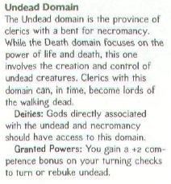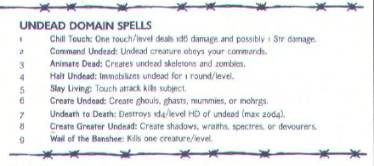
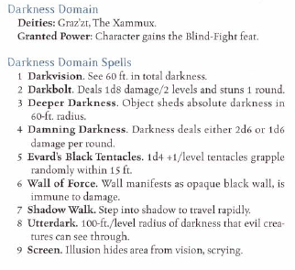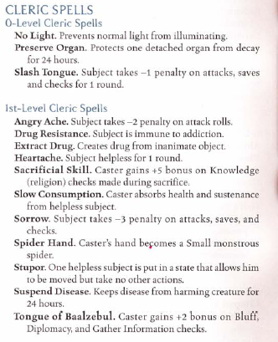
Undead Domain – Dragon Issue #312
Darkness Domain & List of Spells – Book of Vile Darkness

RP Notes: He proclaims, "I hear the Jackals as they march. Their taste for blood cannot be quenched. Their hunger cannot be satisfied! Their obedience to the master knows no equal!"

The Book of the Damned
Turn Undead – ”Vis vires Raughir coacto tu!” – The power of Raughri compels you!
No Light - "Acerbus comburo lux lumen. Umbras deprehendo nos." – Darkness consume the light of day. Shadows overtake us.
Slash Tongue – ”Profatus contra gandis diabolus dominus domnoet dolor oportet frequento tui lingua!” - Speak out against the great devil master and pain shall visist your tongue!

Hide from Undead – ” Vacuus ossis contineo haud animus. Vacuus capitis contineo haud oculus. Econtra lacuna tu I appareo!” –Empty bones hold no soul. Empty heads hold no eyes. The same as empty space to you I become.
Heartache – ” Moeror supervenio tu!” – Sorrow overtake you!
Cure Light Wounds – ”Convalesco Raughir emanio venio hunc vulnus. Caruncula pario caruncula, ossis pario ossis, cruor pario cruor.” – Strength of Raughir flow into this wound. Flesh to spawn flesh, bone to spawn bone, blood to spawn blood.
Sorrow – ”Quoque infelicitas, secus miserabilis!” –Too bad, so sad!
Bless – ”Abrogo animus absit damnod penetro tui viscus ac idoneus ivi tu imperv frendo hostes hostium’s ossis pulvis!” –Take the courage of the damed into your heart and the worthy of you shall grind the enemy's bones to dust!
Chill Touch – ”Frigus pulso letifer!” – The cold touch of death-dealing!
Dark Bolt – ”Imperium Atrum!” – Power of Darkness!
Wither Limb – ”Vietus animus, vietus viscus, vietus crur!” – Withered soul, withered heart, withered limbs!
Feat Collection
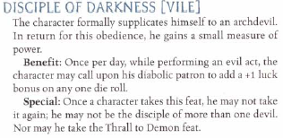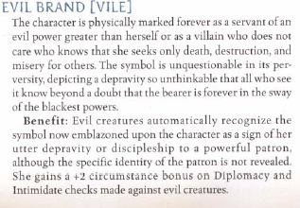

Spell Collection
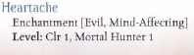
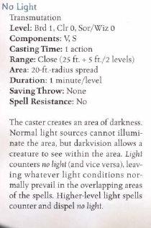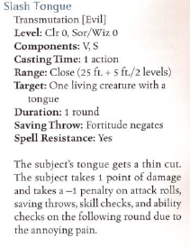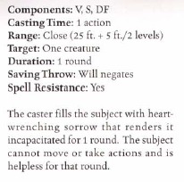
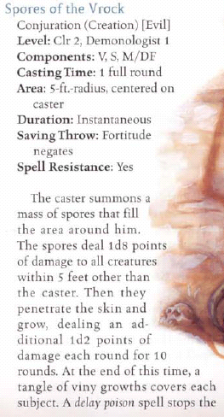
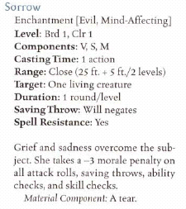

2nd Level
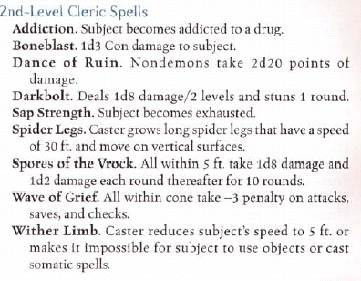

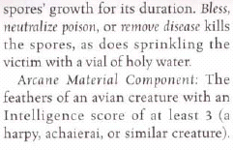

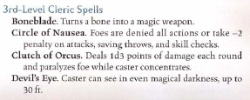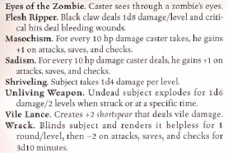
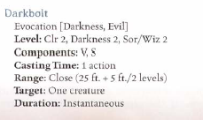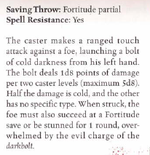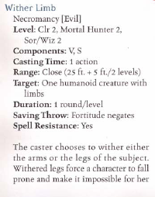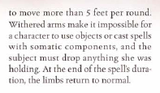
“This is what we do to those that fail Saurgoth and Raughir” The words run fearfully from the tall black skinned man directed at the child. “Traitors, thieves, beggars, they are all the same understand child?” The empty eye sockets of the Priest of the Sightless look down at the boy. The boy whose mother was a slaver of the Black Lotus, one of the few women captains of the ships that raid the coasts of Dogon Saunri and Yaskar. She was a fair woman, born of some farmer in Hirratak she fell in with the Black Lotus in the Yintse before moving down off shore of the Shifting Sands of Dogon Saunri. His father however was a native of the sands and the coasts. A chieftain of the Laoz Tribe, one of the last hints of the barbarian tribes that once over ran the Uruadum continent. He was a large man, a strong warrior and fiercely independent. The young boy, no more than ten looked back at the fire that now flared up in the lush greenery that is the coast of Saurgoth the Abhorrent Master’s province. “I understand.”
With empty eye sockets the Sightless priest smiled at the boy, “Good. Then let me show you how to prove your worth to the Dungwalme, and fix the failures of your family.” The boy nodded and moved off at the side of the Priest never looking back again at the bonfire that was fueled by his mother and father, fueled by traitors, and by failures...

